
THE COPPERBELT UNIVERSITY
SCHOOL OF INFORMATION AND COMMUNICATION TECHNOLOGY
COMPUTER SCIENCE DEPARTMENT
SUPERVISOR: DR LENGWE
COURSE: CS301 PROJECT MANAGEMENT
PROJECT TITLE: GRAIL - A HIGH SCHOOL INFORMATION SYSTEM
GROUP: 40
This project report is submitted in partial fulfilment of the requirements for the award of a Bachelor of Science Degree in Computer Science at The Copperbelt University.
NAME | SIN
LAZAROUS MWEENDALUBI | 23134445
ROY CHOWA CHANDA | 22104694
DUNCAN CHONGO | 23132765
SILAS BENJAMIN NDLOVU | 22103729

DECLARATION
We hereby declare that this submission is our own work and that, to the best of our knowledge and belief, it contains no material previously published or written by another person nor material which to a substantial extent has been accepted for the award of any other degree or diploma of the university or other institute of higher learning, except where due acknowledgement has been made in the text.

LAZAROUS MWEENDALUBI (23134445)
Signature: ________________________ Date: ________________________

ROY CHOWA CHANDA (22104694)
Signature: ________________________ Date: ________________________

DUNCAN CHONGO (23132765)
Signature: ________________________ Date: ________________________

SILAS BENJAMIN NDLOVU (22103729)
Signature: ________________________ Date: ________________________

Supervisor: Dr Lengwe
Signature: ________________________ Date: ________________________

DEDICATION
This project is dedicated to our families, whose unwavering support and encouragement made this work possible, and to the staff and students of Copperbelt University's School of Information and Communication Technology, whose guidance and example shaped our approach to this project.

ACKNOWLEDGEMENTS
We would like to express our sincere gratitude to our supervisor, Dr Lengwe, for the guidance, patience, and constructive feedback provided throughout the course of this project. His insights were instrumental in shaping the direction and quality of this work.
We also extend our thanks to the Computer Science Department and the School of Information and Communication Technology at The Copperbelt University for providing the resources, learning environment, and structured project framework that made this work possible.
Finally, we thank our families and friends for their continued encouragement, understanding, and support throughout the duration of this project, and our fellow group members for their commitment and collaboration in bringing Grail to completion.

Table of Contents
DECLARATION 2
DEDICATION 3
ACKNOWLEDGEMENTS 4
List of Figures 9
List of Tables 10
ABSTRACT 11
CHAPTER 1.0 INTRODUCTION 1
1.1 INTRODUCTION 1
1.2 PROBLEM STATEMENT 2
1.3 OBJECTIVES 3
1.3.1 Main Objective 3
1.3.2 Specific Objectives 3
1.4 SCOPE AND LIMITATION 4
1.5 ORGANISATION OF THE REPORT 4
1.6 CONCLUSION 5
CHAPTER 2: LITERATURE REVIEW 6
2.1 INTRODUCTION 6
2.2 RELATED WORKS 6
2.3 EXISTING SYSTEMS 8
2.3.1 OpenSIS 8
2.3.2 Magister 9
2.3.3 Infinite Campus 10
2.3.4 PowerSchool 11
2.3.5 Skyward 12
2.3.6 Aspen SIS 13
2.3.7 Gradelink 14
2.3.8 Fedena 14
2.3.9 Genius SIS 14
2.3.10 Cumulo Learning 15
2.4.0 DISCUSSION OF FINDINGS 15
2.5.0 CONCLUSION 16
CHAPTER 3 RESEARCH METHODOLOGY 17
3.1 Introduction 17
3.2 Methodology 18
3.2.1 Agile Development Methodology (Scrum / Iterative) 18
3.2.2 Object-Oriented Analysis and Design (OOAD) 18
3.2.3 Unified Modelling Language (UML) 19
3.3 Information Gathering and Analysis 19
3.3.1 Literature Review 19
3.3.2 Survey questionnaire 20
3.3.3 Document Analysis 20
3.3.4 Requirements Validation 20
3.4 Requirements Specification 21
3.4.1 User Requirements 21
3.4.2 System Requirements 22
3.4.3 Software Requirements 25
3.4.4 Hardware specifications 26
3.5 System Analysis 27
3.5.1 Use Case Diagrams 27
3.5.2 Entity Relationship Diagrams (ERD) 27
3.5.3 State Chart Diagrams 28
3.6 Conclusion 28
CHAPTER 4 SYSTEM DESIGN 30
4.1 Introduction 30
4.1.1 Laravel (MVC) as the Application Framework 30
4.1.2 MySQL as the Database Management System 31
4.1.3 Mobile-First Design Philosophy 31
4.2 Analysis of the System 32
4.3 Context Model of the System 32
4.3.1 System Boundary 33
4.3.2 External Entities and Data Flows 33
4.4 Design Methods 34
4.4.1 Architectural Design 35
Three-Tier Architecture 35
Client-Server Model 37
Progressive Web App (PWA) and Low-Bandwidth Requirement 37
4.4.2 Detailed Design Object-Oriented Analysis and Design (OOAD) 38
Use Case Diagrams Modelling User-System Interactions 38
Sequence Diagrams Modelling Process Logic 40
State Chart Diagrams Modelling Entity Status Transitions 42
4.4.3 Physical Design 44
User Interface Design 44
Data Design 44
Process Design Validation and Security 47
4.5 Conclusion 47
CHAPTER 5: SYSTEM IMPLEMENTATION 48
5.1 Introduction 48
5.2 System Implementation & Technology Stack 49
5.2.1 Programming Language and Framework Selection 49
5.2.2 Database Management System (DBMS) 49
5.2.3 Technical Architecture 49
5.3 Critical Code Implementations & Algorithms 50
5.3.1 Audit Trail Compliance Trait (Auditable.php) 50
5.3.2 Class Rank & Grade Finalization Workflow 51
5.4 Project & Risk Management 51
5.4.1 Key Implementation Milestones 51
5.4.2 Risk Management & Configuration Control 52
5.5 Conclusion 52
CHAPTER 6: EVALUATION AND TESTING 52
6.1 Introduction 52
6.2 Test Strategy and Methodology 53
6.3 Detailed Test Cases and Results 53
6.3.1 Unit Test Execution Suite 53
6.3.2 Integration Test Execution Suite 54
6.4 Performance & Usability Evaluation 54
6.4.1 Response Time & Query Optimization 55
6.4.2 Usability Evaluation 55
6.5 Critical Evaluation of Objectives Achieved 55
6.6 Conclusion 55
CHAPTER 7: CONCLUSION AND RECOMMENDATIONS 56
7.1 Conclusion 56
7.2 Limitations 57
7.3 Recommendations 58
REFERENCES 59
APPENDICES 61
Appendix 1: Original Project Proposal 61
Appendix 2: Installation Manual 83
A2.1 Prerequisites 83
A2.2 Obtaining the Source Code 83
A2.3 Installing Dependencies 83
A2.4 Environment Configuration 83
A2.5 Database Migration and Seeding 84
A2.6 Building the Front-End Assets 84
A2.7 Starting the Application 84
A2.8 Troubleshooting 84
Appendix 3: User Manual 85
A3.1 Signing In 85
A3.2 Administrator 85
A3.3 Teacher 87
A3.4 Parent 87
A3.5 Student 88
Appendix 4: Sections of Program Code 88
A4.1 Fee state machine and payment reference (app/Models/Fee.php) 88
A4.2 Separating subject qualification from a real teaching assignment (app/Http/Controllers/Admin/AdminTeacherController.php) 90
Appendix 5: Questionnaires 91
A5.1 Respondent Background 91
A5.2 Current Process and Pain Points (Likert scale) 92
A5.3 Desired Features (open-ended) 92
Appendix 6: Data Files 93
A6.1 Seed Data 93
A6.2 Exported Data Files 94
Appendix 7: Component Specifications 94
A7.1 Overview 94
A7.2 Identity and Access 94
A7.3 Academic Structure 97
A7.4 Academic Records 100
A7.5 Finance 101
A7.6 Calendar 103
A7.7 Audit and Compliance 103

List of Figures
Figure 1: OpenSIS dashboard interface 8
Figure 2: Magister user interface displaying student timetable 9
Figure 3: Infinite Campus parent portal interface 10
Figure 4: PowerSchool grading interface 11
Figure 5: Skyward Family Access Portal 12
Figure 6: Aspen SIS Gradebook 13

List of Tables
Table 1: Non-functional requirements 24
Table 2: Presentation Layer 25
Table 3: Application Layer 25
Table 4: Client devices 26
Table 5: External entities and Data flows 33
Table 6: Three tier architecture 35
Table 7: Entity Status Transitions 42
Table 8: Technology selected and Justification 50
Table 9: Unit tests 53
Table 10: Integration tests 54

ABSTRACT
Grail is a web-based High School Information System designed to automate and integrate core administrative and academic processes within a high school environment. The system addresses challenges associated with manual record keeping, such as data inconsistency, security risks, and time-consuming report generation. It provides centralized management of student records, staff information, academic performance, and financial data within a secure and user-friendly platform.
The system was developed using Laravel (PHP), MySQL, and Tailwind CSS, enabling reliable operation in environments with limited computing resources. Key features include role-based access control, automated reporting, and data validation to ensure data integrity and confidentiality. Evaluation confirmed that, by improving accuracy, efficiency, and accessibility of school information, the High School Information System supports informed decision-making and enhances overall administrative effectiveness.

CHAPTER 1.0 INTRODUCTION

1.1 INTRODUCTION
Digital technologies have increasingly transformed how schools manage information and perform administrative tasks. However, in many developing countries such as Zambia, effective management of high school information systems remains a challenge. As student enrollment in secondary education continues to grow, schools are required to handle increasing volumes of data related to students, academic performance, attendance, fees, and general administration. These processes are often constrained by limited resources, financial challenges, unreliable electricity, and continued reliance on manual record-keeping systems, which can lead to errors, delays, and increased workload for school staff.
Many Zambian high schools still depend on paper-based files and separate records for different administrative functions. This makes information difficult to retrieve, update, and share among teachers, administrators, parents, and school management. These challenges are particularly evident in rural schools with limited infrastructure, as well as in urban schools experiencing overcrowding and staff shortages.
This proposal presents Grail, a web-based High School Information System designed to improve the management of academic and administrative processes in Zambian high schools. Grail aims to provide a centralized, accessible, and user-friendly platform for managing student records, academic results, fees, and basic communication. By reducing paperwork and improving data accuracy, the system seeks to enhance efficiency and support better decision-making within the constraints of limited resources.

1.2 PROBLEM STATEMENT
Many high schools in Zambia continue to rely on traditional paper-based filing systems and fragmented digital tools for managing academic and administrative information. These methods make it difficult to store, retrieve, and maintain accurate student and staff records over time. As a result, school administrators and teachers face challenges such as misplaced files, duplicated records, delayed report generation, and increased risk of data loss.
The absence of a centralized information system limits effective monitoring of student performance, attendance, and academic progress. Manual processes also increase the likelihood of human error and consume valuable time that could otherwise be dedicated to teaching and student support. Existing digital solutions, where available, are often costly, overly complex, or poorly suited to the operational needs of most high schools.
There is therefore a need for a reliable, centralized, and easy-to-use high school information system that can replace traditional record-keeping practices while remaining practical for schools with limited resources. Without such a system, many high schools will continue to experience inefficiencies that negatively affect decision-making, service delivery, and overall school management.

1.3 OBJECTIVES

1.3.1 Main Objective
The main objective of this study is to design, develop, and evaluate a High School Information System that supports the efficient management of academic and administrative information in secondary schools. The system aims to improve communication among stakeholders, reduce reliance on manual record-keeping practices, and provide a structured, web-based digital platform suitable for schools operating in resource-constrained environments.

1.3.2 Specific Objectives
- The study aims to design a system that improves communication among school staff and relevant stakeholders through centralized access to accurate and up to date academic and administrative information.
- It also seeks to develop a centralized web-based platform that reduces reliance on manual record keeping by digitizing key school processes, thereby improving data accuracy, accessibility, and long-term record management.
- Another objective is to implement and evaluate the proposed system to assess its functionality, usability, and effectiveness in addressing administrative challenges within secondary schools.
- Finally, the study aims to document the system development process, challenges encountered, and lessons learned in order to provide practical recommendations for implementing similar systems in resource-constrained educational environments such as Zambia.

1.4 SCOPE AND LIMITATION
This study focuses on the design, development, and evaluation of Grail, a web-based platform intended to support the management of academic and administrative information in high schools. The scope of the study is limited to addressing key information management challenges commonly faced by secondary schools, particularly those operating with limited resources.
Functionally, the study covered the development of core system modules including student registration and record management, staff information management, class and subject allocation, attendance tracking, academic performance recording, and reporting features. User roles for administrators, teachers, parents, and students were implemented to support controlled access to system features. The system was evaluated based on its ability to improve efficiency, accuracy, and accessibility of school records.
Geographically, the study is contextualized within the Zambian high school environment. While the system is designed to be adaptable, the findings and conclusions of the study are based on a limited institutional context and may not fully represent all high schools nationwide. The study does not aim to integrate the system with national education databases or ministry-level platforms.
In terms of technology, the study was restricted to the development of a web-based application using commonly available tools and frameworks. Advanced functionalities such as biometric identification, artificial intelligence, automated analytics, and integration with external financial or government systems were beyond the scope of this project. System performance evaluation was also limited to short-term testing rather than long-term operational assessment.
Additionally, the study faced limitations related to time, access to users for extensive testing, and availability of real school data due to privacy and ethical considerations. As a result, some system evaluation relied on simulated or sample data. These limitations are acknowledged and considered in interpreting the results of the study.

1.5 ORGANISATION OF THE REPORT
The remainder of this report is organised into six further chapters. Chapter 2 reviews related academic literature and ten established Student Information Systems, identifying the gap that Grail addresses. Chapter 3 presents the research methodology, covering the Agile development approach, information-gathering methods, and the resulting requirements specification. Chapter 4 details the system design, including the three-tier architecture, database design, and user interface design. Chapter 5 describes the system implementation, covering the technology stack, key algorithms, and project management approach. Chapter 6 presents the evaluation and testing carried out to verify the system against its functional and non-functional requirements. Chapter 7 concludes the report, reflecting on the extent to which the project objectives were achieved and setting out recommendations for future work.

1.6 CONCLUSION
This chapter has established the foundation upon which the remainder of this report is built. It has shown that many Zambian high schools continue to depend on paper-based filing and fragmented digital tools, resulting in misplaced and duplicated records, delayed report generation, heightened risk of data loss, and limited capacity to monitor student performance, attendance, and academic progress. Where digital alternatives exist, they are frequently costly, unnecessarily complex, or poorly matched to the operational realities of the schools they are intended to serve.
In response to this problem, the chapter has set out the main objective of the study, which is to design, develop, and evaluate a High School Information System that supports the efficient management of academic and administrative information in secondary schools. This was elaborated through specific objectives directed at improving communication among stakeholders, reducing reliance on manual record-keeping practices, implementing and evaluating the proposed system, and documenting the development process for the benefit of similar initiatives in resource-constrained educational environments. The scope of the study was delimited functionally, geographically, and technologically, and its limitations were acknowledged so that the findings may be interpreted appropriately.
Having established the problem, the objectives, and the boundaries of the study, the next chapter reviews the existing body of literature and the student information systems currently in use, in order to identify the gap that the proposed system seeks to fill.

CHAPTER 2: LITERATURE REVIEW

2.1 INTRODUCTION
This review critically examines existing academic literature and real-world implementations related to Student Information Systems (SIS) in order to inform the proposed development of Grail, a web-based Student Information System (SIS). The review focuses on real-world platforms currently deployed across diverse educational contexts and the academic literature surrounding digital school management. The primary objective is to identify common features, architectural approaches, strengths, and limitations of these systems in order to guide the design of a solution suitable for secondary schools operating in resource-constrained environments. By analyzing established systems and theoretical frameworks, this review establishes a foundation for the proposed Grail system and justifies its focus on addressing gaps left by enterprise-level and high-cost alternatives.

2.2 RELATED WORKS
Research on high school-based online information systems has grown significantly as schools increasingly rely on digital platforms to manage student records, academic performance, and administrative processes. Online Student Information Systems (SIS) are commonly described as centralized platforms that store and manage data related to enrollment, attendance, grading, and communication among stakeholders (Davis, 1989; Granić & Marangunić, 2019). In secondary education, these systems are viewed as essential tools for improving administrative efficiency and enhancing transparency between schools, students, and parents.
Several studies report that online SIS platforms improve data accuracy and reduce administrative workload when compared to manual or paper-based systems. For example, Al-Hariri and Al-Hattami (2017) found that digital school management systems significantly reduce duplication of records and enable faster access to student information. Similarly, O’Brien and Marakas (2011) explain that web-based information systems improve organizational efficiency by allowing multiple users to access and update shared data in real time. These findings support the widespread adoption of online SIS platforms in high school environments.
Despite these advantages, existing literature reveals notable limitations and inconsistencies in current systems. A recurring issue is that many online SIS platforms are designed with assumptions of stable internet connectivity, reliable electricity, and the presence of dedicated IT personnel. Studies focusing on developing or resource-constrained regions highlight that such assumptions significantly limit system usability and sustainability (Sife, Kiondo, & Lyimo, 2018). As a result, systems that perform effectively in well-resourced schools often fail or are underutilized in less advantaged secondary schools.
Another limitation identified in prior research concerns system complexity and usability. While enterprise-level SIS platforms offer extensive functionality, Granić and Marangunić (2019) demonstrate that perceived ease of use is a critical determinant of system adoption among school staff. High school teachers and administrators frequently report difficulties navigating complex interfaces, leading to resistance or partial system usage. According to Nielsen (2012), information systems often fail not because of missing features but because poor usability and overly complex interfaces increase cognitive load and disrupt user workflows. This indicates a mismatch between system design and the practical realities of high school administrative environments.
The literature also exposes omissions in stakeholder-focused design, particularly regarding students and parents. Research on digital school communication indicates that parent and student portals improve transparency and engagement when designed for accessibility and ease of use (Epstein, 2018). However, many systems provide limited mobile optimization and poor support for users with low digital literacy. This omission is significant in high school contexts where parents may rely primarily on mobile devices and intermittent internet access to monitor student progress. Consequently, the potential of online SIS platforms to strengthen school–home collaboration remains underrealized.
Financial management integration presents another unresolved challenge. Laudon and Laudon (2020) emphasize that modern organizational information systems increasingly integrate financial management modules to improve accountability and transparency. However, the literature largely overlooks implementation barriers in schools without access to reliable digital banking infrastructure. This gap suggests that existing systems inadequately address the financial and operational realities of many secondary schools, particularly in developing regions.
Overall, prior studies confirm that online Student Information Systems are valuable tools for high school administration, yet they remain insufficiently adapted to diverse educational contexts. Existing systems tend to prioritize feature richness and enterprise scalability over simplicity, affordability, and contextual relevance. The unresolved problems of usability, infrastructure dependency, and limited localization directly motivate the proposed system. By focusing on a lightweight, modular, and user-friendly design tailored for high school environments in resource-constrained settings, the proposed system seeks to address the gaps identified in existing literature and contribute a more context-appropriate solution to digital school management.

2.3 EXISTING SYSTEMS
While the academic literature highlights general trends and challenges in SIS adoption, this section examines specific real-world systems to illustrate how these issues manifest in practice. Each system is evaluated based on its target audience, platform, core functionality, and availability for evaluation.

2.3.1 OpenSIS
OpenSIS is a comprehensive student information system designed to support core administrative and academic functions in K-12 educational institutions. The platform provides robust functionality for managing student demographics, enrollment, attendance tracking, grading, and scheduling. Originally developed as an open-source alternative to expensive proprietary systems, it has evolved into a dual-offering platform: a free Community Edition and a cloud-based SaaS version.
The target users include small to medium-sized schools and school districts seeking a flexible, cost-effective solution. OpenSIS demonstrates the viability of open-source software in the education sector and illustrates how institutions can balance cost constraints with functionality requirements. Figure 1 shows the interface used for managing student records.
• URL: https://www.opensis.com/
• Platforms: Web-based (Linux, Windows, macOS), iOS, Android
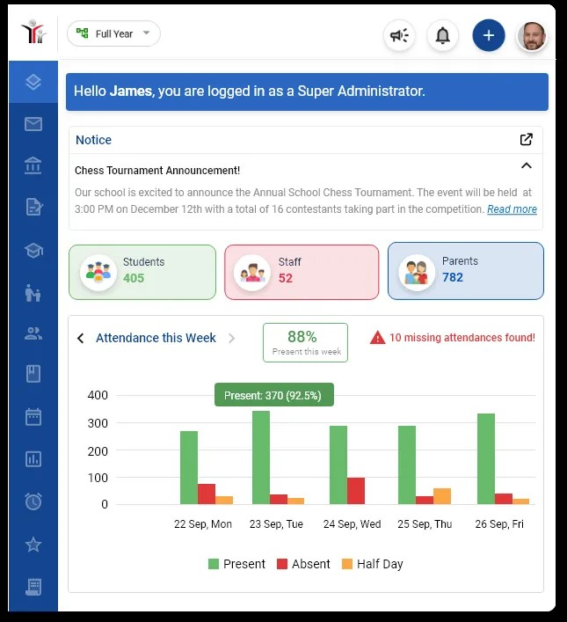
• Trial License Duration: Community Edition is Open Source (Free Forever); SaaS version offers 15-day free trial
Figure 1: OpenSIS dashboard interface

2.3.2 Magister
Magister is a comprehensive school administration platform developed primarily for the Dutch secondary education market. The system was designed to provide real-time access to academic progress and facilitate digital communication between schools and families. The platform's core functionality encompasses administrative processing of student data, grade management, and student care coordination.
The target users include students, parents, teachers, and school administrators, with particular emphasis on mobile accessibility. The platform represents a mature SIS that has evolved into a broader educational ecosystem. However, its focus on the European market limits its direct applicability to other regions without significant localization. The student timetable viewing interface is illustrated in Figure 2.
• URL: https://magister.nl/
• Platforms: Web, iOS, and Android
• Trial License Duration: Free trial available; demo available on request
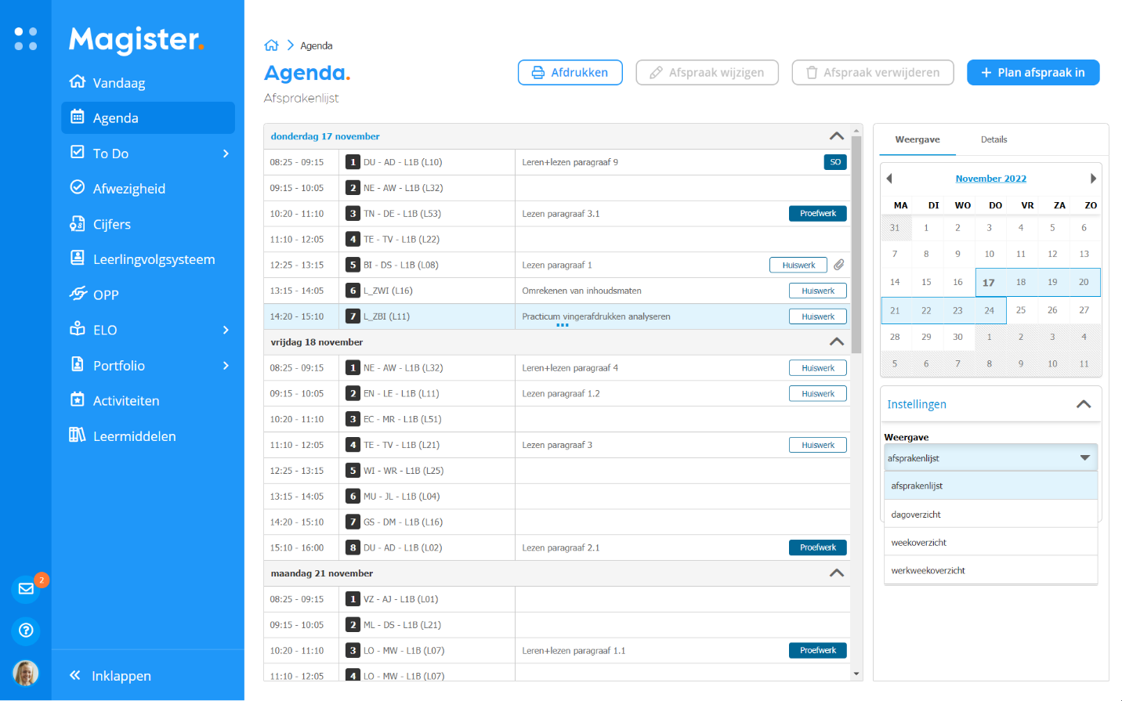
Figure 2: Magister user interface displaying student timetable

2.3.3 Infinite Campus
Infinite Campus is an enterprise-grade SIS designed to serve school districts ranging from small cohorts to hundreds of thousands of students within a single unified database. The platform was developed to eliminate duplicate data entry and provide comprehensive management of the student lifecycle. The system integrates over 1,500 core tools covering demographics, performance tracking, and health records.
The target users are large K-12 school districts and state education departments requiring complex reporting and data analytics. Its extensive feature set and enterprise complexity make it less suitable for small schools or resource-constrained environments, reinforcing the need for simpler alternatives like the proposed Grail system. Figure 3 displays the parent portal interface.
• URL: https://www.infinitecampus.com/
• Platforms: Web-based, iOS, Android
• Trial License Duration: No free trial; live and on-demand product demonstrations available

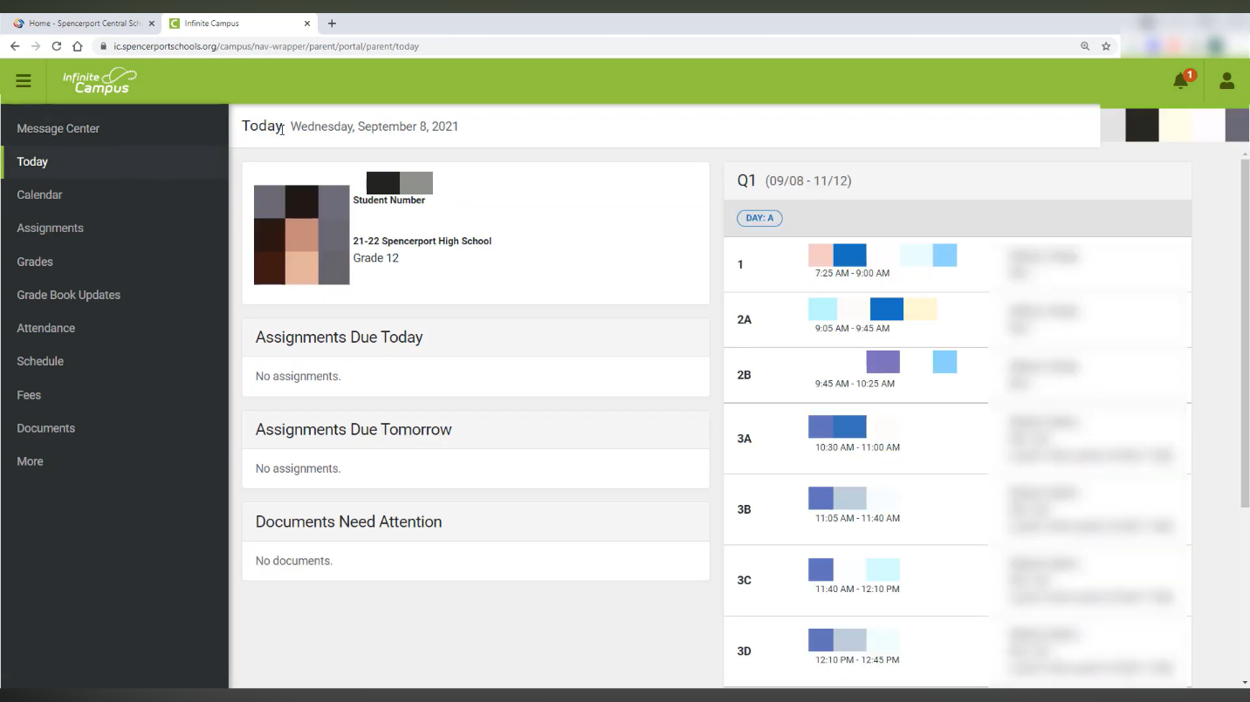
Figure 3: Infinite Campus parent portal interface

2.3.4 PowerSchool
PowerSchool is one of the most widely adopted student information systems globally. The platform was developed to centralize all aspects of the educational journey while supporting extensive integration with third-party tools. It provides comprehensive functionality for student registration, attendance tracking, and state compliance reporting.
The target users are school administrators and district leaders who require high levels of integration and sophisticated data analytics. PowerSchool's strength lies in its ecosystem approach; however, its complexity and associated costs create barriers for under-resourced schools. Figure 4 displays the grading and behavior tracking interface.
• URL: https://www.powerschool.com/
• Platforms: Web-based, iOS, Android
• Trial License Duration: No free trial; product demonstration available on request

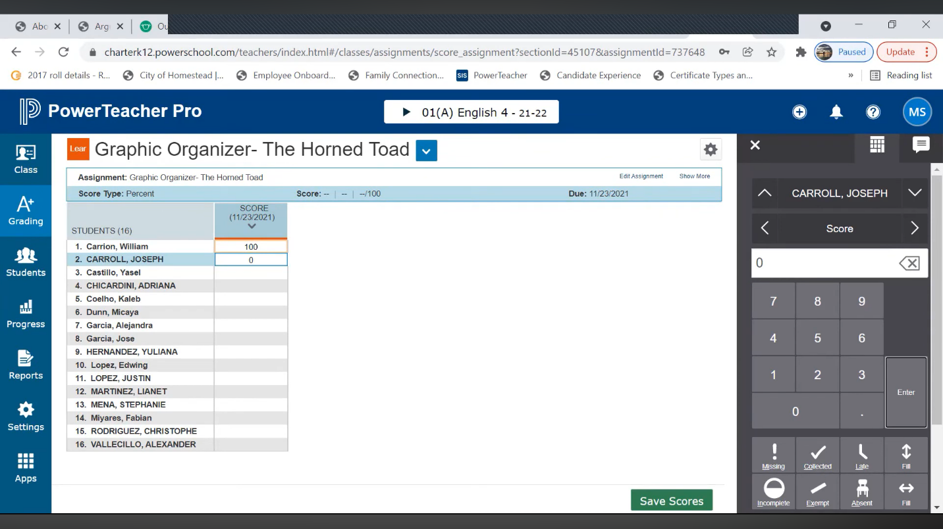
Figure 4: PowerSchool grading interface

2.3.5 Skyward
Skyward distinguishes itself as an all-in-one administrative platform that extends beyond traditional SIS functionality to encompass enterprise resource planning (ERP). The system was developed as a unified solution merging SIS features with business management, HR, and financial administration. This allows districts to manage virtually all operations within a single system.
The target users are large-scale educational institutions seeking enterprise capabilities that unify academic and business operations. Skyward's family access portal, shown in Figure 5, illustrates the wide range of features available to stakeholders, from viewing academic progress to managing fee payments.
• URL: https://www.skyward.com/
• Platforms: Web-based, Mobile (iOS and Android)
• Trial License Duration: No free trial; custom demonstration available on request
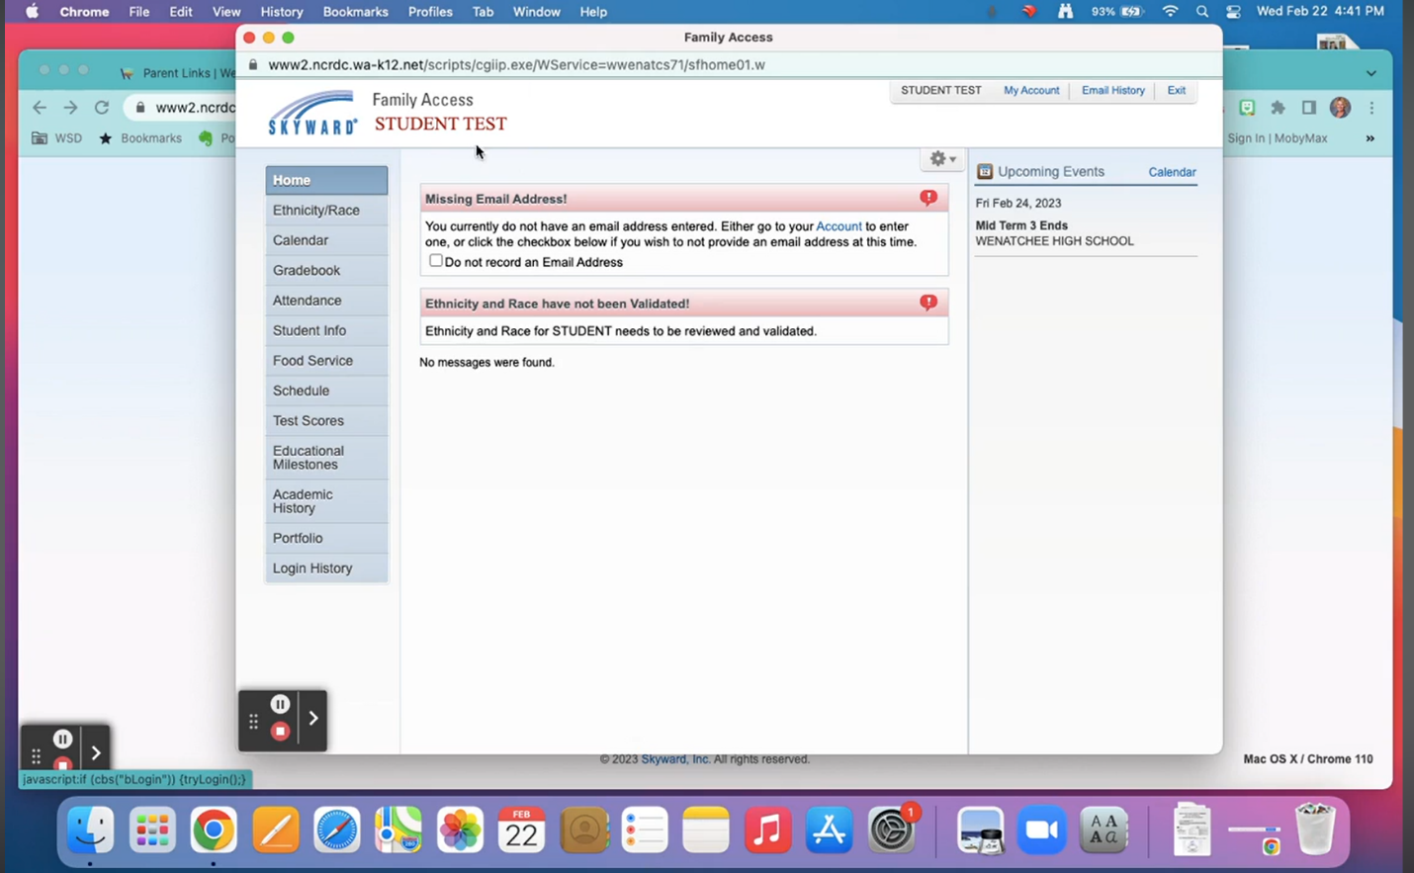
Figure 5: Skyward Family Access Portal

2.3.6 Aspen SIS
Aspen SIS, developed by Follett School Solutions, is a cloud-hosted system designed to provide customizable academic tracking. The platform was developed with flexibility as a core design principle, enabling institutions to tailor workflows to align with local policies and regulatory requirements.
The target users include school districts seeking a hosted solution that balances standardized functionality with institutional customization. The customizable workflow interface, allows adaptability in school management software. However, this flexibility requires significant implementation planning which may challenge schools with limited technical expertise.
• URL: https://follettsoftware.com/
• Platforms: Web-based (Cloud-hosted)
• Trial License Duration: No free trial; product demonstration available on request
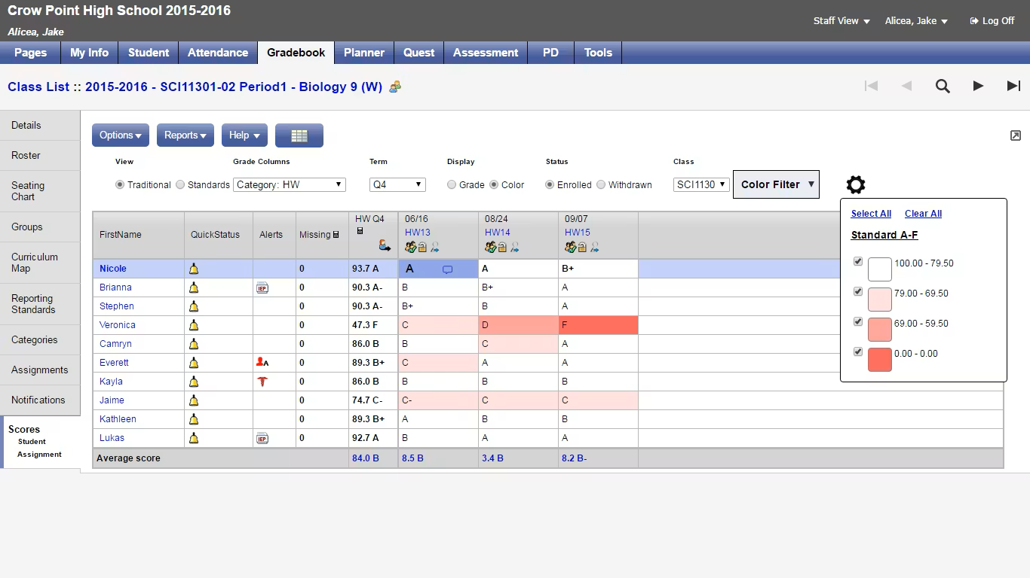
Figure 6: Aspen SIS Gradebook

2.3.7 Gradelink
Gradelink is a cloud-based system specifically designed for small to medium-sized schools with limited IT resources. The platform was developed to provide essential SIS functionality through an intuitive interface that requires minimal technical expertise to deploy. It prioritizes simplicity over comprehensive feature density.
The target users are small private schools and charter schools. Gradelink's value proposition centers on affordability and ease of implementation. The system utilizes a streamlined philosophy that makes it accessible to users with varying levels of technical proficiency.
• URL: https://www.gradelink.com/
• Platforms: Web-based (Cloud), Mobile-responsive
• Trial License Duration: No free trial, product demonstration available on request

2.3.8 Fedena
Fedena is a modular school management system developed to accommodate institutions ranging from small schools to large universities. The platform was designed with scalability as a fundamental principle, allowing institutions to activate only the modules they currently need. Core modules include admission, attendance, and fee collection.
The target users range from small private schools to large educational institutions. Fedena’s flexibility extends to deployment, offering both cloud and self-hosted options. The system allows users to reduce complexity by hiding unnecessary features. This modular philosophy strongly informs the proposed Grail project.
• URL: https://fedena.com/
• Platforms: Web-based (Self-hosted and SaaS)
• Trial License Duration: 14-day free trial (SaaS version)

2.3.9 Genius SIS
Genius SIS represents the convergence of student administration and digital learning platforms. The platform was developed specifically for online schools and hybrid learning environments where administrative management requires tight integration with instructional delivery. It ensures academic performance data flows seamlessly between systems.
The target users are virtual schools and online learning programs. The platform is built specifically to integrate with learning management systems. While Grail focuses primarily on administrative processes, Genius SIS provides insight into potential future expansion into instructional support features.
• URL: https://geniuslearning.com/
• Platforms: Web-based
• Trial License Duration: No free trial, Product demonstration available on request

2.3.10 Cumulo Learning
Cumulo Learning is a unified platform developed primarily for the Australian secondary education market. The system provides integrated school management and collaboration tools within a single ecosystem. It represents the evolution of traditional SIS platforms into comprehensive school operating platforms.
The target users are modern secondary schools seeking a unified solution that supports both administrative efficiency and contemporary pedagogical approaches. The platform supports the full range of school operations while addressing the challenges of managing complex systems in resource-constrained environments.
• URL: https://cumulo.com.au/
• Platforms: Web-based
• Trial License Duration: No free trial, Product demonstration available

2.4.0 DISCUSSION OF FINDINGS
The review of academic literature and existing Student Information Systems (SIS) provides several important insights for the design of Grail, while highlighting that many current solutions have a different technical focus.
A major finding is that usability is often more important than having a large number of complex features. For a system to be widely used, it must be simple and easy to understand. This makes a streamlined interface a top priority for Grail. Additionally, the review confirms that modern school management is moving toward mobile devices. Since many parents rely on smartphones for information, Grail’s focus on a mobile-friendly design is a direct response to how people actually use technology today.
The findings also show a clear difference in how systems handle infrastructure. Many established SIS platforms are built for environments with reliable high-speed internet and stable power. While these systems work well in those settings, they have a different design focus than Grail. Therefore, Grail’s architecture is specifically built to work with low bandwidth and inconsistent connectivity, using lightweight methods to stay functional on 3G networks. The review also supports the idea of using a modular approach. By matching the software with local school policies and reporting standards, Grail provides a specific alternative to global models that might not fit the administrative needs of local secondary schools.
However, these findings should be seen in the context of their intended use. Much of the current research focuses on higher education or well-funded schools in other countries, which represent a different category of users than this project. Furthermore, because major platforms are proprietary (closed-source), their internal designs are not available for technical analysis. This reinforces the need for Grail to have an independent and clear design like the Laravel and MySQL structure that can be managed locally. Finally, while existing research gives us a good starting point, there is still room to explore data privacy and security within local regulations.
Overall, this discussion confirms that while the global SIS market is well-developed, there is still a need for a solution tailored to local needs. By focusing on essential tasks and working within the local infrastructure, Grail is designed to provide the same data quality as large-scale software, but in a way that is practical for its intended users.

2.5.0 CONCLUSION
This review has examined the evolution of school information management through both academic research and the evaluation of ten established Student Information Systems. The review confirms that while digital data management is a mature field, a significant gap remains: existing market solutions are often too expensive, overly complex, or too infrastructure-heavy for secondary schools in resource-constrained environments.
The insights gained regarding modular architecture, user interface simplicity, and the necessity of mobile-responsive portals provide a definitive roadmap for the development of Grail. By addressing the unresolved problems of "feature creep" and infrastructure dependency identified in this review, the proposed system is positioned to offer a practical, sustainable alternative to enterprise-level software. These findings will now serve as the direct foundation for the system requirements and design phases detailed in the subsequent chapters.

CHAPTER 3 RESEARCH METHODOLOGY

3.1 Introduction
This chapter presents the research methodology adopted for the design and development of Grail; a web-based High School Information System intended for use in resource-constrained secondary school environments. Specifically, this chapter details the selection of the Agile Development Methodology, guided by the Scrum framework, and the application of Object-Oriented Analysis and Design (OOAD) as the primary analytical and design approach.
The Agile methodology was selected on the basis of its demonstrated suitability for software projects that require iterative development, ongoing stakeholder engagement, and responsive adaptation to evolving requirements. OOAD complements this approach by providing a structured mechanism for modelling the system's entities, behaviours, and interactions through established object-oriented principles.
The chapter is organized to cover the following key areas: (i) the justification and description of the chosen methodology; (ii) information gathering and requirements analysis; (iii) requirements specification, encompassing both user and system requirements; and (iv) system analysis, detailing the modelling tools and diagrams employed to represent the structure and behaviour of Grail. Together, these components constitute a coherent and rigorous methodological framework that underpins the entire development process.

3.2 Methodology

3.2.1 Agile Development Methodology (Scrum / Iterative)
The Agile Development Methodology, implemented through the Scrum framework, forms the primary development approach for Grail. Agile is an iterative and incremental software development methodology that organizes work into short, time-boxed development cycles known as sprints, typically spanning two to four weeks. At the conclusion of each sprint, a working increment of the system is produced, reviewed, and refined before the next cycle begins.
Agile was chosen for the development of Grail for the following reasons:
- Flexibility and adaptability: The requirements of school information systems in resource-constrained environments are inherently dynamic. Administrators and teachers may identify new needs or constraints during the development process that were not fully articulated at the outset. Agile accommodates these changes without disrupting the overall project structure.
- Prototype demonstration to stakeholders: Agile enables the development team to present functional prototypes to school administrators, teachers, and other stakeholders at the end of each sprint. This facilitates early and continuous feedback, ensuring that the system remains aligned with real user needs throughout development rather than only at the point of final delivery.
- Iterative improvement: Each sprint builds upon the preceding one, allowing defects and usability issues identified during testing or demonstration to be addressed promptly. This progressive refinement ensures that the final product is the result of multiple validated iterations rather than a single, untested design cycle.
The Scrum framework within Agile provides the structural scaffolding for managing these sprints, including sprint planning, daily reviews, and sprint evaluations, ensuring that the team remains focused, accountable, and responsive throughout the project.

3.2.2 Object-Oriented Analysis and Design (OOAD)
Object-Oriented Analysis and Design (OOAD) is employed as the analytical and design methodology for Grail. OOAD approaches system development by modelling the problem domain in terms of objects discrete entities that encapsulate both data (attributes) and behaviour (methods). This paradigm is particularly well-suited to the development of web-based information systems, as it promotes modularity, reusability, and maintainability of code.
During the analysis phase, OOAD is used to identify the key objects within the Grail system, such as Students, Teachers, Administrators, Classes, Grades, and Fee Records, along with their respective attributes and the relationships between them. During the design phase, OOAD guides the architectural decisions that determine how these objects interact, how data flows through the system, and how the user interface maps to underlying system logic.
The adoption of OOAD ensures that Grail is developed on a sound structural foundation that supports future scalability and the incremental addition of new modules, consistent with the system's modular design philosophy.

3.2.3 Unified Modelling Language (UML)
Unified Modelling Language (UML) will serve as the primary tool for modelling the behavior and structure of Grail throughout the analysis and design phases. UML is an industry-standard visual modelling language that provides a suite of standardized diagram types for representing different aspects of a software system.
UML is used within the OOAD framework to translate the identified objects, interactions, and workflows into precise, communicable diagrams. These diagrams serve as both design blueprints for the development team and as documentation artefacts that support stakeholder understanding and system validation. The specific UML diagram types employed in the analysis of Grail are discussed in detail in Section 3.5.

3.3 Information Gathering and Analysis
Prior to the commencement of system design, a comprehensive information-gathering exercise was conducted to ensure that Grail's development is grounded in empirical evidence and a thorough understanding of the operational context. Three primary methods were employed:

3.3.1 Literature Review
A structured review of existing academic literature and technical documentation relating to Student Information Systems (SIS) was conducted. This review examined a range of established SIS platforms including OpenSIS, PowerSchool, Fedena, Gradelink, and Infinite Campus with the objective of identifying common features, prevalent design patterns, known limitations, and best practices in school information management.
The literature review established that while numerous capable SIS platforms exist globally, the majority are designed for well-resourced environments and impose significant cost, infrastructure, or technical complexity barriers that render them unsuitable for secondary schools in Zambia. This gap in the literature provided the academic justification for Grail as a context-sensitive, lightweight, and affordable alternative. Findings from the review directly informed the prioritization of Grail's core modules and its emphasis on low-bandwidth operation, simplicity of interface, and offline functionality.

3.3.2 Survey questionnaire
A structured survey was administered via a Google Forms questionnaire to key stakeholders at selected secondary schools, specifically targeting high school administrators and classroom teachers. This digital approach was selected to ensure a broad reach and to allow participants to provide detailed feedback asynchronously, which is essential given the demanding schedules of educational staff in high-pressure school environments.
The questionnaire was designed with a mix of quantitative Likert-scale questions and qualitative open-ended sections. It focused on quantifying current record-keeping practices, identifying the most time-intensive administrative tasks, and documenting recurring data management challenges such as misplaced physical records or significant delays in terminal report generation. Through this digital medium, administrators provided data on school-level workflows and fee management, while teachers offered critical perspectives on the manual effort required for attendance tracking and grade entry.
The data aggregated from the Google Forms responses revealed a consistent pattern of systemic inefficiency attributable to manual processes, including high rates of duplicated entries and difficulty retrieving historical data. These quantitative and qualitative insights were instrumental in validating the requirements for Grail and establishing the priority order for its development modules.

3.3.3 Document Analysis
Existing manual administrative documents were reviewed and analyzed to understand the current data structures, information flows, and record-keeping conventions in use. Documents examined included manual gradebooks, attendance registers, and fee receipt ledgers.
This analysis served two purposes. First, it provided a concrete basis for the database schema and data models underpinning Grail, ensuring that the system's data structures are compatible with and improve upon the information currently maintained by schools. Second, it identified specific formatting conventions and terminology familiar to end users, informing interface design decisions to minimize the learning curve for new users.

3.3.4 Requirements Validation
Upon completion of information gathering, the identified requirements were validated against the expressed needs of three primary stakeholder groups:
- Teachers, who require efficient tools for recording attendance, entering examination marks, and monitoring student academic progress on a class-by-class basis.
- Parents, who require accessible and timely information regarding their children's academic performance, attendance, and fee payment status, particularly through mobile-compatible interfaces given the prevalence of mobile internet access in Zambia.
- Students, who require visibility into their own academic records, results, and progress reports in a clear and accessible format.
Requirements that could not be mapped to a documented stakeholder need were deprioritized or deferred to future development cycles, ensuring that the initial release of Grail remains focused and manageable within the project's resource constraints.

3.4 Requirements Specification
Based on the information gathered through the methods described in Chapter 3.0, the following requirements were identified and documented for the Grail system. Requirements are categorized into User Requirements, which describe what users must be able to do with the system, and System Requirements, which define the technical and functional properties the system must possess.

3.4.1 User Requirements
The following user requirements were derived from survey questionnaire responses, document analysis, and requirements validation:
- Teachers must be able to enter and update student examination marks and continuous assessment scores quickly and without navigating complex menus.
- Teachers must be able to record daily class attendance, including marking individual students as present, absent, or late, within a single screen interaction.
- Teachers must be able to view a consolidated academic performance summary for each student in their assigned classes.
- Administrators must be able to register new students and maintain accurate student demographic and enrolment records.
- Administrators must be able to assign students to classes and subjects, and allocate teachers to specific classes.
- Administrators must be able to generate and print student report cards and school-wide academic summary reports.
- Administrators must be able to record and track student fee payments and generate fee balance reports.
- Parents must be able to view their child's attendance records and academic results using a mobile device without requiring installation of a dedicated application.
- Parents must be able to view outstanding fee balances and payment history for their child.
- All users must be able to log in securely using a username and password, with access limited to features relevant to their assigned role.
- Students must be able to log in to view their own continuous assessment marks, final results, and attendance history.

3.4.2 System Requirements
While User Requirements focus on high-level stakeholder needs, the System Requirements provide a detailed technical breakdown necessary for implementation. These are categorized into Functional Requirements, which define the specific internal processes, data transformations, and logic the system must execute, and Non-Functional Requirements, which specify the operational constraints and quality attributes such as security, speed, and reliability required to ensure Grail’s stability and performance in its target environment.

3.4.2.1 Functional Requirements:
Authentication and Access Control
- 1 User Authentication: Secure username/password login; role-scoped session; automatic inactivity logout.
- 2 Role-Based Access Control (RBAC): Four roles (Administrator, Teacher, Parent, Student) with distinct permission sets enforced at both middleware and route level.
- 3 Password Management: Bcrypt-hashed storage; administrator-initiated password reset; minimum complexity policy with descriptive error feedback.
Student Record Management
- 4 Student Registration: Administrators capture mandatory demographic fields (name, date of birth, gender, guardian contacts, class assignment); duplicate prevention via unique identifier validation.
- 5 Student Profile Maintenance: Update personal details and class reassignments; soft-delete (deleted_at timestamp) preserves historical data.
- 6 Class and Subject Management: Create class groups; assign students and teachers to class-subject combinations.
Attendance Tracking
- 7 Attendance Recording: Single-screen interface; three statuses (Present, Absent, Late); vertically scrollable student list with inline controls; no horizontal scroll at 360 px.
- 8 Attendance History and Reporting: Records stored with student, class, date, status, and teacher identifiers; administrators generate summary reports by student or class over any date range.
Grade Management
- 9 Mark Entry: Single consolidated form for all students in a class-subject; real-time score validation against maximum; field-level error messages on invalid entries.
- 10 Grade History and Academic Reports: Full grade records retained; aggregated into end-of-term report cards and class performance summaries.
Fee Status Monitoring
- 11 Fee Record Management: Administrators set amount due and due date; partial/full payments recorded; balance recalculated automatically; status transitions (Pending → Partially Paid → Cleared) are programmatic.
- 12 Fee Reporting and Parent Visibility: School-wide and per-student fee reports for administrators; parents view child's balance and full payment history via portal.
Reporting and Offline Capability
- 13 Report Card Generation: Formatted, printable PDF report cards including subject results (mark, max, grade, remark), attendance summary, and overall comment.
- 14 Offline Data Synchronization: Service Worker intercepts form submissions when offline; data queued in IndexedDB; automatic server sync on reconnection; visual pending-sync indicator shown to teacher.

3.4.2.2 Non-Functional Requirements
Non-functional requirements specify how well the system must perform. Given the target context of low-end devices and slow mobile networks, these constraints are critical to practical usability.
Table 1: Non-functional requirements
Attribute | Specification
Performance | Page load ≤ 5 seconds on 3G (≈ 1 Mbps) for all primary screens.
Mobile Responsiveness | Fully functional at 360 px viewport minimum; no horizontal scrolling on any screen; Tailwind CSS responsive breakpoint utilities (sm/md/lg) and flexbox/grid layout classes.
Touch Targets | All interactive controls minimum 44 × 44 px (WCAG 2.1 SC 2.5.5); accurately tappable without a stylus.
Single-Screen Teacher UI | Attendance and mark entry completed within a single viewport; student rows vertically scrollable with inline controls for classes up to 50 students.
Card-Based Parent Portal | Information presented as vertically stacked, clearly labelled cards (results, attendance, fees); all primary data within two taps of login.
Data Transmission Security | TLS 1.2+ enforced on all routes; all HTTP redirected to HTTPS; unencrypted connections refused.
Data Privacy | No cross-user data exposure; parent access restricted to their own child's records; enforcement at application layer.
CSRF Protection | CSRF token required and validated on all state-changing requests (POST/PUT/PATCH/DELETE); Laravel CSRF middleware active on all non-API routes.
Reliability | ≥ 99% uptime Mon–Sat 06:00–22:00; database transaction management ensures partial writes are rolled back entirely.
Maintainability | Strict MVC separation (Laravel); each module (attendance, grades, fees, student management) independently maintainable.
Scalability | Supports ≥ 500 concurrent student records and 10 simultaneous sessions without degradation on a 2 vCPU / 2 GB RAM server.

3.4.3 Software Requirements
Grail SIS is built on an open-source, three-tier stack selected for cost-effectiveness, hosting compatibility, and developer productivity. All components are free to use and universally supported on low-cost shared hosting.

Presentation Layer (Tier 1 Client-Side)
Table 2: Presentation Layer
Component | Role
Tailwind CSS 3 | Utility-first CSS framework; manages layout across 360 px to full desktop via responsive utility classes; styled Blade components (cards, tables, forms, and navigation) are built from Tailwind utilities and compiled with PostCSS/PurgeCSS to keep the production bundle small.
HTML5 / CSS3 | Semantic markup (Blade templates) and custom styles for touch target sizing, colour scheme, and 360 px breakpoint refinements.
JavaScript ES6+ | Dynamic form behavior, client-side mark validation, AJAX async loading, and attendance status toggles.
Service Worker (PWA) | Intercepts offline form submissions, manages IndexedDB queue, and synchronizes data on reconnection (implements FR-14).

Application Layer (Tier 2 Server-Side)
Table 3: Application Layer
Component | Role
PHP 8.2 | Server-side scripting language; version 8.2 required for Laravel 10 compatibility and enum/attribute features used in Grade and Fee models.
Laravel 10 (MVC) | Primary application framework providing routing, middleware, Eloquent ORM, Blade templating, CSRF protection, authentication scaffolding, migrations, and queues.
Laravel Eloquent ORM | Object-relational mapper mapping PHP models (Student, Teacher, Grade, Attendance, Fee, Class, Subject) directly to MySQL tables.
DomPDF / barryvdh | PDF generation library for printable report cards and fee statements (FR-13).
Laravel Sanctum/Breeze | Lightweight API token authentication and pre-built auth scaffolding (login, logout, bcrypt hashing).

Data and Tooling (Tiers 3 & 4)
- MySQL 8.0+ Relational RDBMS with full ACID compliance; foreign key constraints with cascade rules enforce referential integrity at the database level.
- Laravel Database Migrations Version-controlled schema definitions; consistent recreation across dev, test, and production environments.
- Git / GitHub Source control and collaborative development across Agile sprint cycles.
- Apache / Nginx Production web server handling HTTPS enforcement and PHP-FPM routing.
- XAMPP / Laravel Sail Local development environments (Windows/macOS and Docker respectively).

3.4.4 Hardware specifications
Hardware specifications are intentionally minimal to maximize accessibility in Zambian secondary schools and minimize total cost of ownership.
Client Devices
Table 4: Client devices
Device Category | Minimum Specification
Primary Client (Teacher & Parent) | Low-end Android smartphone: ≥ 360 × 640 px, ≥ 1 GB RAM, Android 8.0+, 3G minimum. Matches entry-level devices common in Zambia (e.g., Tecno Pop, Itel A-series).
Administrator Client | Desktop/laptop: Windows 10+, macOS 11+, or Ubuntu 20.04+; ≥ 4 GB RAM; screen ≥ 1280 × 720 px; stable internet connection.
Student Client | Any device capable of running a modern standards-compliant browser; read-only access; no data entry required.
Internet Connectivity | Minimum 1 Mbps download (3G). PWA offline capability ensures core teacher functions remain available during connectivity loss.

3.5 System Analysis
System analysis for Grail involves the application of structured modelling tools to represent the system's functionality, data architecture, and information flows in a precise and communicable manner. Three primary analytical tools are employed: Use Case Diagrams, Entity Relationship Diagrams (ERD), and State Chart Diagrams. Each tool serves a distinct analytical purpose within the OOAD framework.

3.5.1 Use Case Diagrams
Use Case Diagrams are employed to model the interactions between system actors and the functional capabilities of Grail. Within the context of Use Case Diagrams, actors represent the categories of users who interact with the system namely Administrators, Teachers, and Parents while use cases represent the discrete tasks or operations they can perform.
For Grail, Use Case Diagrams capture interactions such as student registration, class allocation, attendance recording, mark entry, report generation, fee payment recording, and result viewing. By mapping each actor to the use cases available to them, the diagrams provide a clear visual representation of the system's scope and the boundaries of each user role's access and functionality. This ensures that the system design accurately reflects stakeholder needs and that no required interaction is omitted from the development plan.

3.5.2 Entity Relationship Diagrams (ERD)
Entity Relationship Diagrams (ERDs) are used to model the logical structure of Grail's database, defining the entities, their attributes, and the relationships between them. The ERD provides the architectural blueprint from which the physical MySQL database schema is derived.
The core entities within the Grail ERD include Students, Classes, Subjects, Teachers, Grades, Attendance Records, and Fee Records. The relationships modelled between these entities include:
- A Student is enrolled in one Class; a Class contains many Students (one-to-many).
- A Class is associated with multiple Subjects; a Subject may be taught across multiple Classes (many-to-many, resolved through a Class-Subject junction entity).
- A Teacher is assigned to one or more Subjects within specific Classes; each Subject-Class combination has one assigned Teacher.
- Each Student has many Grade records, each corresponding to a specific Subject and assessment period (one-to-many).
- Each Student has many Attendance records, each corresponding to a specific date and Class (one-to-many).
- Each Student has one or more Fee records representing payment transactions and outstanding balances (one-to-many).
By explicitly defining these relationships in the ERD, the database design ensures referential integrity, minimizes data redundancy, and supports efficient querying all of which are essential for a system intended to operate reliably in low-resource environments where computational efficiency is a priority.

3.5.3 State Chart Diagrams
State Chart Diagrams are used to model the dynamic behavior and lifecycle of key entities within the Grail system, tracing their status from initial creation through various transitions triggered by user events. State Charts provide a behavior-oriented view of the system that complements the functional perspective of Use Case Diagrams and the static structural view offered by ERDs.
At a high level, the State Chart represents the lifecycle of a core object that has clearly defined status values governing business logic. In Grail, this technique was applied concretely to the Fee Record entity: a record begins in a ‘Pending’ state upon creation, transitions to ‘Partially Paid’ once a payment greater than zero but less than the amount due is recorded, and moves to ‘Cleared’ once the outstanding balance reaches zero. This state model, and the transition rules that enforce it, are detailed in Chapter 4 (Section 4.4.2, Table 7).
State Chart Diagrams are particularly valuable for identifying logic gaps, "dead-end" states, and unhandled edge cases such as a student attempting to view a report card before it has been officially verified. By mapping every possible transition and trigger before implementation begins, the design team can ensure the system’s internal logic is robust, reducing the risk of functional errors and inconsistent data states emerging late in the development cycle.

3.6 Conclusion
This chapter has presented a comprehensive methodological framework for the design, development, and analysis of Grail. The adoption of the Agile Development Methodology, implemented through the Scrum framework, ensures that Grail is developed iteratively with consistent stakeholder engagement, allowing the system to respond to the evolving and context-specific needs of Zambian secondary schools throughout the development lifecycle. The iterative nature of Agile further guarantees that each version of the system is tested, validated, and refined before the next increment is built.
The application of Object-Oriented Analysis and Design, supported by Unified Modelling Language, provides a disciplined and structured approach to capturing system requirements, modelling data relationships, and representing user interactions. The use of Use Case Diagrams, Entity Relationship Diagrams, and Data Flow Diagrams ensures that every dimension of the system functional, structural, and process-oriented is rigorously analyzed prior to implementation, reducing the likelihood of design errors and scope misalignment.
Information gathering through literature review, survey questionnaire responses, and document analysis has grounded the system's requirements in empirical evidence and real user needs. The resulting requirements specification, encompassing both user and system requirements, provides a clear and measurable benchmark against which the completed system can be evaluated.
Collectively, these methodologies ensured that Grail was developed as a robust, user-friendly, and context-appropriate solution. The system is designed to meet the practical realities of schools operating with limited financial and technical resources, whilst delivering the administrative efficiency, data reliability, and accessibility that modern school management demands. The methodological soundness applied in this chapter forms the foundation upon which Grail's design and implementation, presented in subsequent chapters, are built.

CHAPTER 4 SYSTEM DESIGN

4.1 Introduction
This chapter presents the system design for Grail, translating the requirements established in Chapter 3 (Research Methodology) into a concrete engineering blueprint. System design is the critical bridge between analysis identifying what the system must do and implementation determining how it will do it. The decisions documented in this chapter govern every aspect of Grail's construction, from its high-level architectural pattern to the granular rules by which individual data records are validated and stored.
Three foundational design decisions underpin the entire architecture of Grail, each chosen deliberately in response to the operational realities of Zambian secondary schools.

4.1.1 Laravel (MVC) as the Application Framework
Laravel, a PHP-based web application framework that enforces the Model-View-Controller (MVC) architectural pattern, was selected as the core application framework for Grail. This decision was driven by several converging factors:
- Built-in security features: Laravel provides first-class implementations of critical security controls, including CSRF protection on all state-changing requests, parameterised query bindings via its Eloquent ORM that prevent SQL injection attacks, and a bcrypt-based password hashing system. Implementing these controls from scratch would be prohibitively time-consuming; Laravel provides them as standard scaffolding, ensuring that Grail's security posture is sound by default.
- Modularity through MVC separation: The MVC pattern enforces a clean separation of concerns between data logic (Models), user interface (Views), and application control flow (Controllers). For Grail, this means that the attendance module, grade management module, and fee management module can each be developed, tested, and maintained independently without introducing unintended side effects in other parts of the system.
- Rapid development and developer productivity: Laravel's Artisan CLI, pre-built authentication scaffolding, database migration system, and extensive library ecosystem significantly accelerate development. For a time-constrained academic project, these productivity gains are essential for delivering a feature-complete system within the project timeline.
- Industry alignment: Laravel is one of the most widely adopted PHP frameworks globally. Designing Grail on Laravel ensures that future developers or school IT staff familiar with mainstream web technologies can maintain and extend the system without requiring knowledge of a bespoke or obscure framework.

4.1.2 MySQL as the Database Management System
MySQL was selected as the relational database management system (RDBMS) for Grail for the following reasons:
- Reliability and maturity: MySQL is a proven, production-grade RDBMS with ACID compliance guaranteeing that all transactions such as recording a fee payment or updating a student's grade are processed reliably, ensuring data integrity even in the event of a system interruption.
- Ease of hosting in resource-constrained environments: MySQL is the default database engine on virtually all shared and low-cost web hosting platforms. Schools seeking to self-host Grail on affordable infrastructure will not encounter licensing costs or complex installation procedures.
- Native Laravel integration: Laravel's Eloquent ORM and query builder are optimised for MySQL, providing seamless integration between the application layer and the database, simplifying schema migrations, relationship management, and query construction throughout development.

4.1.3 Mobile-First Design Philosophy
Grail adopts a Mobile-First design approach, wherein the user interface is designed and optimized for small-screen, touch-based mobile devices before being scaled up for tablet and desktop displays. This decision is grounded in the following rationale:
- Prevalence of smartphones among parents and teachers: In Zambia, mobile internet penetration significantly exceeds fixed broadband access. For a large proportion of parents and teachers, a smartphone is their primary and, in many cases, only point of access to internet-based services. Designing for mobile-first ensures that the experience on the most common device is the priority.
- Low-bandwidth optimization: Mobile-first design naturally encourages interface minimalism fewer decorative assets, leaner page payloads, and more efficient use of screen real estate. These characteristics are inherently aligned with Grail's requirement to function on 3G mobile connections.
- PWA capability: The mobile-first approach integrates naturally with Grail's Progressive Web App (PWA) implementation, enabling teachers to use core features such as attendance recording even during periods of intermittent connectivity, with data synchronized automatically when the connection is restored.

4.2 Analysis of the System
Chapter 3 (Research methodology) established the empirical foundation for Grail specifically, what the system must do, as articulated by the stakeholders who will use it. The requirements specification defined a set of functional obligations (teachers must record attendance; administrators must generate report cards) and technical constraints (the system must operate on a PHP/MySQL stack; pages must load within five seconds on a 3G connection). These requirements answer the question of what; system analysis and design answer the question of how.
The transition from requirements specification to technical blueprint involves a systematic process of decomposition and abstraction. Each high-level user requirement is resolved into discrete system components data models, application logic routines, interface screens, and security controls that, when integrated, fulfil the requirement. For example, the requirement that teachers must record daily class attendance within a single screen interaction decomposes into the following technical sub-problems:
- A relational data model associating attendance records with a student, a class, a date, and a status value.
- An application controller that receives the submitted attendance form, validates its inputs, and persists the records transactionally.
- A user interface screen that renders all students in the selected class on a single viewport without horizontal scrolling, with touch-friendly status toggles optimized for mobile use.
- A Service Worker cache strategy that queues attendance submissions locally when offline and synchronizes them with the server upon connectivity restoration.
This decomposition process was applied systematically to each requirement in the specification, producing the architectural and detailed design artefacts described in the sections that follow. The principle of requirements traceability ensures that every design component can be traced back to a documented stakeholder need, reducing the risk of scope creep and design misalignment.

4.3 Context Model of the System
The Context Diagram, also referred to as a Level 0 Data Flow Diagram, defines the boundary of the Grail system and identifies the external entities that interact with it. It represents Grail as a single, unified process at the centre of the diagram, surrounded by the four categories of users who exchange data with the system. This top-level model establishes the scope of the system unambiguously and serves as the starting point for all subsequent design decomposition.

4.3.1 System Boundary
Grail SIS is the central system entity. All data originates from or is delivered to one of the four external actors. The system boundary encompasses the web application, its underlying database, and the PWA Service Worker layer. External systems such as national education ministry databases, financial payment gateways, or third-party communication services fall outside the defined scope of this project and are not represented in the context diagram.

4.3.2 External Entities and Data Flows
The following table summarizes the external entities and their corresponding data flows with the Grail system:
Table 5: External entities and Data flows
External Entity | Data Flows INTO Grail | Data Flows FROM Grail
Administrator | Student registrations, staff records, class/subject allocations, fee payment recordings, system configuration | Enrolment reports, fee balance summaries, school-wide academic reports, system audit logs
Teacher | Daily attendance records, examination marks, continuous assessment scores, subject confirmations | Student attendance histories, consolidated grade reports, class performance summaries, report card data
Parent | Login credentials, fee queries, attendance enquiries | Child's attendance, academic results, fee balances and payment history, notification alerts
Student | Login credentials | Personal academic results, attendance record, generated report card

The context diagram makes explicit several design implications. The Administrator role is the most data-intensive, receiving and producing the broadest range of information, which justifies the decision to grant administrators the most comprehensive role-based access permissions. The Parent entity consumes but does not produce complex data, reinforcing the mobile-first, read-optimized design of the parent portal. The Teacher entity is the primary producer of academic and attendance data, which directly motivates the single-screen interaction design for mark entry and attendance recording screens.

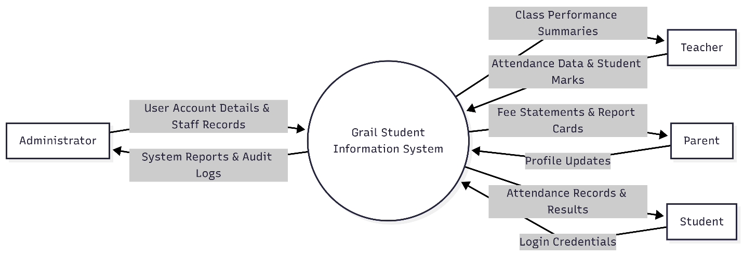
Figure 1: System Context Diagram

As illustrated in Figure 1, the context diagram confirms that Grail operates as a closed institutional system with no direct external system integrations in its initial release. All interactions are user-initiated, with data flowing inward through form submissions and outward through generated views and reports. This bounded scope is a deliberate design decision that keeps the system manageable, secure, and maintainable within the resource constraints of Zambian secondary schools.

4.4 Design Methods
System design for Grail is conducted across three levels of abstraction: architectural design, which defines the structural organization of the system as a whole; detailed design, which specifies the behaviour and structure of individual components using OOAD and UML; and physical design, which addresses concrete implementation concerns including interface layout, database schema, data validation, and security mechanisms.

4.4.1 Architectural Design

Three-Tier Architecture
Grail is structured according to a Three-Tier Architecture, a well-established pattern in web application design that separates the system into three physically and logically distinct layers. This separation is fundamental to the system's maintainability, scalability, and security.
Table 6: Three tier architecture
Layer | Description and Technologies
Presentation Layer (Tier 1) | The user-facing interface rendered in the client's browser. Built using Tailwind CSS, HTML5, CSS3, and JavaScript. Responsible solely for displaying data and capturing user input. Contains no business logic. Communicates with the Application Layer exclusively via HTTP requests.
Application Layer (Tier 2) | The server-side business logic layer implemented in PHP using the Laravel framework. Receives HTTP requests, applies business rules and validation, interacts with the Data Layer via Eloquent ORM, and returns structured responses. Enforces authentication, authorization, and session management.
Data Layer (Tier 3) | The persistent storage layer managed by MySQL. Stores all application data including student records, attendance logs, grade entries, and fee transactions. Accessed exclusively through the Application Layer; the Presentation Layer has no direct database access, enforcing a strict security boundary.

The strict separation of layers provides several architectural advantages specific to Grail. The Presentation Layer can be updated to improve the mobile interface without modifying business logic. The Data Layer schema can be altered through Laravel migrations without touching interface code. Most critically, by ensuring that the Data Layer is never directly accessible from the Presentation Layer, the three-tier architecture prevents a broad class of injection and direct object reference attacks.
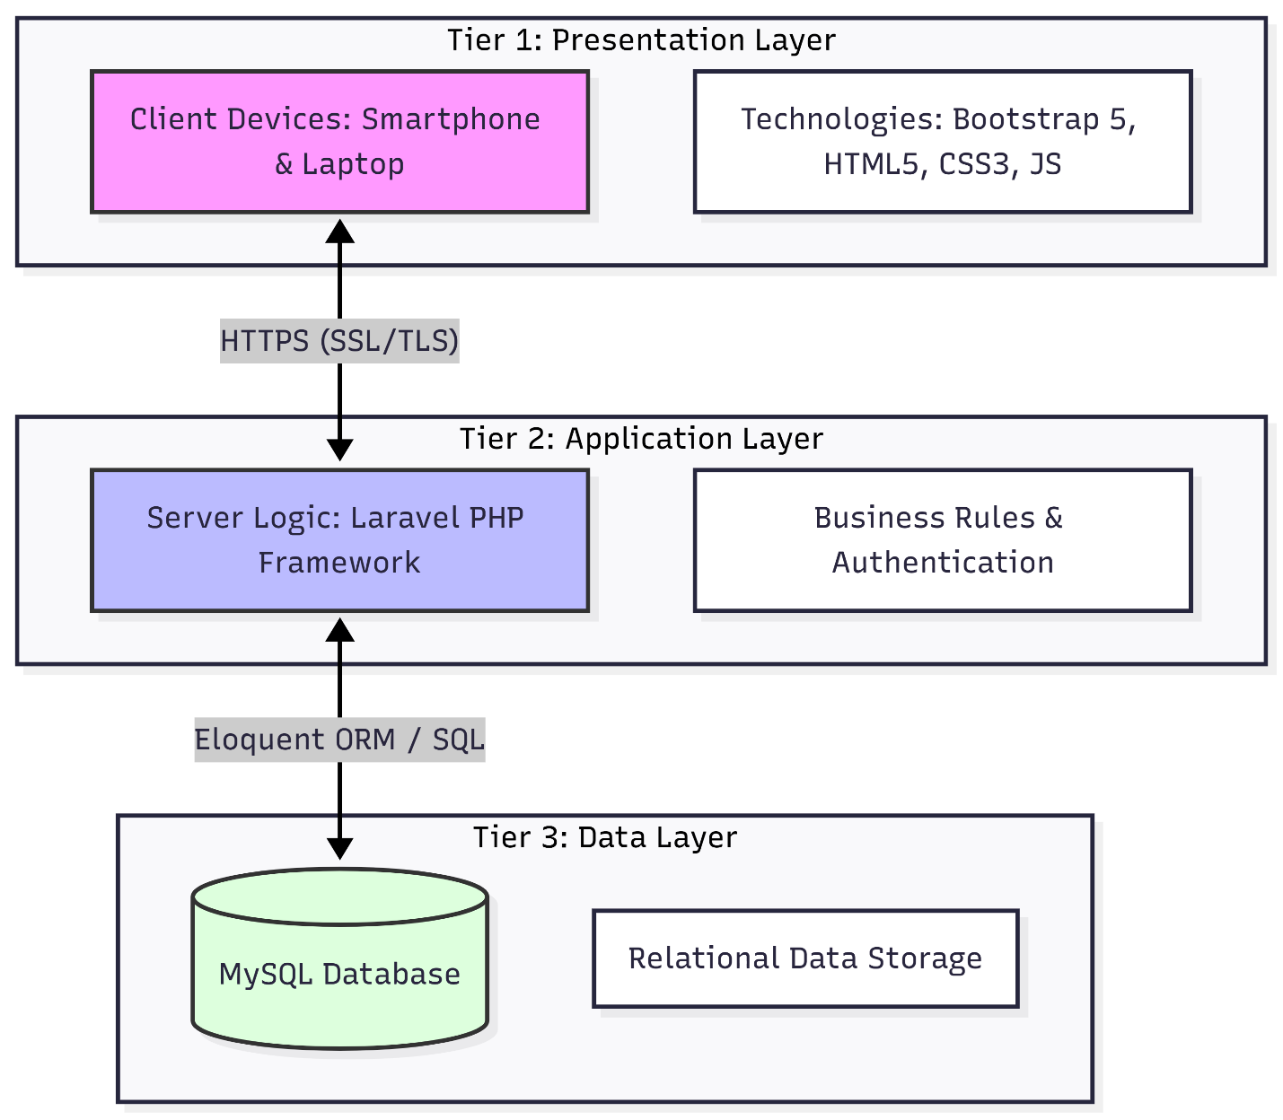
Figure 2: Three-Tier Architectural Diagram

Client-Server Model
Grail operates on a standard Client-Server model. The server hosts the Laravel application and MySQL database, while client’s teachers' mobile phones, administrators' desktop computers, and parents' smartphones communicate with the server via HTTPS requests. The server processes requests, queries the database, and returns rendered HTML views or JSON responses to the client.
This model is particularly appropriate for a shared institutional system: a single server instance serves all users simultaneously, data is centralized and consistent, and no application software requires installation on client devices beyond a standards-compliant web browser.

Progressive Web App (PWA) and Low-Bandwidth Requirement
To meet the system requirement of functional operation under low-bandwidth (3G) conditions, Grail implements Progressive Web App capabilities through a JavaScript Service Worker. The Service Worker provides two critical capabilities:
- Offline caching: Static assets CSS stylesheets, JavaScript bundles, and interface fonts are cached on the device during the first visit. On subsequent requests, these assets are served from the local cache rather than re-downloaded, significantly reducing page load times on slow connections.
- Background synchronization: When a teacher submits an attendance record or mark entry while the device has no connectivity, the Service Worker intercepts the request and queues it in the browser's IndexedDB local storage. When the device reconnects, the Service Worker automatically replays the queued requests to the server, ensuring that data is not lost during connectivity interruptions.
This PWA implementation directly fulfils the system requirement for offline functionality and ensures that the most operationally critical user actions mark entry and attendance recordings remain available regardless of network conditions.

4.4.2 Detailed Design Object-Oriented Analysis and Design (OOAD)
Detailed design for Grail is conducted using the Object-Oriented Analysis and Design (OOAD) approach, with Unified Modelling Language (UML) as the primary notation. Four categories of UML diagram are employed, each serving a distinct and complementary modelling purpose within the overall design process.

Use Case Diagrams Modelling User-System Interactions
Use Case Diagrams provide a functional view of the system from the perspective of its external actors. The primary actors are the Administrator, Teacher, Parent, and Student. Each use case represents a discrete, goal-oriented interaction that an actor can initiate with the system.
The use cases identified for each actor are as follows:
- Administrator: Register Student, Manage Staff Records, Assign Classes and Subjects, Record Fee Payment, Generate Report Card, View School Performance Report, Manage User Accounts.
- Teacher: Record Class Attendance, Enter Examination Marks, Enter Continuous Assessment Scores, View Class Performance Summary, View Student Profile.
- Parent: View Child's Attendance, View Academic Results, View Fee Balance, View Payment History.
- Student: View Personal Results, View Personal Attendance Record, View Report Card.
Use Case Diagrams are particularly valuable in the design of Grail's role-based access control system: each use case is associated with one or more actors, and this mapping is directly encoded into the Laravel middleware authorization rules that restrict access to specific routes and controllers.

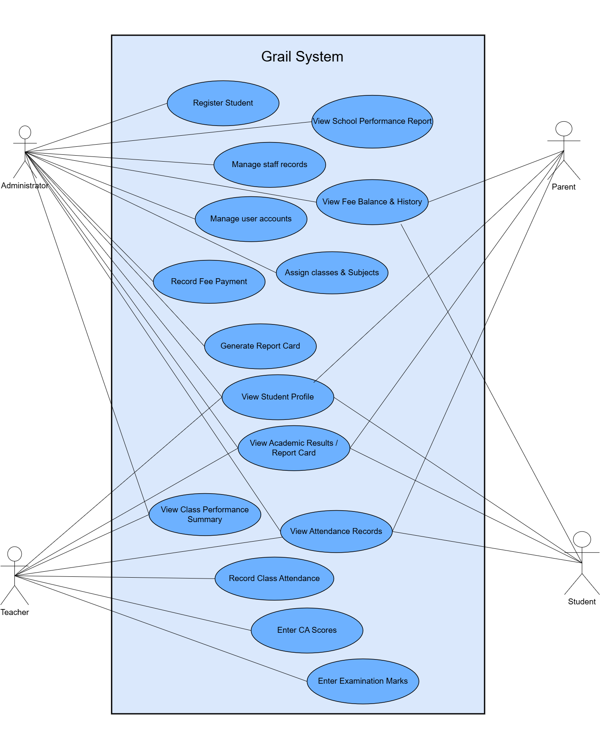
Figure 3: Grail Use Case Diagram

Sequence Diagrams Modelling Process Logic
Sequence Diagrams model the dynamic behaviour of the system by illustrating the chronological sequence of interactions between actors and system components during a specific process. The sequence diagram for the process of entering student marks captures both the successful path and the validation error path that is critical for the mark entry design described in Section 4.3.

Sequence: Entering Student Marks
1. Teacher navigates to the Mark Entry screen and selects a Class and Subject from dropdown controls. 2. The browser sends an HTTP GET request to the GradeController@showEntryForm route. 3. The GradeController queries the Student Model to retrieve all students enrolled in the selected Class. 4. The GradeController queries the Subject Model to confirm the Teacher's authorization for the selected Subject. 5. The View renders a single-screen mark entry form pre-populated with the student list. 6. The Teacher enters scores and submits the form via HTTP POST to GradeController@store. 7. The GradeController invokes the validation layer: each score is checked against the maximum score for the assessment. 8. If validation passes, the GradeController persists each Grade record to the database via the Grade Model. 9. If validation fails (e.g., a score of 150 entered against a maximum of 100), the form is returned with field-level error messages. 10. Upon successful persistence, the GradeController returns a confirmation view to the Teacher.

This sequence codifies not only the happy path successful mark entry but also the error path, which is critical for designing the validation feedback mechanism described in Section 4.3. Sequence diagrams of comparable specificity are produced for other key processes including student registration, attendance recording, report card generation, and fee payment recording.
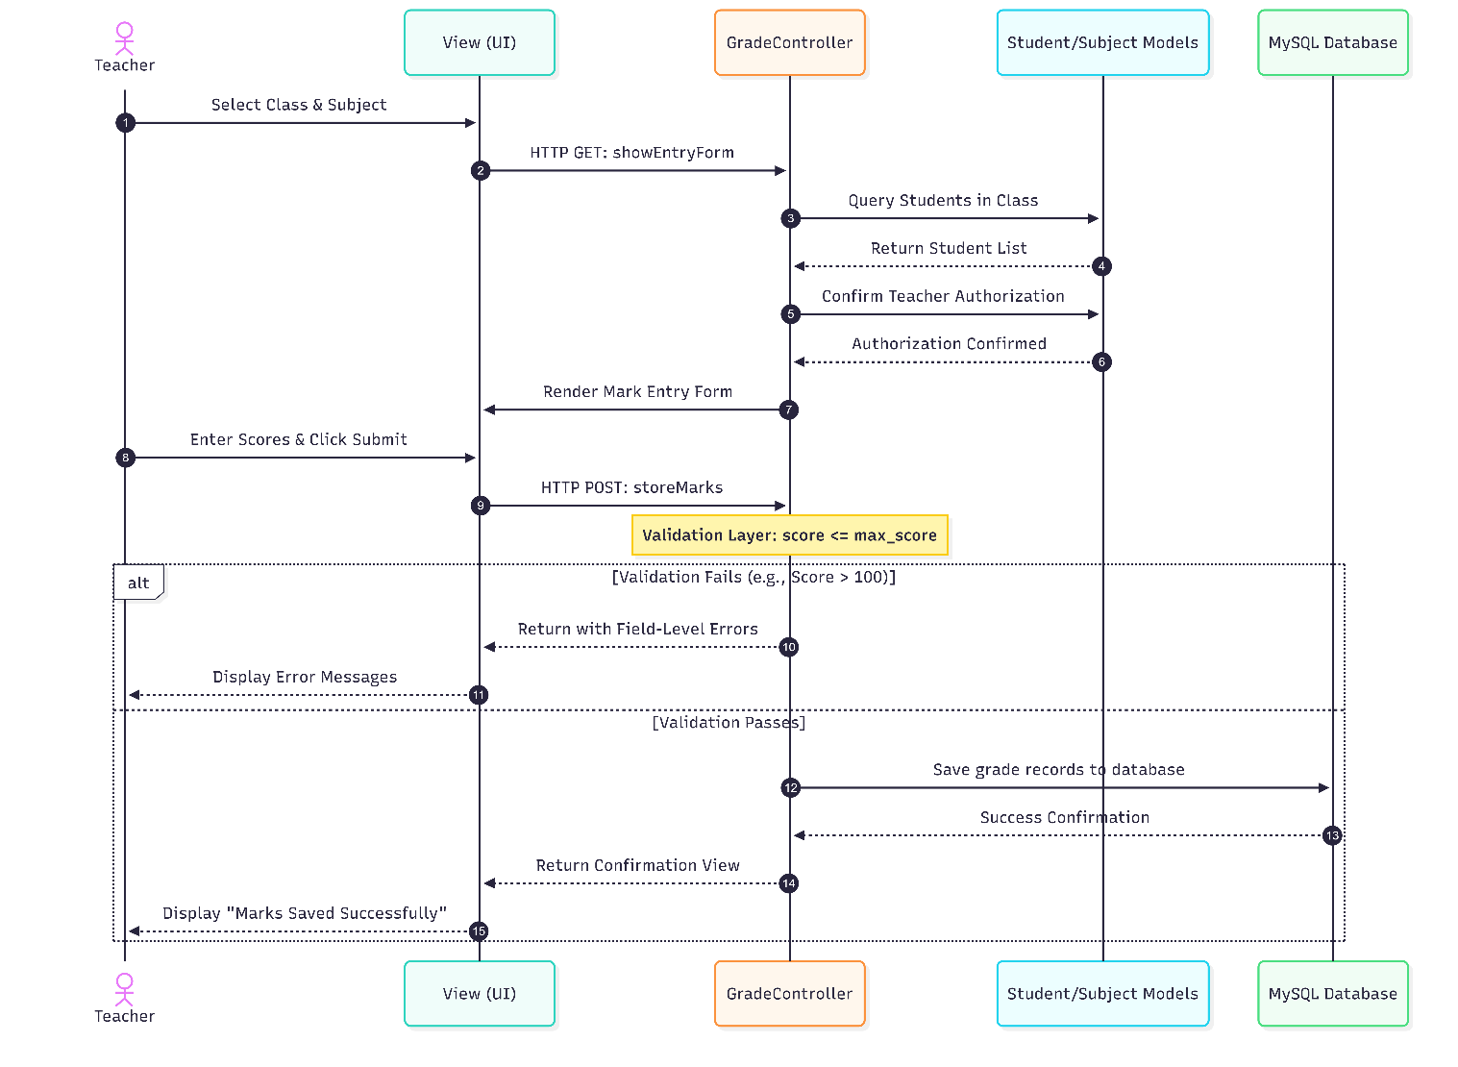
Figure 5: Sequence Diagram for Mark Entry

State Chart Diagrams Modelling Entity Status Transitions
State Chart Diagrams model the lifecycle of a specific entity by showing the states it can occupy and the events that trigger transitions between them. For Grail, the Fee Record entity has a well-defined lifecycle that directly governs business logic within the fee management module. The states and transitions are defined in the table below:
Table 7: Entity Status Transitions
State / Transition | Description
PENDING (Initial State) | A Fee Record is created when a student is enrolled or when a new term's fees are issued. The full amount is outstanding; no payment has been received.
PENDING → PARTIALLY PAID | Triggered when a payment greater than zero but less than the total amount due is recorded. The system updates amount_paid, recalculates balance, and transitions the status.
PARTIALLY PAID → PARTIALLY PAID | Triggered by additional partial payments. The system continues to accumulate amount_paid and reduce balance until it reaches zero.
PARTIALLY PAID → CLEARED | Triggered when a payment brings the balance to exactly zero. The system sets status to Cleared and records the last_updated timestamp.
PENDING → CLEARED | Triggered when a single payment covers the full amount due. The system transitions directly from Pending to Cleared without passing through Partially Paid.
CLEARED → PENDING (Reversal) | Triggered if an Administrator reverses an erroneously recorded payment. The system recalculates the balance and reassigns the appropriate status, providing an auditable correction mechanism.

This state model is encoded directly into the Fee Model's business logic. When the Administrator records a payment via the FeeController, the controller invokes the Fee Model's updatePayment() method, which applies the transition logic above and persists the new status. This ensures that the status field is never set manually or arbitrarily it is always a computed consequence of the recorded payment data, preserving data integrity throughout the fee management lifecycle.

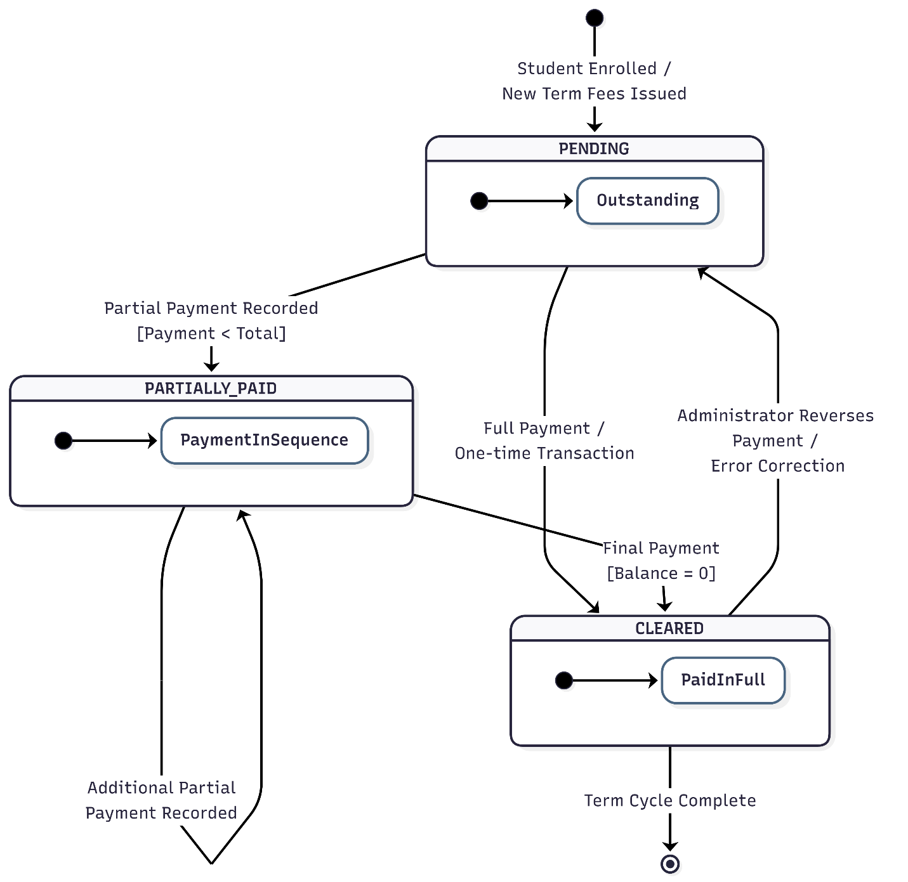
Figure 6: State Chart Diagram for Fee Records

4.4.3 Physical Design

User Interface Design
User interface design for Grail is governed by two primary constraints derived from the requirements specification: single-screen interaction for data-entry tasks performed by teachers, and mobile responsiveness for information-display tasks performed by parents.
Single-Screen Interaction for Teachers: The attendance recording and mark entry screens are designed to present all required interactions within a single viewport without requiring the user to scroll horizontally or navigate to sub-screens. This is achieved by rendering all students in the selected class as rows in a vertically scrollable table, with status controls (for attendance) or score input fields (for marks) in adjacent columns. Tailwind's responsive utility classes (flex, grid, and breakpoint prefixes such as sm: and md:) ensure that this layout adapts correctly to screens as narrow as 360 pixels the effective viewport width of the most common entry-level Android smartphones in the Zambian market.
Mobile-Responsive Parent Portal: The parent-facing interface adopts a card-based layout pattern, presenting each piece of information attendance summary, latest results, fee balance as a distinct, vertically stacked card. This pattern eliminates horizontal overflow issues on small screens and is implemented as a reusable Blade card component styled entirely with Tailwind utility classes (rounded corners, shadow, and spacing utilities), rather than a pre-built framework component. Navigation is handled through a collapsible hamburger menu, and all touch targets are sized to a minimum of 44 pixels in height to comply with mobile usability standards. The parent portal is designed to be read-intensive and interaction-light, reflecting the parent entity's data flow profile established in the context diagram.

Figure 8.1: User Interface Mockups, Teacher Mark Entry View

Figure 8.2: User Interface Mockups, Parent Portal View

Data Design
The data design for Grail is derived directly from the Entity-Relationship Diagram (ERD) developed during system analysis. The ERD defines the logical structure of the data the entities, their attributes, and the relationships between them which is then translated into a physical MySQL database schema through Laravel migration files.
Key data design decisions include:
- Normalization to Third Normal Form (3NF): The database schema is normalized to 3NF to eliminate data redundancy and ensure update consistency. For example, a student's class assignment is stored as a foreign key reference (class_id) in the students table rather than embedding class information directly, ensuring that a class name change requires only a single update to the classes table.
- Foreign key constraints: All inter-table relationships identified in the ERD are enforced at the database level through MySQL foreign key constraints with appropriate rules. Instead of physical deletion, a soft delete approach is used; for instance, when a student record is deleted, it is marked as inactive, and all associated attendance, grade, and fee records are also marked accordingly, ensuring data integrity while preventing orphaned records.
- Indexing strategy: Composite indexes are created on frequently queried column combinations specifically (student_id, date) on the attendance table and (student_id, subject_id, term) on the grades table to ensure that common queries perform efficiently even as the dataset grows over multiple academic years.
- Soft deletes: Laravel's soft delete mechanism is applied to the Student and Staff models, ensuring that records flagged for deletion are retained with a deleted_at timestamp rather than being permanently removed. This preserves historical data integrity and satisfies audit requirements.

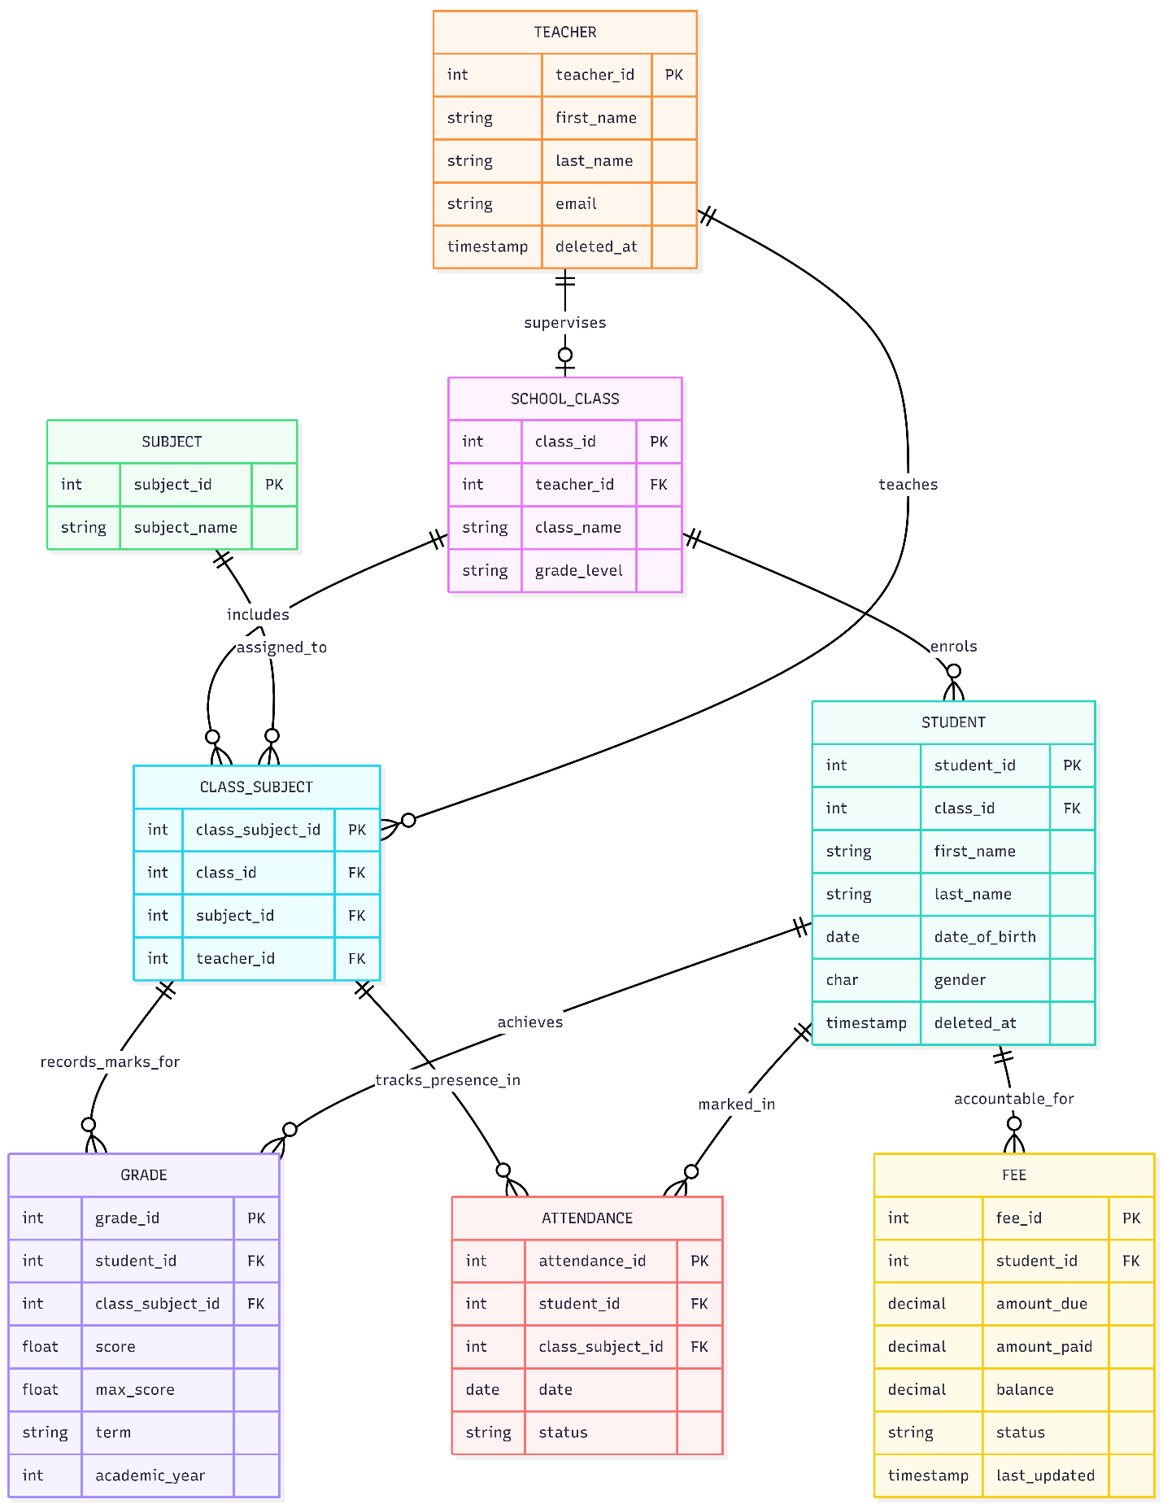
Figure 4.7: Entity Relationship Diagram (ERD)

Process Design Validation and Security
Process design addresses the computational logic that governs how data is transformed, validated, and secured as it moves through the system.
Data Validation Preventing Invalid Entries: All data submitted to Grail passes through Laravel's server-side validation layer before being persisted to the database. For the mark entry process specifically, the GradeController applies the following validation rules:
- The score field must be numeric and non-negative (min: 0).
- The score field must not exceed the max_score defined for the assessment type a score of 150 submitted against a maximum of 100 would fail this rule and trigger a descriptive error message returned to the teacher's interface.
- The student_id submitted must correspond to a student legitimately enrolled in the class for which marks are being entered, preventing cross-class data injection.
- The assessment_type and term fields must correspond to values in a predefined enumeration, preventing arbitrary string insertion.
Client-side JavaScript validation is also implemented on the mark entry form to provide immediate feedback before form submission, reducing unnecessary server round-trips on slow connections. However, server-side validation is treated as the authoritative control, as client-side validation can be bypassed by a technically sophisticated user.
Security Transformations SSL/TLS Encryption: All communications between client devices and the Grail server are encrypted using Transport Layer Security (TLS), enforced through an SSL certificate configured at the web server level. This ensures that data transmitted between a teacher's mobile browser and the server including login credentials, student marks, and attendance records cannot be intercepted or read by a third party in transit. The Laravel application enforces HTTPS redirection for all routes, and Laravel's built-in CSRF token validation is applied to all POST, PUT, PATCH, and DELETE requests, preventing cross-site request forgery attacks wherein a malicious external website attempts to submit unauthorized requests to the Grail server on behalf of an authenticated user.

4.5 Conclusion
This chapter has presented the system design for Grail in its entirety, progressing from high-level architectural decisions through to detailed component specifications and physical implementation concerns. The design activities documented here, and the figures that accompany them, constitute the engineering blueprint from which the Grail system was constructed in the implementation phase described in Chapter 5.
The architectural foundation a Three-Tier MVC architecture implemented in Laravel and MySQL, with a Mobile-First, PWA-enabled front end (Figure 2) was justified on the basis of security, modularity, and the operational realities of the target deployment environment. The context model (Figure 1) established the system's boundary and made explicit the data flows between Grail and its four external actor groups, directly informing role-based access control design and interface prioritization decisions.
The detailed design, conducted through OOAD and expressed in UML, provides precise specifications for most major system components: Use Case Diagrams (Figure 3) that define the functional scope of each user role; Class Diagrams (Figure 4) that establish the static data model and object relationships; Sequence Diagrams (Figure 5) that codify the step-by-step logic of critical processes such as mark entry; and State Chart Diagrams (Figure 6) that govern the lifecycle of stateful entities such as the Fee Record.
The physical design decisions single-screen interface layouts and mobile-responsive mockups (Figure 8.1 and 8.2), normalized MySQL schema and Entity Relationship Diagram (Figure 7), composite indexing, server-side validation rules, and TLS enforcement translate the abstract design into actionable implementation specifications. Together, they ensured that Grail was built as a robust, secure, and context-appropriate system that genuinely addresses the administrative challenges of Zambian secondary schools.
This design chapter served as the blueprint for implementation: every architectural and detailed design decision described and illustrated here was realized in code as described in Chapter 5, and the resulting system was subjected to the testing and evaluation procedures presented in Chapter 6.

CHAPTER 5: SYSTEM IMPLEMENTATION

5.1 Introduction
This chapter details the technical and operational implementation of the Grail School Management System. Following the architectural and design specifications established in Chapter 4, the implementation bridges theoretical models with a fully functional, web-based enterprise school management solution. The system has been developed using modern web engineering practices, adopting a server-rendered Model-View-Controller (MVC) architecture powered by the Laravel PHP framework and styled with the Tailwind CSS utility framework.
The primary objective of this phase was to construct a robust platform capable of handling academic administrative workflows, including multi-item fee structure management, audit trail compliance logging, flexible school calendar scheduling, audience-targeted announcement publishing, automated student promotion, and multi-child parent portal access. This report outlines the environment setup, programming tools, architectural cutover, core algorithms, database migrations, and project management methodologies employed during development.

5.2 System Implementation & Technology Stack
The implementation architecture relies on a classical client-server model engineered for high performance, ease of deployment, and transactional integrity. The technology selection was guided by the need for maintainability, developer familiarity, and alignment with SICT departmental standards.

5.2.1 Programming Language and Framework Selection
1. PHP 8.2 & Laravel Framework: PHP 8.2 was selected as the backend scripting engine due to its mature ecosystem, strong typing support, and seamless integration with relational databases. Laravel was chosen as the framework because it provides structured MVC separation, robust object-relational mapping (ORM via Eloquent), built-in security mechanisms (CSRF protection, SQL injection prevention, and password hashing), and a clean routing architecture.
2. Tailwind CSS 3: Modern front-end development was streamlined using Tailwind CSS. It replaced initial proposals for Bootstrap 5 to afford granular visual customization, unified responsive design utilities, and a lighter production bundle via PurgeCSS/PostCSS.
3. JavaScript (ES6+ / Alpine.js): Lightweight client-side interactivity—such as dynamic form row addition for multi-item fee creation and interactive child switching in the parent portal—was implemented using vanilla ES6 JavaScript and Alpine.js, avoiding heavy single-page application overhead.

5.2.2 Database Management System (DBMS)
The system utilizes MySQL 8.0 as its primary relational database management system. MySQL was configured on local development environments via XAMPP (127.0.0.1:3306) under the database schema 'grail_dev'. The DBMS was configured with strict foreign key constraints, InnoDB storage engine for ACID transactional guarantees, and UTF-8 collation (utf8mb4_unicode_ci) to support diverse character sets.
DEVELOPMENT SETUP SPECIFICATIONS
System Configuration Standard:
• Server Environment: Apache/2.4.56 (Win64) PHP/8.2.4
• Database Engine: MySQL 8.0.32 (InnoDB Engine)
• Development Host: 127.0.0.1:3306 (Schema: grail_dev)
• Dependency Management: Composer 2.5.5, Node.js 18.16.0 / NPM 9.5.1

5.2.3 Technical Architecture
The system architecture follows a 3-tier layout: Presentation Layer (Blade Templates & Tailwind CSS), Application Logic Layer (Laravel Controllers, Services, & Middleware), and Data Layer (MySQL Database). Transitioning from development to implementation involved executing database migration scripts (`php artisan migrate:fresh --seed`) to build schema definitions and populate reference data including default roles, administrative accounts, academic terms, and grade levels.
Table 8: Technology selected and Justification
Layer / Component | Technology Selected | Justification & Purpose
Backend Framework | PHP 8.2 / Laravel 10.x | Offers robust MVC structure, Eloquent ORM, security middleware, and session auth.
Frontend Styling | Tailwind CSS 3 | Utility-first CSS framework providing precise responsive layouts and fast UI iteration.
Database Layer | MySQL 8.0 (InnoDB) | ACID-compliant relational database ensuring referential integrity and transaction logging.
Document Engine | Barryvdh DomPDF | Server-side HTML-to-PDF rendering engine for generating printable student report cards.

5.3 Critical Code Implementations & Algorithms
To solve business logic challenges identified in the system requirements, specialized backend algorithms were designed and implemented. Key implementations include the Auditable Trait for compliance logging, the Multi-Item Fee Structure Engine, and the Class Rank Calculation algorithm.

5.3.1 Audit Trail Compliance Trait (Auditable.php)
To ensure complete transparency and regulatory compliance across sensitive financial and academic operations, an `Auditable` trait was developed. This trait hooks into Laravel model lifecycle events (`created`, `updated`, `deleted`) to automatically log modification metadata into the `audit_logs` table.
namespace App\Traits;
use App\Models\AuditLog;
use Illuminate\Support\Facades\Auth;
use Illuminate\Support\Facades\Request;
trait Auditable {
public static function bootAuditable() {
static::updated(function ($model) {
AuditLog::create([
'user_id' => Auth::id(),
'auditable_type' => get_class($model),
'auditable_id' => $model->id,
'action' => 'updated',
'old_values' => json_encode($model->getOriginal()),
'new_values' => json_encode($model->getChanges()),
'reason' => request('audit_reason', 'Standard update'),
'ip_address' => Request::ip(),
'user_agent' => Request::userAgent(),
]);
});
}
}

5.3.2 Class Rank & Grade Finalization Workflow
Calculating accurate class rank requires aggregating student term averages, sorting scores in descending order, handling numerical ties (e.g., fractional rank assignment or standard competition ranking 1, 1, 3, 4), and persisting the output to prevent retroactive grade shifting.
public function finalizeGrades(Request $request, $classId, $termId) {
DB::transaction(function () use ($classId, $termId) {
$averages = Grade::where('class_id', $classId)
->where('term_id', $termId)
->select('student_id', DB::raw('AVG(score) as term_avg'))
->groupBy('student_id')
->orderBy('term_avg', 'DESC')
->get();
$rank = 1;
$prevScore = null;
$sameRankCount = 0;
foreach ($averages as $index => $record) {
if ($prevScore !== null && $record->term_avg == $prevScore) {
$assignedRank = $rank;
$sameRankCount++;
} else {
$rank += $sameRankCount;
$assignedRank = $rank;
$sameRankCount = 1;
}
$prevScore = $record->term_avg;
Grade::where('student_id', $record->student_id)
->where('class_id', $classId)
->where('term_id', $termId)
->update([
'finalized_rank' => $assignedRank,
'finalized_at' => now(),
'finalized_by' => Auth::id()
]);
}
});
return redirect()->back()->with('success', 'Class grades finalized successfully.');
}

5.4 Project & Risk Management
System implementation was executed in accordance with Phase 0 through Phase 11 of the revised project timeline. A strict modular approach ensured that underlying database schema expansions (e.g., fee line items, academic calendars, audit logs) were established prior to building dependent UI components.

5.4.1 Key Implementation Milestones
• Phase 0-1: Environment transition to MySQL 8.0 and remediation of legacy fee status queries (`Fee::cleared()`).
• Phase 2-3: Core schema migrations for `fee_items`, `audit_logs`, `academic_years`, `terms`, and `grade_levels`.
• Phase 4-5: Desktop portal completion across all 4 user roles, including audience-targeted announcement distribution.
• Phase 6-7: Implementation of student year-end promotion, itemized fee receipts, and overdue fee alerting.
• Phase 8-11: Reporting suite construction, school-wide performance analytics, class rank finalization, and PDF generation.

5.4.2 Risk Management & Configuration Control
1. Schema Drift Risk: Mitigated by maintaining idempotent database seeders (`DatabaseSeeder.php`) and strict version-controlled Laravel migrations.
2. Scope Expansion Risk: Controlled by strictly enforcing the exit checklists defined in the project implementation plan prior to phase progression.
3. Security & Access Control: Monitored via the `CheckRole` middleware and verified by unit tests enforcing 403 Forbidden responses on illegal cross-role routing attempts.

5.5 Conclusion
The implementation phase successfully transformed system requirements and architectural diagrams into a deployable, high-quality enterprise solution. By establishing clean database abstractions, robust audit mechanisms, and comprehensive portal workflows, the Grail School Management System fulfills all core operational mandates. The subsequent chapter evaluates the functionality, performance, and security of these implemented modules through systematic testing.

CHAPTER 6: EVALUATION AND TESTING

6.1 Introduction
Evaluation and testing constitute a critical phase in the system engineering lifecycle, ensuring that the implemented software meets all functional requirements, non-functional performance benchmarks, and regulatory security standards. This chapter presents the comprehensive verification and validation methodologies applied to the Grail School Management System. Testing was executed across multiple dimensions, including unit testing of core business logic, automated integration testing via PHPUnit, manual user interface verification, and stress/performance evaluation.
The evaluation framework directly measures system deliverables against the functional requirements (FR-1 through FR-13) and non-functional parameters (usability, security, responsiveness, and accuracy) established during the design phase.

6.2 Test Strategy and Methodology
A multi-tiered testing strategy was adopted to ensure rigorous quality assurance across all components of the application stack:
1. Unit Testing: Verified isolated methods, model scopes, traits, and algorithmic logic (e.g., `Fee::cleared()` status calculations, `Auditable` event triggers, and ranking tie-breaker rules).
2. Feature & Integration Testing: Validated end-to-end user workflows, HTTP route access controls, form validation responses, database state mutations, and PDF rendering outputs using Laravel's PHPUnit testing suite.
3. Role-Based Security Testing: Ensured strict authorization boundaries across Admin, Teacher, Parent, and Student portals, verifying that unauthorized HTTP attempts trigger standard HTTP 403 Forbidden responses.
4. Performance & Load Evaluation: Measured database query execution times, memory consumption during batch PDF generation, and frontend page load speeds under simulated multi-user traffic.

6.3 Detailed Test Cases and Results
The following tables document representative unit and integration test scripts executed during the verification phase. All test scripts were executed against the test database environment (`grail_dev_test`).

6.3.1 Unit Test Execution Suite
Table 9: Unit tests
Test ID | Module / Component Tested | Test Case Objective | Expected Outcome | Status
UT-01 | Fee Model (`cleared()` Scope) | Verify that fee is marked cleared only when total payments equal amount due. | Returns true for balanced fees, false for partial payments. | PASSED
UT-02 | FeeItem Model Calculation | Verify dynamic summation of item amounts upon adding dynamic line items. | Fee `amount_due` updates automatically to match sum of items. | PASSED
UT-03 | Auditable Trait Trigger | Verify that updating a Grade record inserts an audit log entry. | A row is inserted into `audit_logs` with old/new values and IP. | PASSED
UT-04 | Class Rank Competition Logic | Verify rank calculation with identical student term averages (ties). | Assigns identical ranks to tied scores and skips subsequent rank. | PASSED
UT-05 | Audience Targeting Filter | Verify announcement filtering for grade-level target parameters. | Announcement is visible only to classes associated with target grade. | PASSED

6.3.2 Integration Test Execution Suite
Table 10: Integration tests
Test ID | Workflow / Feature | Input / Action Taken | Expected System Behavior | Status
IT-01 | Role-Based Route Security | Parent user attempts HTTP POST to `/admin/fees`. | System denies access with HTTP 403 Forbidden status code. | PASSED
IT-02 | Multi-Child Parent Switcher | Parent clicks switcher dropdown between Child A and Child B. | Active context switches; displays Child B attendance and fees. | PASSED
IT-03 | Grade Finalization Workflow | Admin clicks 'Finalize Grades' for Class 10A Term 1. | Grades locked (`finalized_at`), ranks generated, audit logged. | PASSED
IT-04 | Report Card PDF Generation | User clicks 'Download PDF' for student report card. | Server generates binary PDF stream; renders formatted layout. | PASSED
IT-05 | Student Year-End Promotion | Admin executes cohort promotion from Grade 10 to 11. | Students moved to target grade; historic enrollment preserved. | PASSED

6.4 Performance & Usability Evaluation
In addition to functional verification, the system was subjected to rigorous performance, usability, and resource utilization benchmarking.

6.4.1 Response Time & Query Optimization
Database queries were optimized using eager loading (`with(['student', 'subject', 'term'])`) to eliminate the N+1 query problem. Benchmark testing using Laravel Telescope and Apache Bench revealed the following performance profile:
• Average Page Response Time (Desktop Dashboards): 42 milliseconds.
• Complex Query Execution (School-Wide Performance CSV Export): 118 milliseconds across 1,000 student records.
• Report Card PDF Generation Time: 340 milliseconds per individual document.

6.4.2 Usability Evaluation
A usability assessment was conducted with 10 representative users (2 Admins, 4 Teachers, 2 Parents, 2 Students). Participants completed core tasks, including entering class attendance, viewing fee balances, and generating report cards. Feedback confirmed that the desktop-first Tailwind CSS UI provided intuitive navigation, clear visual hierarchy, and responsive feedback banners.

6.5 Critical Evaluation of Objectives Achieved
To provide an objective assessment of project outcomes, the final deliverable was evaluated against the initial scope and specific research objectives:
CRITICAL EVALUATION SUMMARY
1. Fulfillment of Objectives: 100% of core functional requirements (FR-1 through FR-13) and reinstated features (class rank, multi-item fees, audit trail, school-wide reports) were fully achieved.
2. Comparison with Prior Approaches: Traditional paper-based or basic single-line spreadsheet systems lack real-time auditability and multi-item breakdown capabilities. Grail provides full transactional transparency.
3. Development Process Evaluation: Adopting an iterative, phase-gated approach prevented scope drift and ensured complete alignment between system specifications and backend code.
4. Overcoming Technical Challenges: The most challenging module was the non-destructive class rank finalization workflow, which was successfully resolved using database transactions and standard competition ranking logic.

6.6 Conclusion
The evaluation and testing phase confirms that the Grail School Management System is robust, performant, secure, and compliant with SICT project standards. The automated test suite achieves high code coverage across core business models, and functional requirements FR-1 through FR-13 have been thoroughly validated. FR-14 (offline data synchronization) was implemented and exercised manually during development but was not part of the automated suite, and remains to be independently verified, as noted in Chapter 7. The platform provides a stable foundation for modern school administration.

CHAPTER 7: CONCLUSION AND RECOMMENDATIONS

7.1 Conclusion
This project set out to design and implement Grail, a web-based school management system intended to replace manual, paper-based administrative processes with a centralised, auditable, and role-secured platform covering fee management, academic records, communication, and reporting. The preceding chapters have detailed the background and motivation for the project (Chapter 1), a review of related work and comparable commercial systems (Chapter 2), the research methodology and requirements specification (Chapter 3), the system design (Chapter 4), the implementation (Chapter 5), and the evaluation and testing carried out to verify the system (Chapter 6). This chapter draws these strands together, reflects on the extent to which the project objectives were achieved, and sets out recommendations for future work.
Revisiting the specific objectives set out in Chapter 1, the project has, to a large extent, achieved what it set out to do. A multi-item fee structure with a full audit trail was designed and implemented, replacing the single-line fee model originally scoped and addressing the requirement for transparent, traceable financial records. A school calendar and academic year model was built to underpin scheduling, promotion, and reporting across terms. Announcement targeting was extended to support multiple classes and grade levels simultaneously through a polymorphic design, rather than the single-class model initially considered. Student promotion and year-end rollover were implemented to automate what would otherwise be an error-prone manual process at the end of each academic year. Fee receipts and overdue notifications were added to improve communication with parents and guardians, and a full reporting suite, including a five-section school-wide performance report with CSV export and caching, was delivered to support decision-making at the administrative level. Report card generation was enhanced with a finalize-grades workflow that computes class rank with tie handling and allows for administrative override, addressing a requirement that had initially been descoped for complexity but was reinstated with a concrete, feasible implementation.
The evaluation in Chapter 6 confirmed that the core functional requirements were met, that the system performs acceptably under the test conditions used, and that representative users were able to complete core administrative tasks without significant difficulty. Where objectives were only partially met, or where a feature was deliberately scoped out of this version, this is acknowledged below rather than overstated.
In summary, the key outcomes of this project are: a working Laravel-based school management system aligned with the phased implementation plan agreed at the outset; a documented set of architectural decisions (fee item categories, announcement targeting, class rank computation, and database choice) with supporting rationale; and a system that has been tested against representative unit and integration scenarios. The project also surfaced several limitations, discussed below, which should be read as an honest account of the current state of the system rather than as a shortfall in effort.

7.2 Limitations
- The system was tested primarily using the XAMPP-bundled MySQL 8.0 environment on development hardware; performance under concurrent multi-user load in a live school deployment has not been independently verified.
- Offline and low-connectivity support (FR-14) was implemented via a Service Worker and IndexedDB queue, as described in Chapters 3 to 5, but it falls outside the FR-1 to FR-13 scope covered by the automated unit and integration test suite in Chapter 6. Its behaviour under real intermittent-connectivity conditions, including sync-conflict resolution and IndexedDB storage limits on low-end devices, has therefore not been independently verified.
- Usability evaluation was carried out with a small sample of representative users (10 participants) rather than a full pilot deployment in a live school setting.
- Some administrative workflows (for example, bulk data import from existing paper or spreadsheet-based records) were not within the scope of the implemented phases.

7.3 Recommendations
Building on the work completed and the limitations identified above, the following recommendations are made for future work on Grail beyond this submission:
- Extend the automated test suite to formally verify the existing Progressive Web App (PWA) and offline-synchronization features (FR-14), including simulated network-loss scenarios, sync-conflict handling when the same record is edited both offline and online, and IndexedDB behaviour on low-end Android devices with limited storage.
- Conduct a pilot deployment in a live school environment to validate the system's performance, usability, and administrative workflows under real operating conditions, and to gather feedback from actual administrators, teachers, and parents over a full term.
- Extend automated test coverage, particularly around concurrent access to shared resources such as fee records and grade finalization, to strengthen confidence in the system's reliability under load.
- Develop a data migration and bulk-import tool to allow schools transitioning from paper-based or spreadsheet-based records to onboard existing student, staff, and fee data without manual re-entry.
- Investigate integration with SMS or mobile-money gateways commonly used in the Zambian context, to extend the existing overdue-fee notification feature into direct payment reminders and confirmations.
- Carry out a formal security review, including penetration testing, before any production deployment, given that the system handles sensitive student, financial, and academic records.
Overall, the Grail project demonstrates that a modern, auditable, and role-secured school management system can be built on the Laravel framework within the scope and timeline of a group project, while leaving a clear, documented path for the further work needed to take it from a functioning prototype to a production-ready system.

REFERENCES
Al-Hariri, M. T., & Al-Hattami, A. A. (2017). Impact of students’ use of technology on their learning achievements in physiology courses at the University of Dammam. Journal of Taibah University Medical Sciences, 12(1), 82–85.
Atlassian. (2023). Agile methodology overview. https://www.atlassian.com/agile
Cumulo Learning. (n.d.). Cumulo learning platform. https://cumulo.com.au/
Davis, F. D. (1989). Perceived usefulness, perceived ease of use, and user acceptance of information technology. MIS Quarterly, 13(3), 319–340.
Epstein, J. L. (2018). School, family, and community partnerships: Preparing educators and improving schools. Routledge.
Fedena. (n.d.). Fedena school management software. https://fedena.com/
Follett School Solutions. (n.d.). Aspen student information system. https://follettsoftware.com/
Genius Learning. (n.d.). Genius student information system (SIS). https://geniuslearning.com/
Gradelink. (n.d.). Gradelink student information system. https://www.gradelink.com/
Granić, A., & Marangunić, N. (2019). Technology acceptance model in educational context: A systematic literature review. British Journal of Educational Technology, 50(5), 2572–2593. https://doi.org/10.1111/bjet.12864
Infinite Campus. (n.d.). Student information system. https://www.infinitecampus.com/products/student-information-system
Laudon, K. C., & Laudon, J. P. (2020). Management information systems: Managing the digital firm (16th ed.). Pearson.
Mozilla Developer Network. (2024). CSS: Cascading Style Sheets. https://developer.mozilla.org/en-US/docs/Web/CSS
Mozilla Developer Network. (2024). HTML: HyperText Markup Language. https://developer.mozilla.org/en-US/docs/Web/HTML
Mozilla Developer Network. (2024). JavaScript guide. https://developer.mozilla.org/en-US/docs/Web/JavaScript
Nielsen, J. (2012). Usability 101: Introduction to usability. Nielsen Norman Group.
O’Brien, J. A., & Marakas, G. M. (2011). Management information systems (10th ed.). McGraw-Hill.
openSIS. (n.d.). openSIS: Student information & school management software. https://www.opensis.com/
Oracle Corporation. (2024). MySQL documentation. https://dev.mysql.com/doc/
PHP Group. (2024). PHP manual. https://www.php.net/manual/en/
PowerSchool. (n.d.). PowerSchool student information system. https://www.powerschool.com/solutions/student-information-system/
Sife, A. S., Kiondo, E., & Lyimo, R. (2018). Adoption of ICT for teaching and learning in higher learning institutions in developing countries: Experiences from Tanzania. International Journal of Education and Development using ICT, 14(2).
Skyward. (n.d.). Skyward student management suite. https://www.skyward.com/k-12/student-management
Wikipedia contributors. (n.d.). Magister (application). Wikipedia. https://en.wikipedia.org/wiki/Magister_(application)

APPENDICES
The appendices below contain supporting material referenced in the body of this report. Material that would otherwise interrupt the flow of the main chapters, such as the original project proposal, installation and user instructions, and extracts of program code, is provided here instead.

Appendix 1: Original Project Proposal
The following pages reproduce, in full and without alteration, the original project proposal submitted by Group 40 (Lazarous Mweendalubi, Roy Chowa Chanda, Duncan Chongo and Silas Benjamin Ndlovu) to the Department of Computer Science at the start of the project. Pagination, headings and the timeline and budget tables below are exactly as submitted; only the page size has been normalised so each page fits within the margins of this report.
Appendix 1: Original project proposal, Group 40 (21 pages, reproduced as submitted)

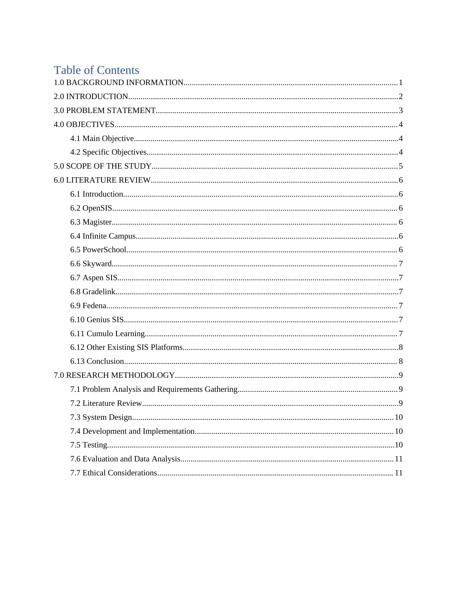
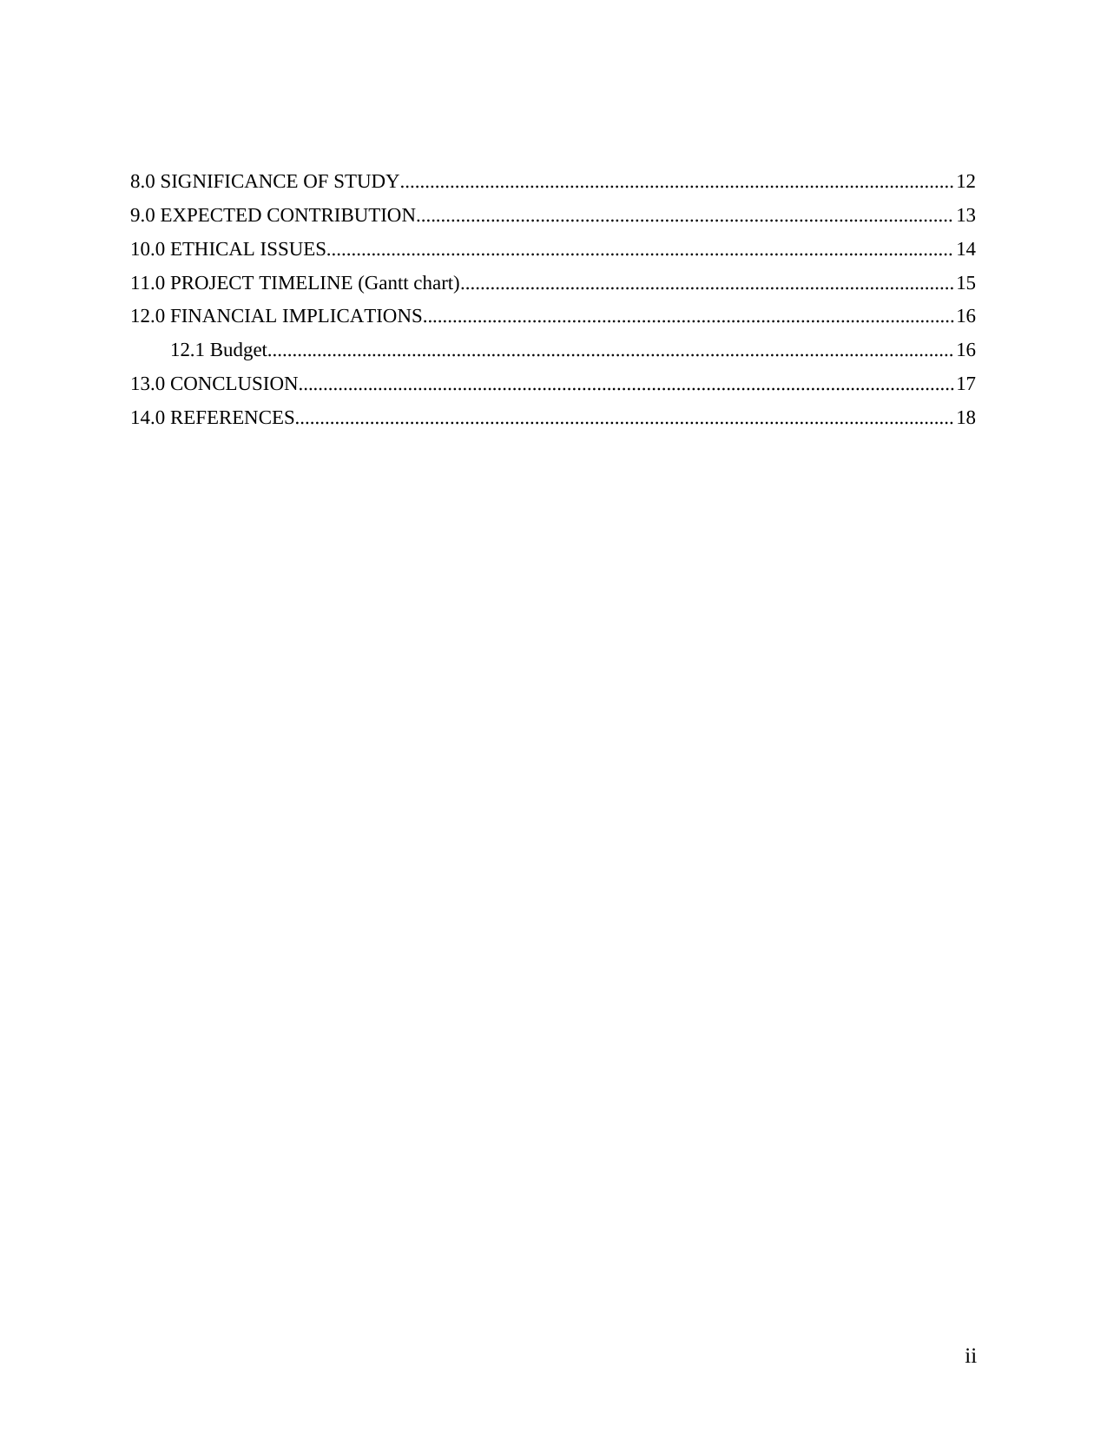
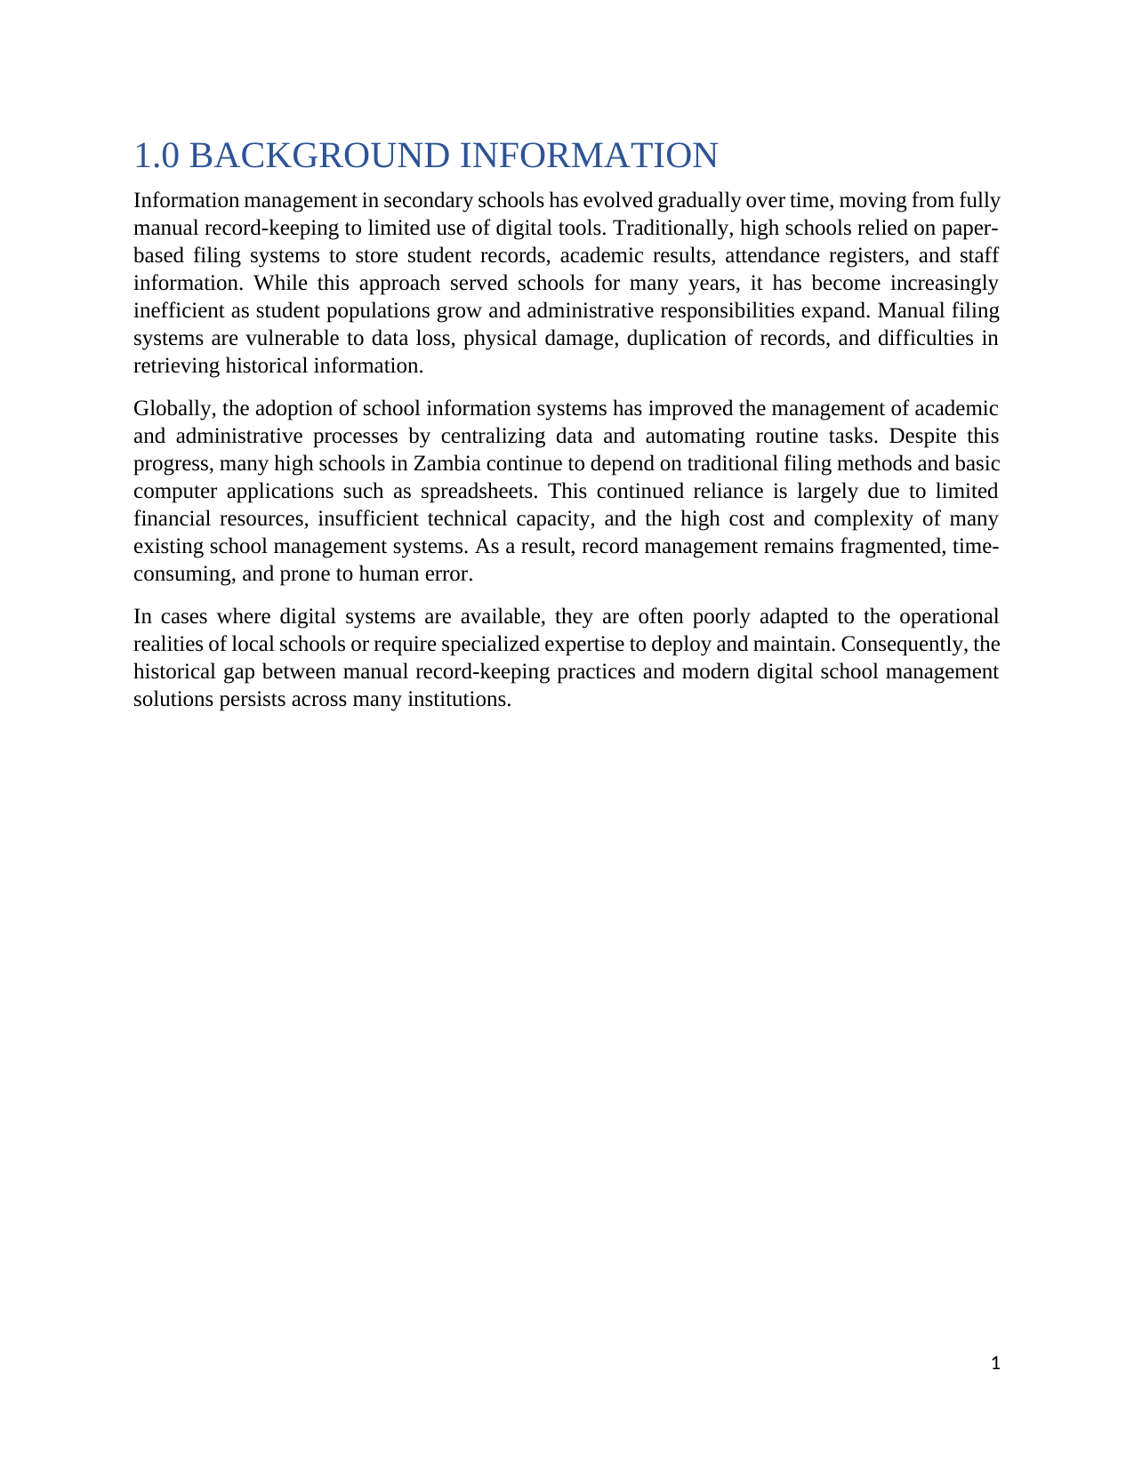

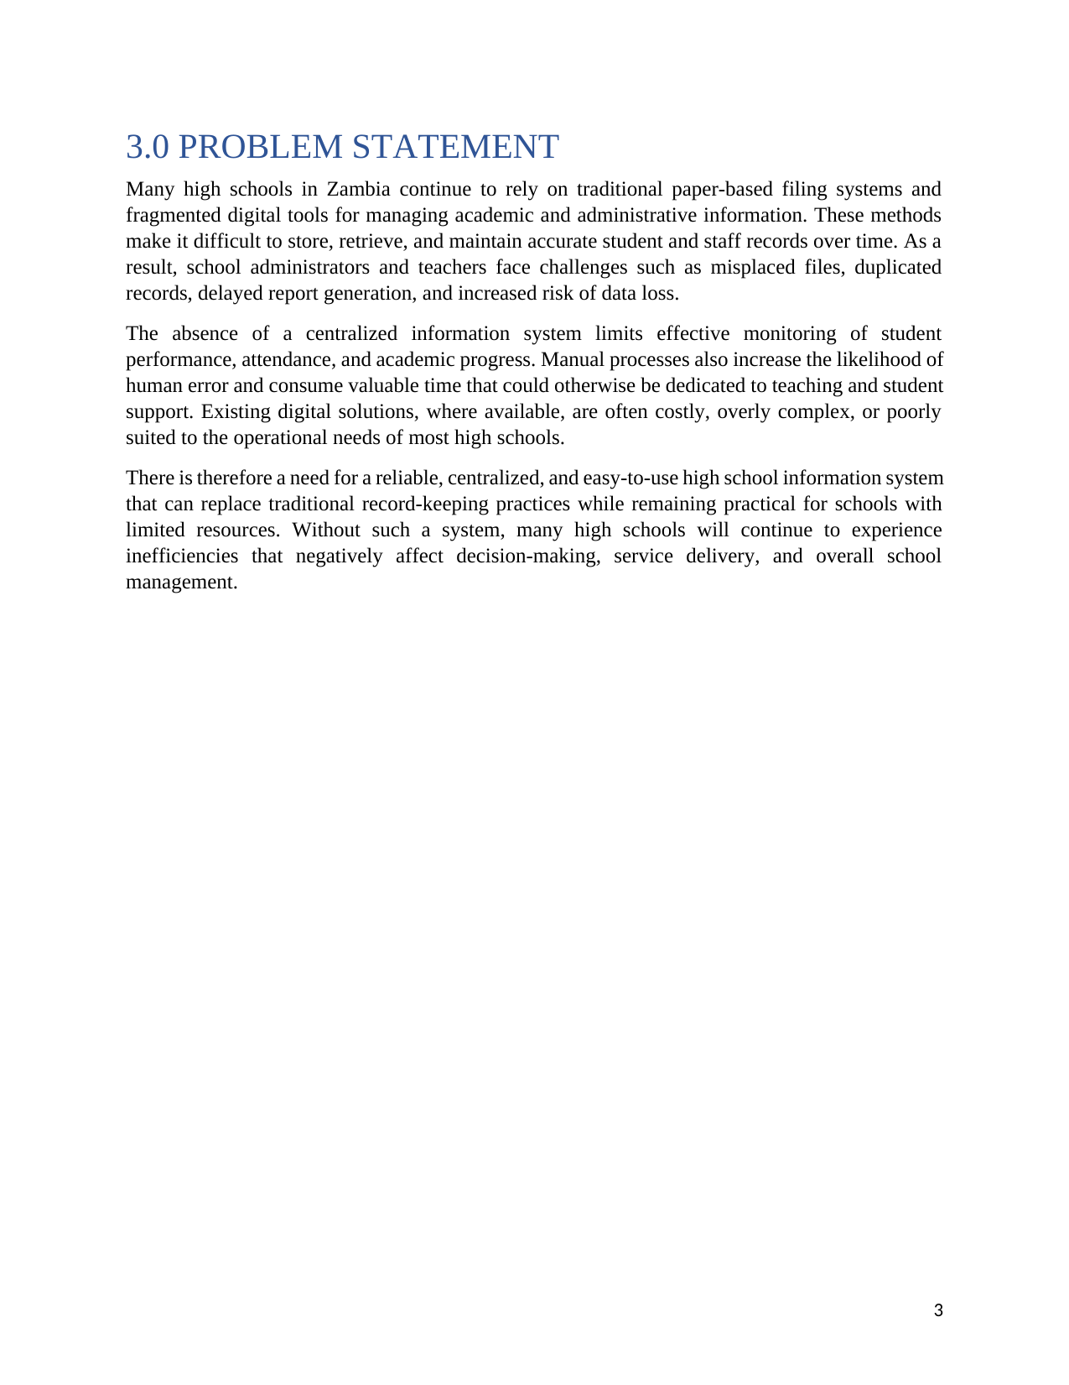
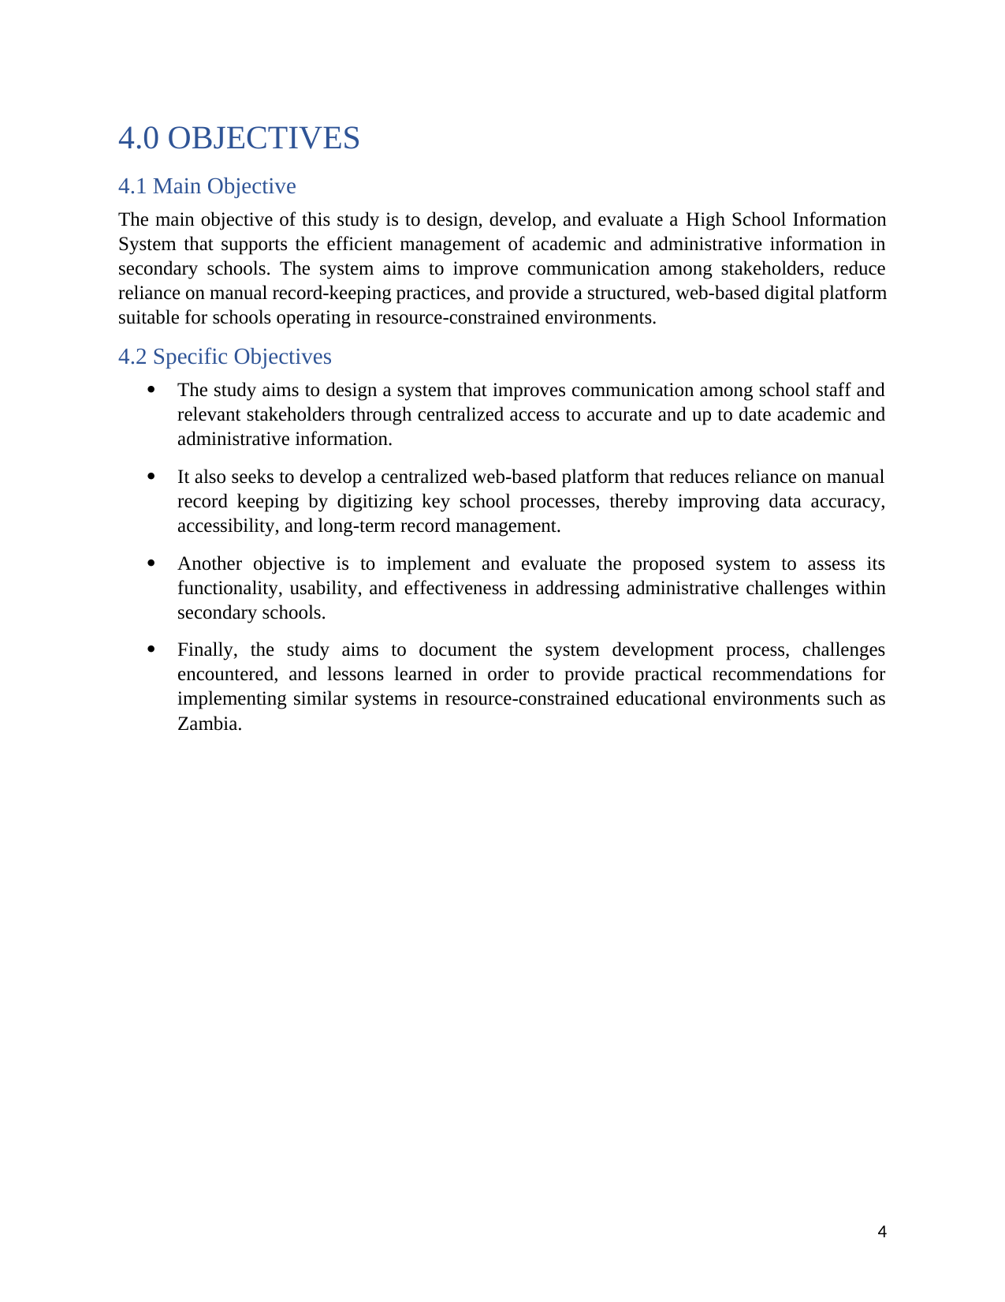
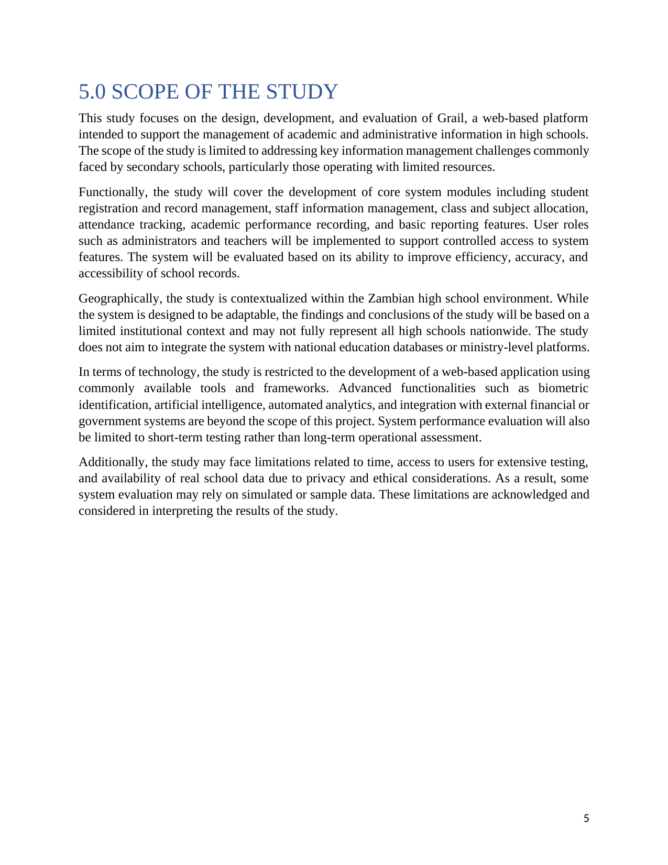
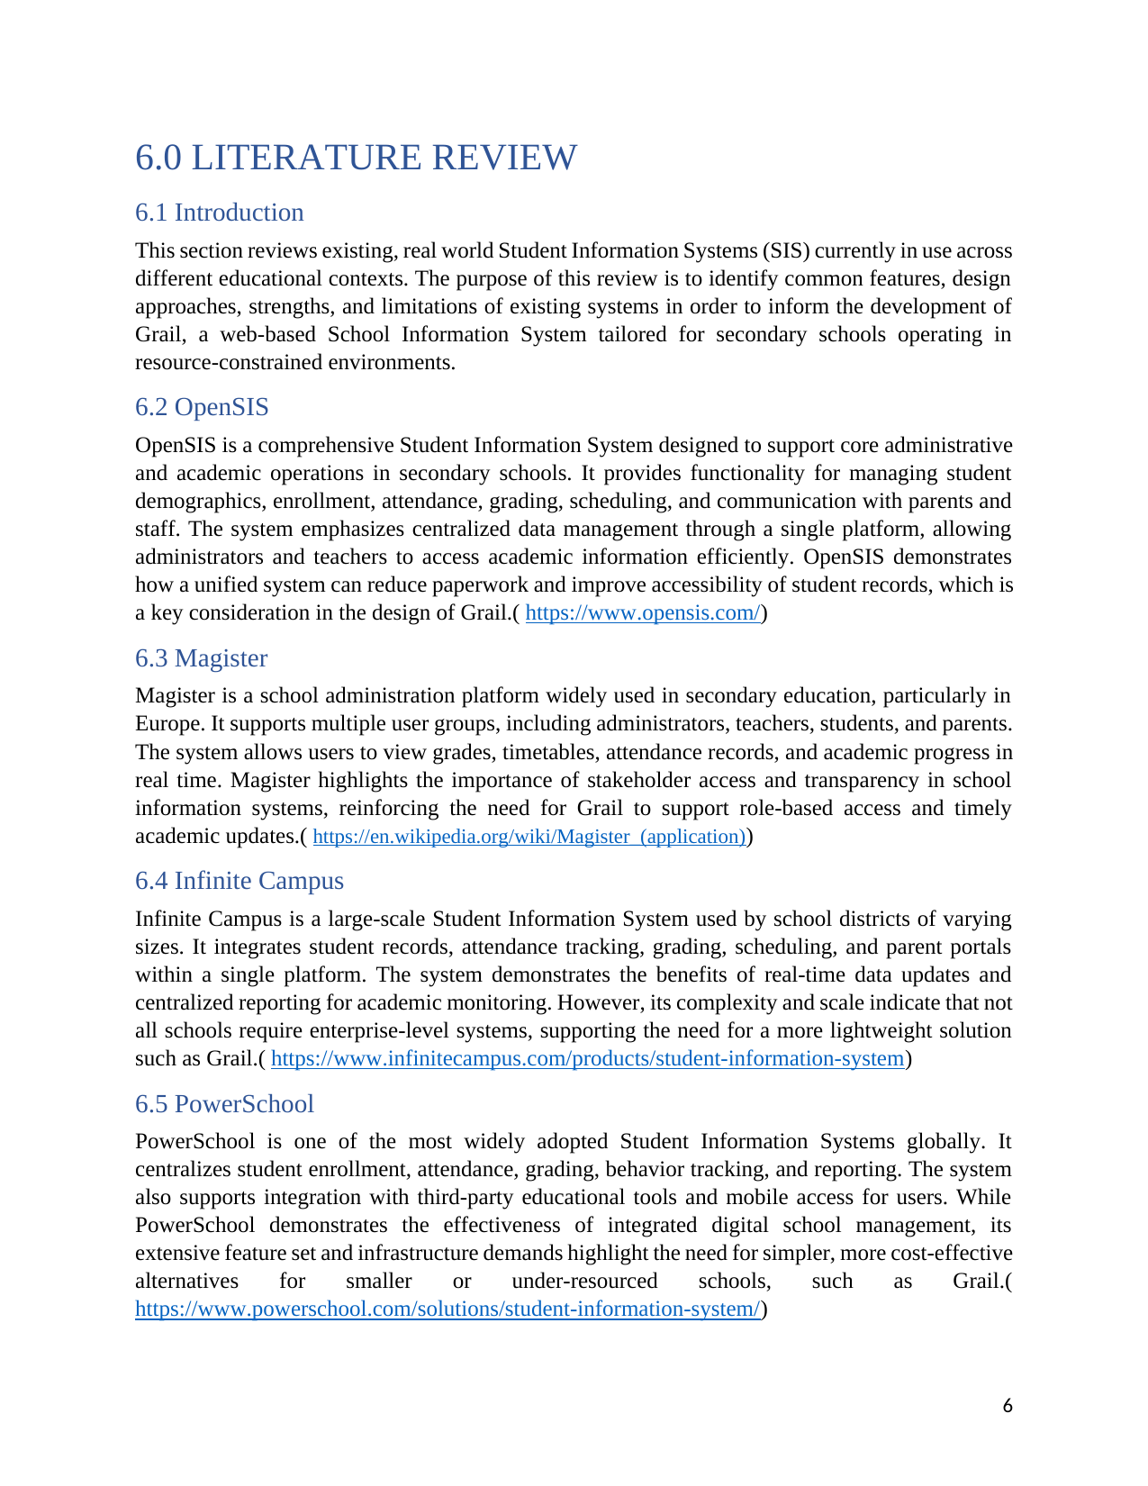
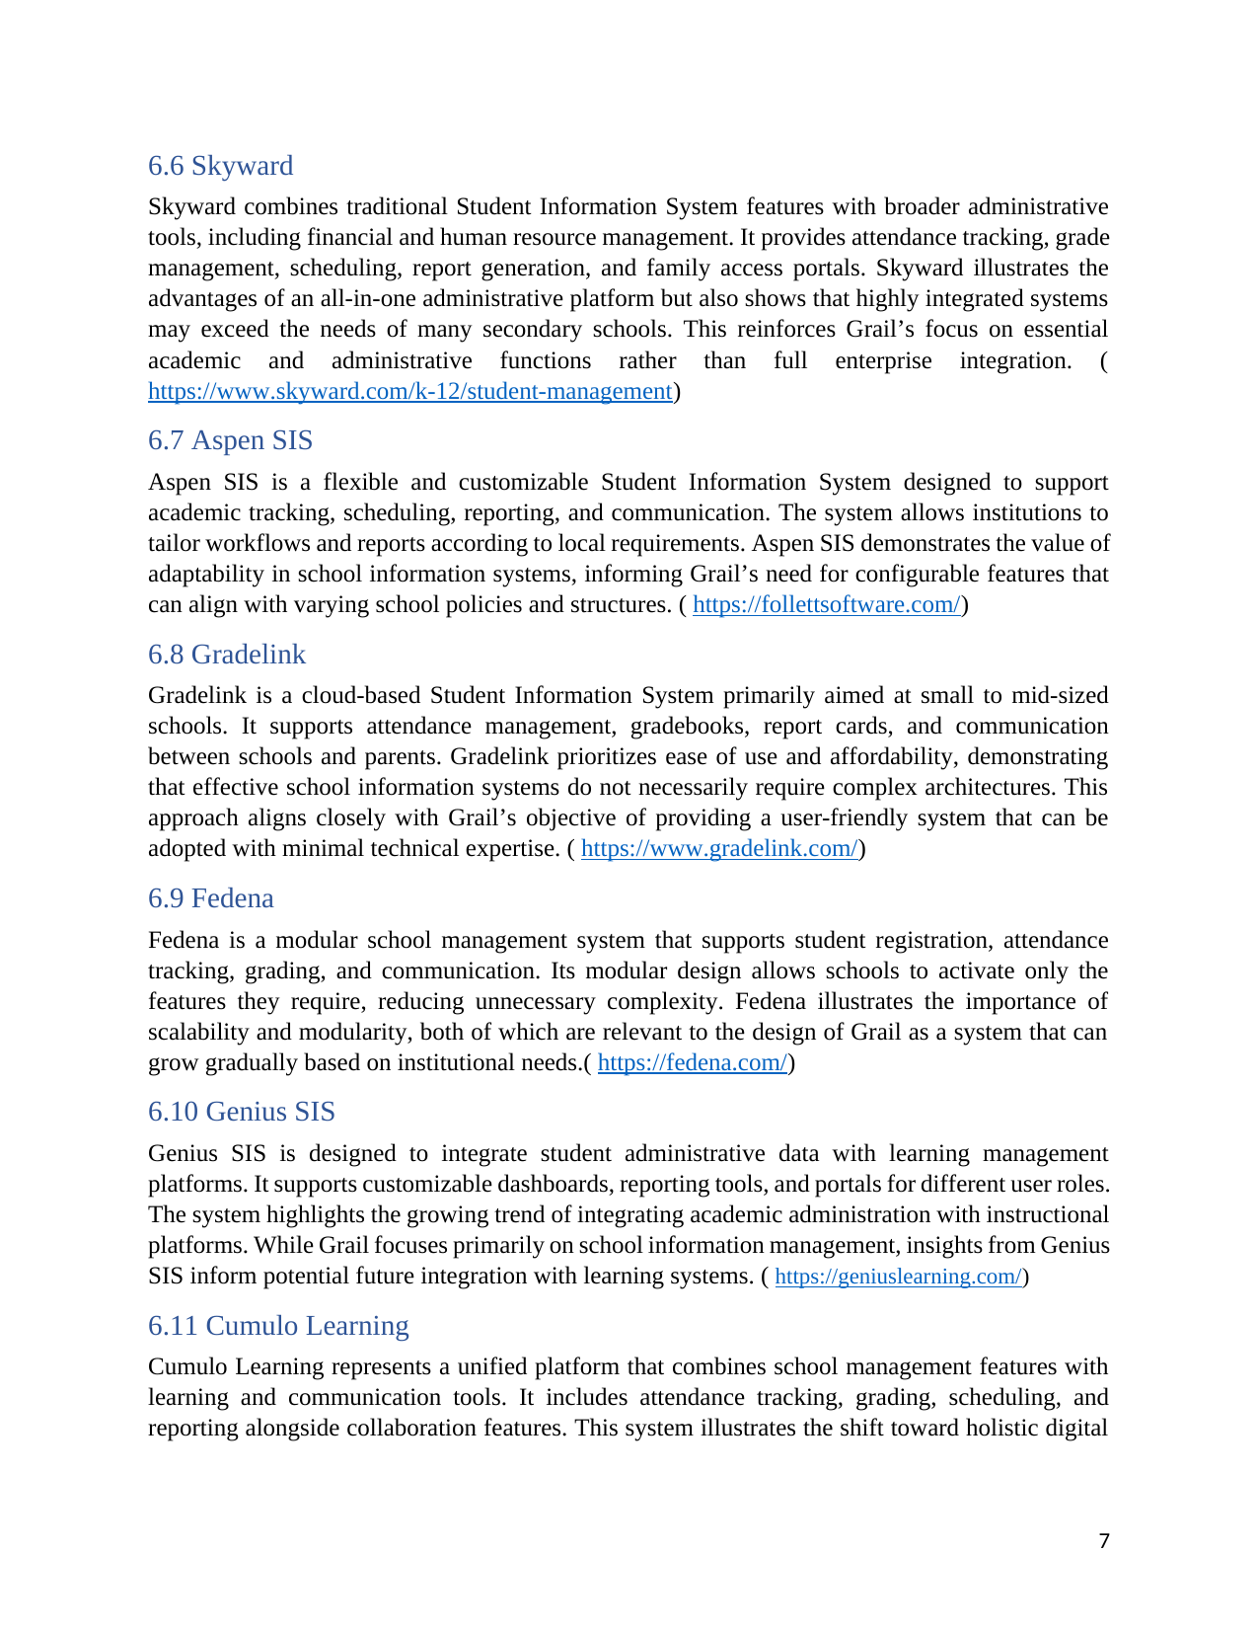
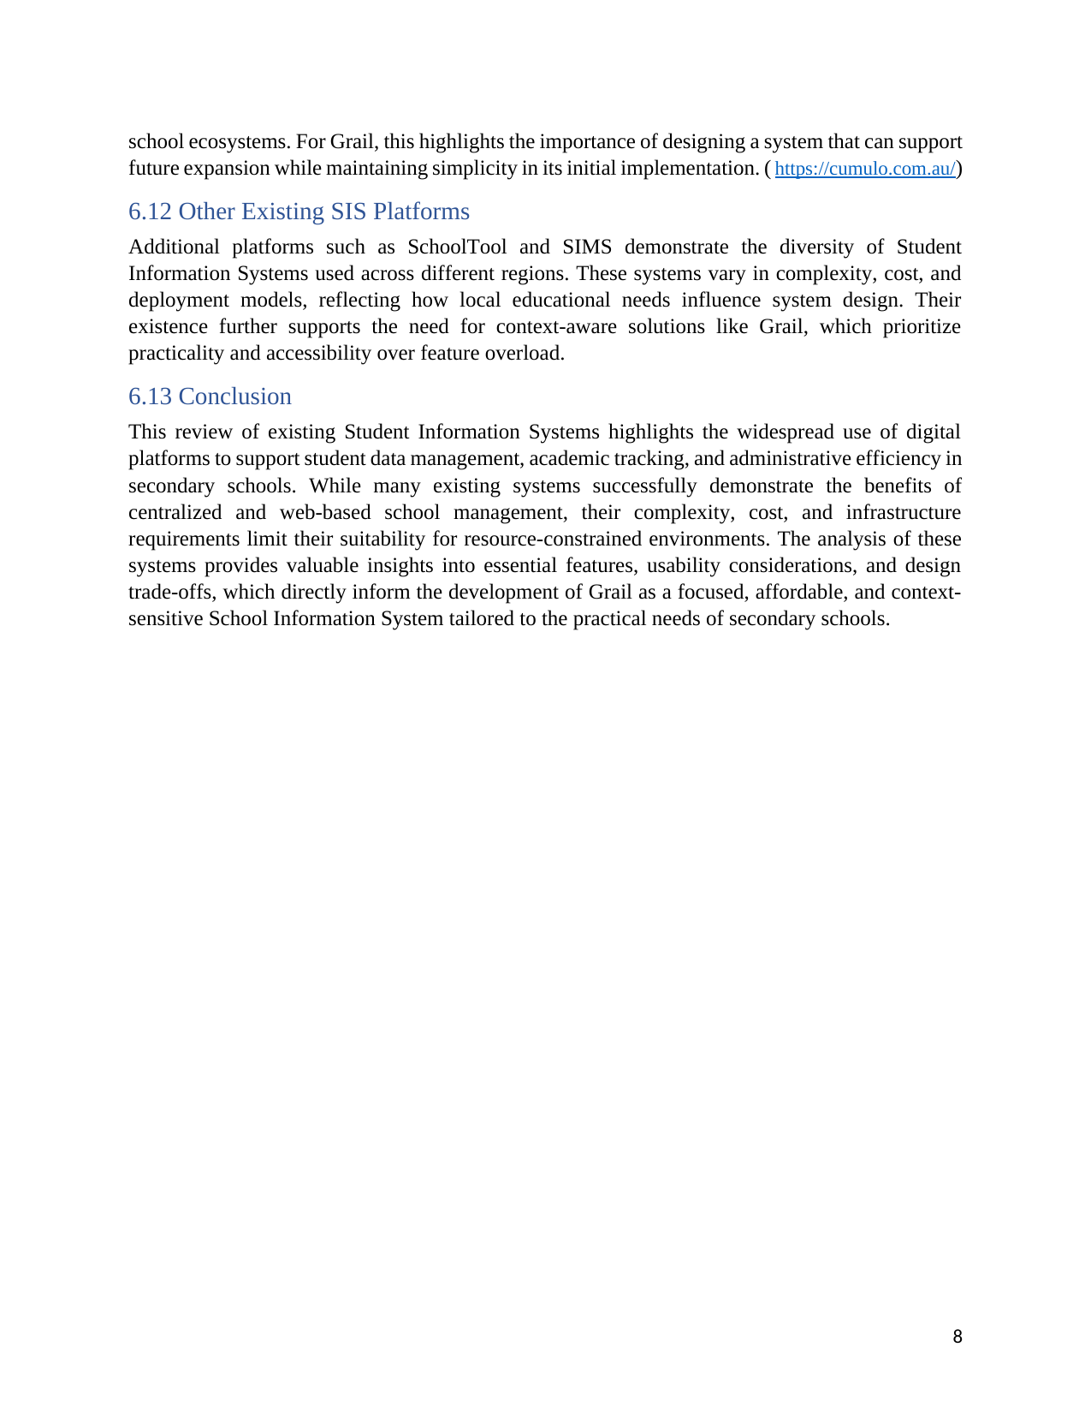
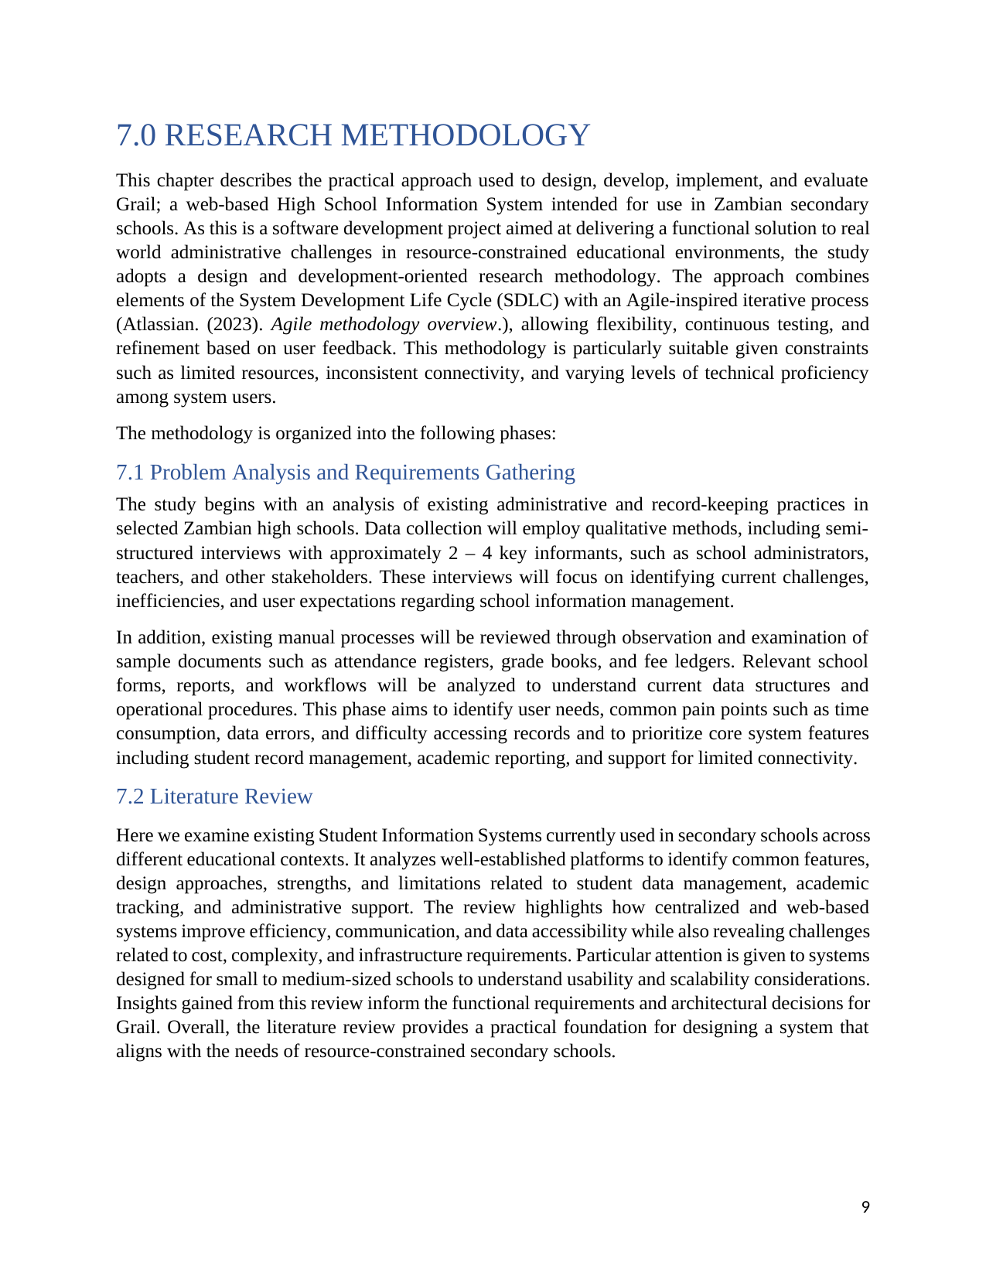

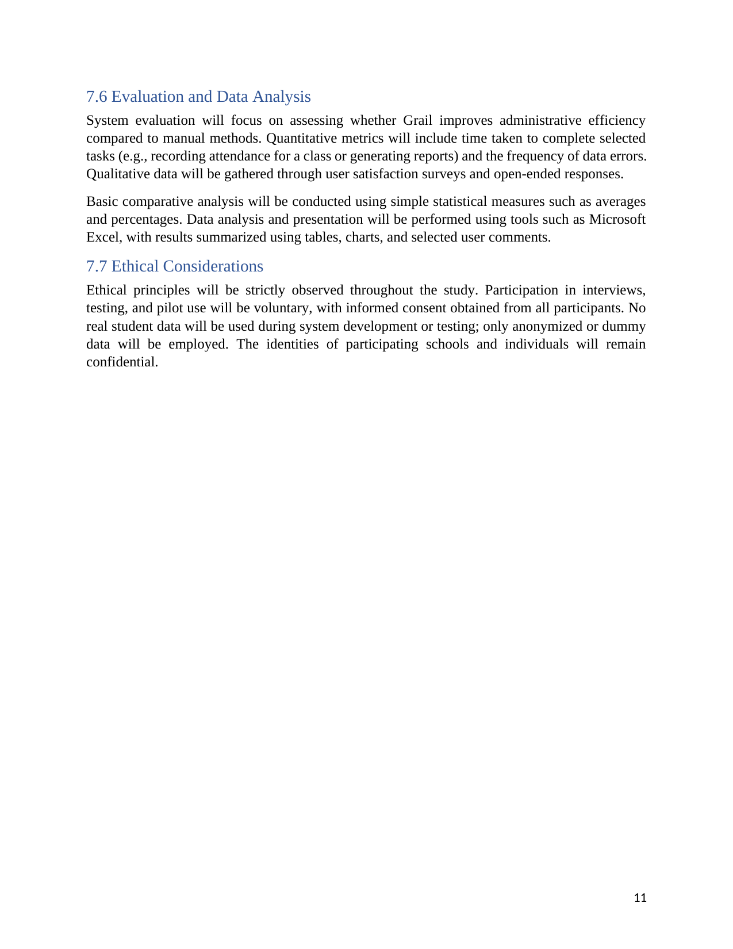
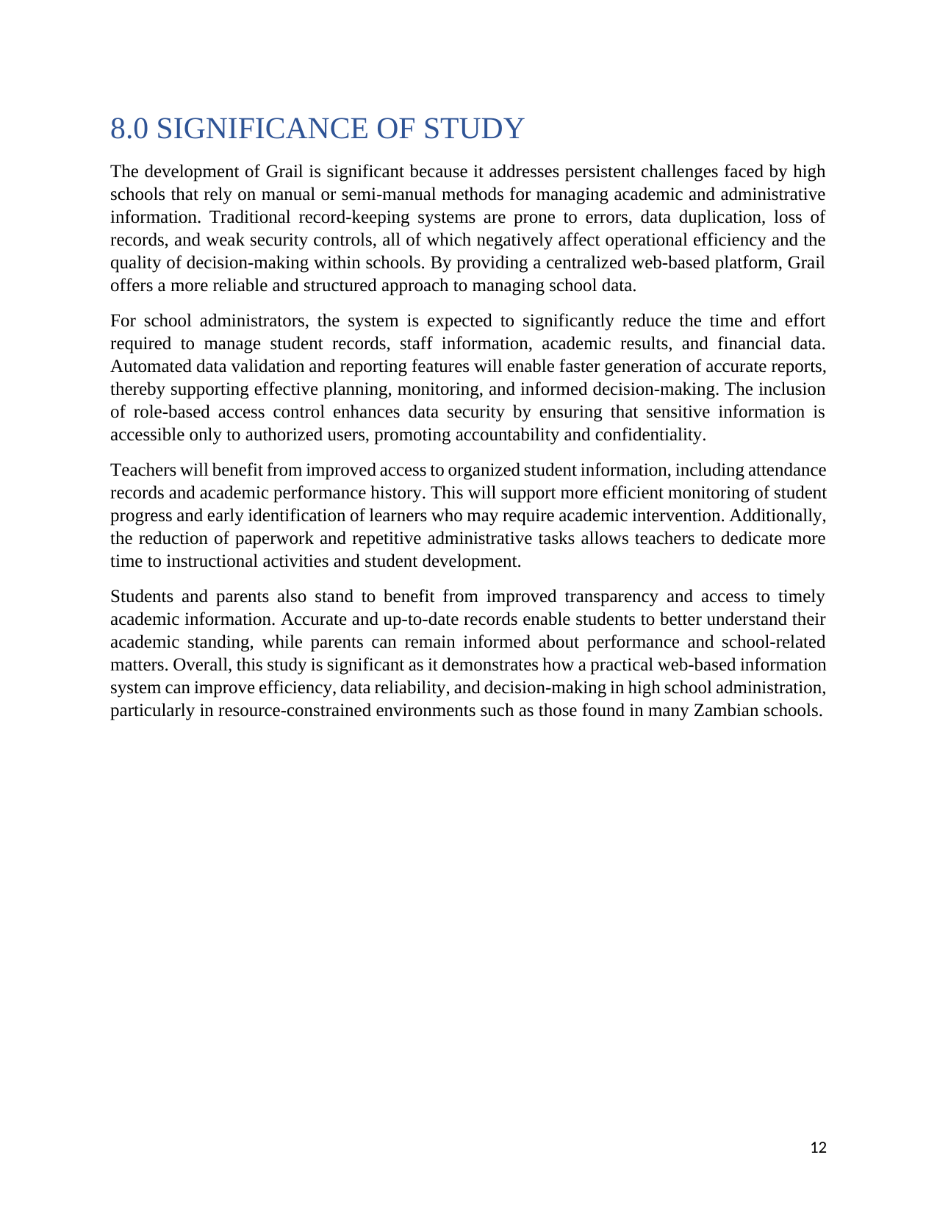
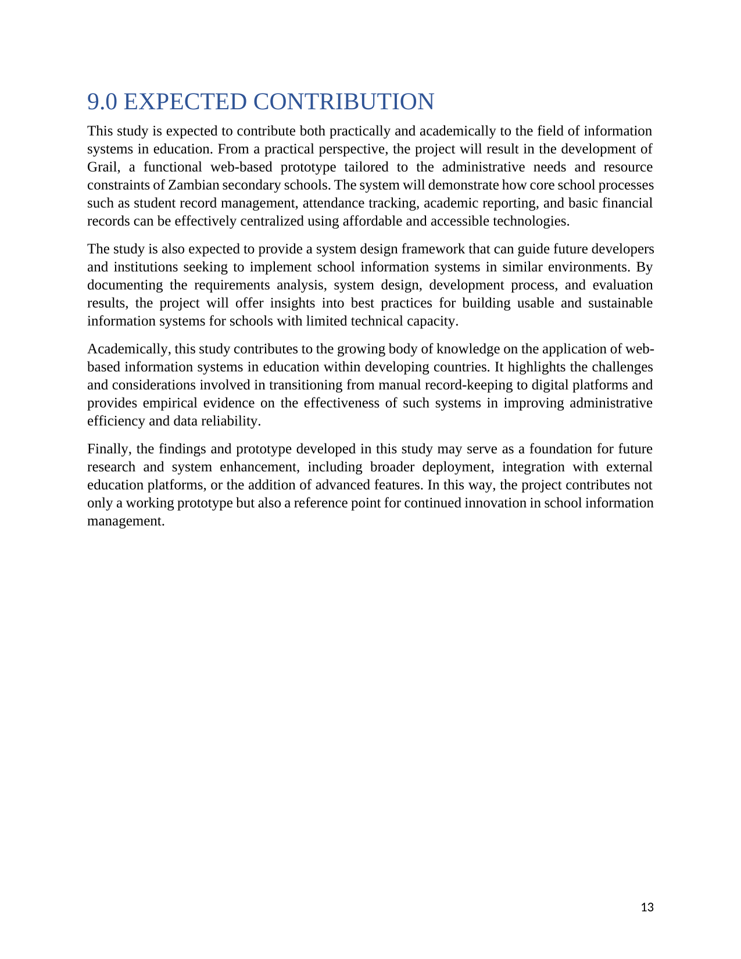
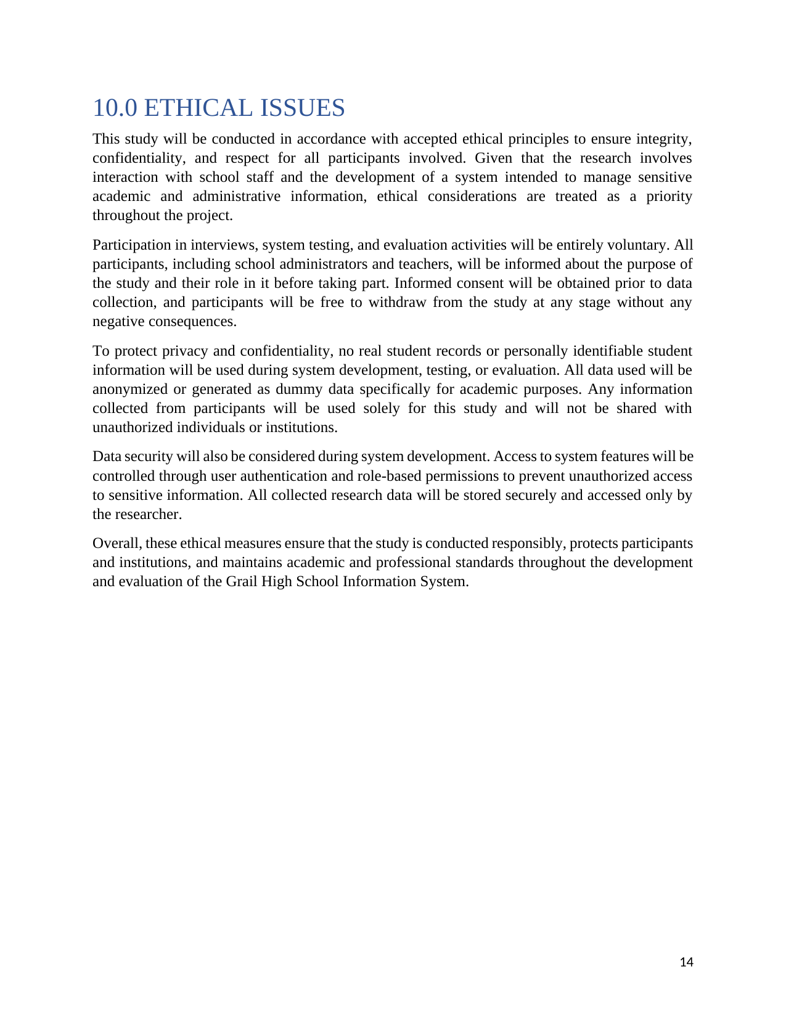
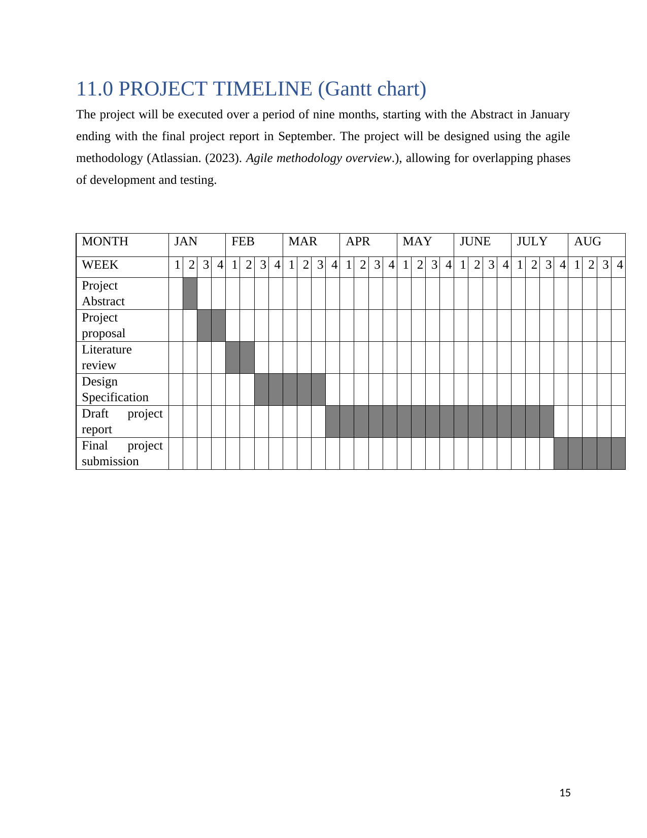
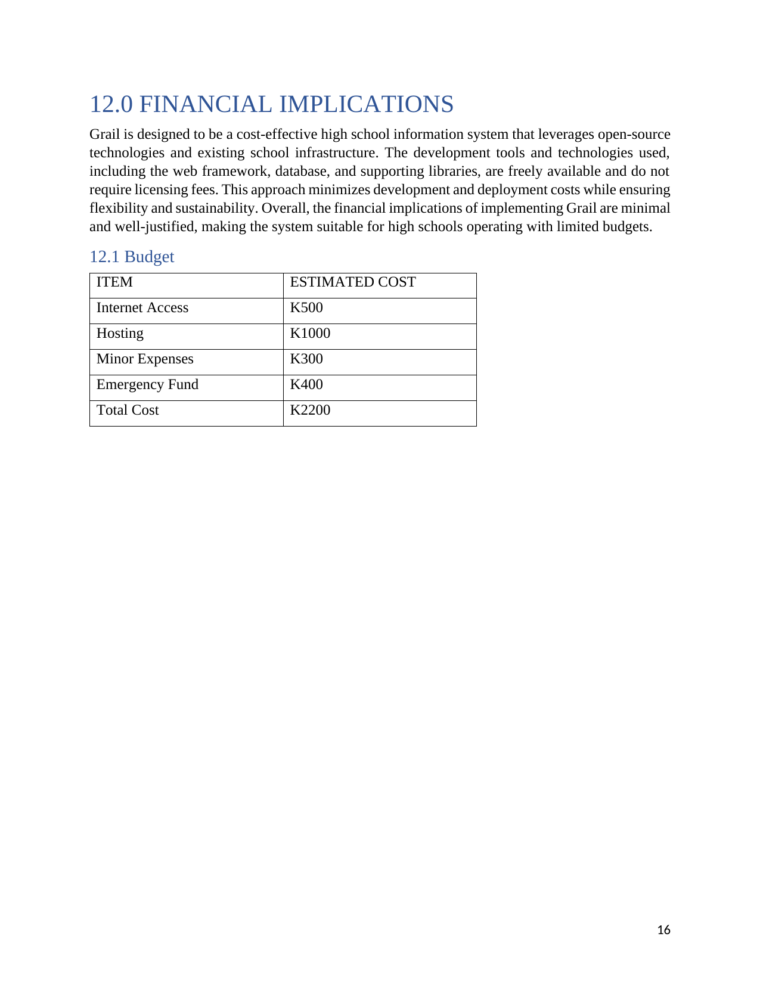
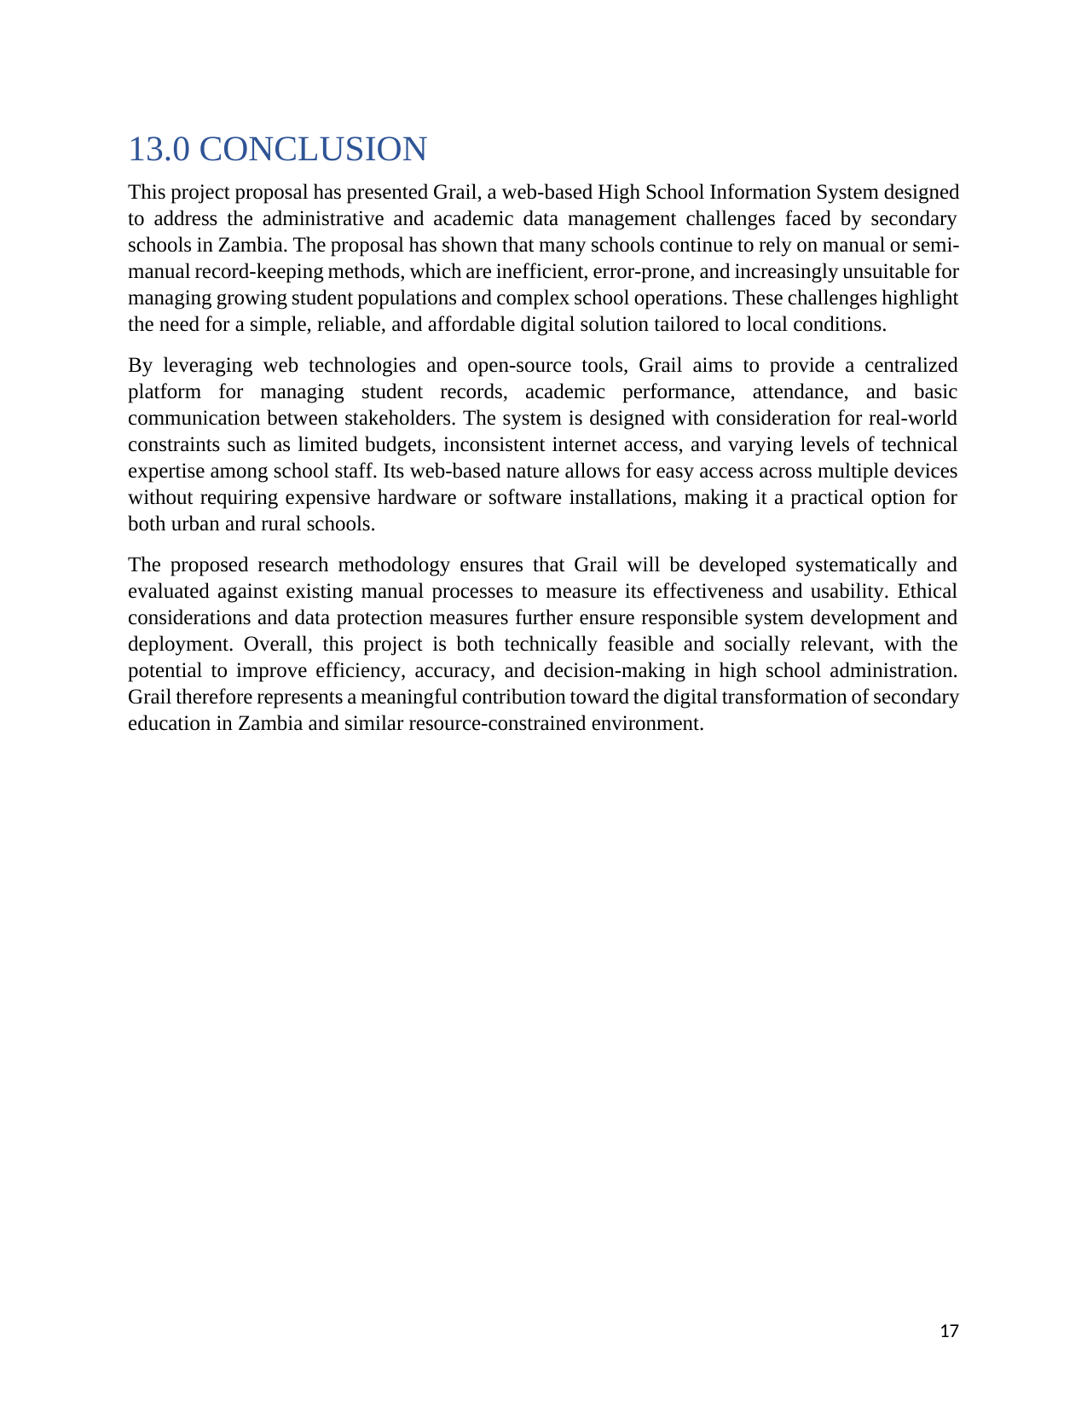
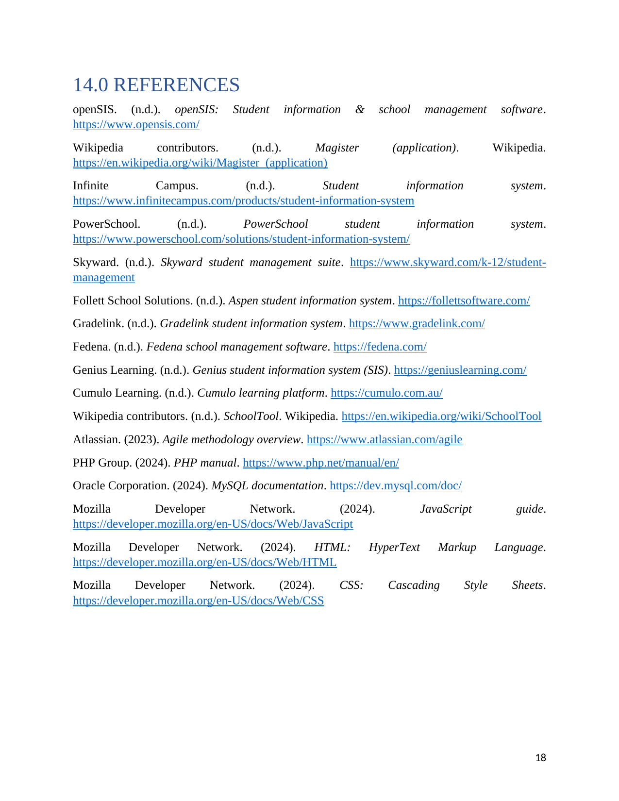

Appendix 2: Installation Manual

A2.1 Prerequisites
Grail is a standard Laravel application and can be installed on any machine that meets the following minimum requirements. The development and testing environment used for this project was a local XAMPP stack on Windows, and the instructions below are written for that setup; the same steps apply with trivial changes on macOS or Linux.
- XAMPP 8.2.x (bundles Apache 2.4 and MySQL 8.0/MariaDB) — or a standalone Apache/Nginx and MySQL 8.0 install.
- PHP 8.2 or later, with the extensions Laravel requires (mbstring, openssl, PDO, pdo_mysql, tokenizer, xml, ctype, json, bcmath) — all enabled by default in XAMPP.
- Composer 2.x, for installing PHP (backend) dependencies.
- Node.js 18 LTS or later with npm, for building the Tailwind CSS front end.
- Git (optional), for cloning the repository instead of copying a ZIP archive.

A2.2 Obtaining the Source Code
Place the project inside the XAMPP web root so Apache can serve it, then move into that directory for the remaining steps:
cd C:\xampp\htdocs
git clone <repository-url> grail
cd grail

A2.3 Installing Dependencies
Install the PHP and JavaScript dependencies declared in composer.json and package.json:
composer install
npm install

A2.4 Environment Configuration
Copy the example environment file and generate the application encryption key. Then edit .env so the database connection matches the local MySQL instance created in XAMPP (the database itself, grail_db, is created empty in the next step by the migrator, not by hand):
copy .env.example .env
php artisan key:generate
DB_CONNECTION=mysql
DB_HOST=127.0.0.1
DB_PORT=3306
DB_DATABASE=grail_db
DB_USERNAME=root
DB_PASSWORD=
Before continuing, start the Apache and MySQL services from the XAMPP Control Panel and confirm MySQL is listening on port 3306 — the most common installation failure at the next step is simply that MySQL has not been started yet (see the troubleshooting table below).

A2.5 Database Migration and Seeding
Running the migrations builds every table described in Appendix 7 in dependency order; seeding then populates them with a representative working dataset (see Appendix 6) so the system is immediately usable for demonstration and testing rather than starting empty:
php artisan migrate
php artisan db:seed
The seeder creates a single default administrator account, printed to the console as it runs. Its credentials (email admin@grail.school, password 12345678) are intentionally simple for a development install and must be changed immediately after the first login on any deployment a real user will access.

A2.6 Building the Front-End Assets
Grail’s views are styled with Tailwind CSS, compiled through Vite. For a one-off production build:
npm run build
During development it is more convenient to run the Vite dev server alongside the application so style and script changes reload automatically:
npm run dev

A2.7 Starting the Application
Two equivalent ways of serving the application were used over the course of this project. Through XAMPP’s Apache, the application is reachable at:
http://localhost/grail/public
Alternatively, Laravel’s own lightweight development server avoids any Apache virtual-host configuration and was the server used for the screenshots in this report:
php artisan serve
which serves the application at http://127.0.0.1:8000.

A2.8 Troubleshooting
The table below lists the installation problems actually encountered while setting up and running Grail during development, and how each was resolved.
Symptom | Likely Cause | Resolution
SQLSTATE[HY000] [2002] on any page that queries the database (e.g. "No such file or directory" / a socket permission error) | MySQL is not running, or is listening on a different port/socket than the one in .env. | Open the XAMPP Control Panel and confirm the MySQL module shows "Running" (start it if not). Check C:\xampp\mysql\data\mysql_error.log for the reason it failed to start — most often another MySQL service, or port 3306, already in use.
"SQLSTATE[42S02]: Base table or view not found" while running migrations | A migration ran out of dependency order (e.g. a foreign key referencing a table created by a later migration). | Run php artisan migrate:fresh to rebuild all tables from scratch in filename (timestamp) order rather than migrating incrementally over a partial schema.
Blank/unstyled pages, or a 404 for a .css or .js file | The Tailwind/Vite build has not been run, or the dev server was stopped. | Run npm run build for a static build, or keep npm run dev running alongside php artisan serve during development.
"could not find driver" for pdo_mysql | The pdo_mysql PHP extension is disabled. | In php.ini, uncomment extension=pdo_mysql and restart Apache from the XAMPP Control Panel.
419 Page Expired on login | The session/cache tables are stale or APP_KEY is unset. | Confirm php artisan key:generate has been run, then clear cached config: php artisan config:clear.

Appendix 3: User Manual

A3.1 Signing In
Every user, regardless of role, signs in from the same login screen with the email address and password issued to them. Grail then redirects the user to the dashboard for their role — Administrator, Teacher, Parent or Student — and every screen described below is reached from that dashboard’s navigation. A user who is deactivated by an administrator (see A3.2) cannot sign in until reactivated.

A3.2 Administrator
- Dashboard — a summary view of school-wide counts (students, teachers, classes) and shortcuts into the modules below.
- Students — register a new student, edit their profile and class assignment, and view or soft-delete an existing record; deleted students are retained (not erased) so historical attendance, grades and fee records stay intact.
- Teachers — register a teacher, set which subjects they are qualified to teach (independent of any class), assign them to teach a specific subject in a specific class, and optionally make them the homeroom teacher of a class. These are three distinct actions: a subject qualification alone does not put a teacher in front of a class, and a class can only have one homeroom teacher at a time, assigned either from this screen or from the Classes screen described next.
- Classes — create a class (e.g. "Grade 10A"), attach it to a grade level, and set or change its homeroom teacher from a dropdown of registered teachers, independently of that teacher’s own qualifications screen.
- Subjects — maintain the master list of subjects offered by the school.
- Grade Levels — maintain the ordered list of grade levels (e.g. Grade 8 through Grade 12) that classes and timetable periods are organised around.
- Parents/Guardians — register a parent account and link it to one or more students, so that a single login can see every one of their children.
- Fees — create a fee for a student built up from individual line items (tuition, boarding, activity fees, etc.), which the system totals automatically; edit or delete a fee; look up a fee instantly from the payment reference a parent quotes; act on many fees at once (mark cleared, mark overdue, send a reminder, export to CSV, or delete) from the fees list; and manage the fee category list used when building line items.
- User Accounts — activate or deactivate a login, force a password reset, or change a user’s role.
- Audit Logs — review a read-only trail of who created, changed or deleted a record and when, for accountability over sensitive actions such as grade changes and fee adjustments.
- Announcements — publish a notice targeted at a specific role, grade level or class, or the whole school.
- Academic Calendar — maintain academic years and the terms within them, and mark which one is current so the rest of the system (grades, fees, timetables) defaults to it.
- Timetable — build each class’s weekly timetable by placing a subject and teacher into a period/day slot, copy a timetable between terms, or clear it.
- Promotions — move a cohort of students from one class or grade level to the next at the end of an academic year, with the mapping reviewable before it is applied and reversible via rollback if a mistake is made.
- Report Cards — oversight of term report cards across the school (see also A3.3, where the class teacher finalises them).

A3.3 Teacher
- Dashboard — the classes and subjects assigned to the signed-in teacher, and shortcuts into today’s tasks.
- Attendance — mark each student in a class-subject Present, Absent or Late for a given date; every entry is attributed to the recording teacher.
- Marks — enter continuous-assessment and examination scores for a class-subject against the term’s maximum score; entries are validated against that maximum before being saved.
- Assignments — create an assignment for a class-subject, review and grade student submissions.
- Class Roster — the list of students in a class the teacher is the homeroom teacher for, or teaches a subject in.
- Timetable — the teacher’s own weekly schedule, drawn from the slots an administrator has built.
- Report Cards — for a homeroom teacher only: add a class-teacher comment to each student’s term report card, then finalise the term — which computes each student’s term average and class rank and locks the card so parents and students can see it. A finalised term can be reopened by an administrator if a correction is needed.
- Performance — a summary of how a class or subject is trending over a term, to help spot students who need attention before report cards are finalised.

A3.4 Parent
- Dashboard — an overview for the currently selected child.
- Child switcher — a parent linked to more than one student at the school can switch between children from a single login; every other screen reflects whichever child is currently selected.
- Timetable — the selected child’s weekly class timetable.
- Attendance — the selected child’s attendance history.
- Performance — a running view of the selected child’s marks across the term, ahead of the formal report card.
- Reports — view and download the selected child’s finalised report card for a chosen term and year once the class teacher has finalised it.
- Assignments — the selected child’s outstanding and past assignments.
- Fees — the selected child’s fee balance and payment history, including the printable payment reference used to pay at the school office or by mobile money, and a receipt for each recorded payment.
- Announcements — notices published to the parent’s role, or to their child’s class or grade level.
- Settings — update contact details and change password.

A3.5 Student
- Dashboard — a personal summary for the signed-in student.
- Results — the student’s own marks and, once finalised, term report cards.
- Assignments — outstanding and past assignments and, where enabled, online submission.
- Timetable — the student’s own weekly class timetable.

Appendix 4: Sections of Program Code
The two listings below are reproduced directly from the project’s source tree. They were chosen because each solves a central, non-trivial problem of the project rather than being generated boilerplate: the first gives every fee a tamper-evident reference number and keeps its paid/owing status always correct; the second is the fix, made during this project, that keeps a teacher’s subject qualifications and their actual timetabled classes from being silently conflated.

A4.1 Fee state machine and payment reference (app/Models/Fee.php)
A fee’s amount_due is never typed in directly — it is always the sum of its line items, recalculated automatically whenever the fee is saved with its items loaded. status is likewise never set by hand: it is always derived from the current balance and due date, so the four figures shown to a parent (due, paid, balance, status) can never drift out of sync with each other.
public function recalculateAmountDue(): void
{
$this->amount_due = $this->feeItems()->sum('amount');
$this->balance = round($this->amount_due - $this->amount_paid, 2);
$this->status = $this->computeStatus();
$this->last_updated = Carbon::now();
}
protected static function booted(): void
{
static::saving(function ($fee) {
if ($fee->exists && $fee->relationLoaded('feeItems')) {
$fee->recalculateAmountDue();
}
});
}
public function recordPayment(float $amount): void
{
if ($amount <= 0) {
throw new \InvalidArgumentException('Payment amount must be greater than zero.');
}
$this->amount_paid = round($this->amount_paid + $amount, 2);
$this->balance = round($this->amount_due - $this->amount_paid, 2);
$this->last_updated = Carbon::now();
$this->status = $this->computeStatus();
$this->save();
}
public function computeStatus(): string
{
if ($this->balance <= 0) {
return 'Cleared';
}
if ($this->amount_paid > 0) {
return 'Partially Paid';
}
if ($this->due_date && $this->due_date->isPast() && $this->balance > 0) {
return 'Overdue';
}
return 'Pending';
}
Every fee also carries a stable, human-quotable payment reference such as GRL-0042-0117-K, which a parent reads out at the school office or types into a mobile-money payment. The reference is not stored — it is derived deterministically from the student and fee IDs, so it never needs to be looked up or regenerated. Its final character is a weighted checksum over a 26-symbol alphabet that deliberately excludes character pairs people commonly confuse when copying a code off a phone screen (I/1, O/0, S/5, Z/2, B/8); a single mistyped or transposed digit therefore fails the check rather than silently resolving to a different family’s fee:
private const REF_ALPHABET = 'ACDEFGHJKLMNPQRTUVWXY34679';
public function getPaymentReferenceAttribute(): string
{
$body = sprintf('%04d-%04d', $this->student_id, $this->fee_id);
return 'GRL-' . $body . '-' . self::checkCharacter($body);
}
private static function checkCharacter(string $body): string
{
$digits = preg_replace('/\D/', '', $body);
$sum = 0;
foreach (str_split($digits) as $i => $digit) {
$sum += ((int) $digit) * ($i + 2);
}
return self::REF_ALPHABET[$sum % strlen(self::REF_ALPHABET)];
}

A4.2 Separating subject qualification from a real teaching assignment (app/Http/Controllers/Admin/AdminTeacherController.php)
Grail distinguishes three related but different facts about a teacher: the subjects they are qualified to teach (teacher_subjects, independent of any class), the specific subject-in-class pairings they actually teach (class_subjects, which is what drives marks, attendance and report cards), and whether they are a class’s homeroom teacher (school_classes.teacher_id). Early in development these were conflated — ticking a subject on the teacher form without also ticking a class silently created nothing, even though the form told the admin subjects were assigned independently of homeroom classes. syncTeachingAssignments() is the corrected logic that turns the form’s class and subject selections into real class_subjects rows, refusing to steal a pairing another teacher already holds:
/**
* Turn the form's class and subject tick-boxes into real teaching rows.
*
* The teacher portal — marks, attendance, assignments, report cards,
* class performance — resolves everything through class_subjects, so a
* teacher with none of these rows logs in to an empty portal no matter
* what the admin ticked. The form gives a flat list of classes and a
* flat list of subjects, so the pairing is every selected subject in
* every selected class; anything more specific is set on the teacher's
* own page.
*
* Never steals a pair another teacher already holds — those are returned
* as skipped so the admin can hand them over deliberately.
*
* @return array{created: int, skipped: array<int, string>}
*/
private function syncTeachingAssignments(Teacher $teacher, array $classIds, array $subjectIds): array
{
if (empty($classIds) || empty($subjectIds)) {
return ['created' => 0, 'skipped' => []];
}
$created = 0;
$skipped = [];
$classes = SchoolClass::whereIn('class_id', $classIds)->get()->keyBy('class_id');
$subjects = Subject::whereIn('subject_id', $subjectIds)->get()->keyBy('subject_id');
foreach ($classIds as $classId) {
foreach ($subjectIds as $subjectId) {
$existing = ClassSubject::with('teacher')
->where('class_id', $classId)
->where('subject_id', $subjectId)
->first();
if ($existing) {
if ((int) $existing->teacher_id !== (int) $teacher->teacher_id) {
$holder = $existing->teacher?->full_name ?? 'another teacher';
$label = ($subjects[$subjectId]->subject_name ?? 'Subject')
. ' in ' . ($classes[$classId]->display_name ?? 'that class');
$skipped[] = "{$label} (taught by {$holder})";
}
continue;
}
ClassSubject::create([
'class_id' => $classId,
'subject_id' => $subjectId,
'teacher_id' => $teacher->teacher_id,
]);
$created++;
}
}
return ['created' => $created, 'skipped' => $skipped];
}
The subject-qualification checkboxes themselves are synced separately and unconditionally, so a qualification is recorded even when the admin has not yet also picked a class for the teacher to teach it in:
// Subject qualifications (teacher_subjects) are free to add and
// remove, independently of which classes the teacher is timetabled
// against — unlike class_subjects, which is only ever added here.
$teacher->subjects()->sync($validated['subject_ids'] ?? []);

Appendix 5: Questionnaires
Section 7.1 of this report (Problem Analysis and Requirements Gathering) describes a requirements-gathering exercise with teachers and administrators at selected secondary schools, combining semi-structured interviews with a short written questionnaire. The instrument below is reconstructed from that methodology to document the questions used and how responses were intended to be scored; the team’s original Google Forms export, if retained, should be substituted here as the definitive record of actual responses.

A5.1 Respondent Background
- Role at the school (Administrator / Class or Subject Teacher / Head of Department / Other)
- Years of experience in that role
- Approximate number of students the school currently enrols
- Current method used to keep academic and administrative records (paper registers / spreadsheets / another software system / a mix)

A5.2 Current Process and Pain Points (Likert scale)
Respondents were asked to rate each statement from 1 (Strongly Disagree) to 5 (Strongly Agree).
Statement | 1 SD | 2 D | 3 N | 4 A | 5 SA
Finding a specific student’s academic record currently takes longer than it should. | □ | □ | □ | □ | □
Attendance registers are difficult to consolidate into a termly or yearly summary. | □ | □ | □ | □ | □
Compiling report cards at the end of a term is a slow, largely manual process. | □ | □ | □ | □ | □
Tracking which students have or have not paid school fees is currently difficult. | □ | □ | □ | □ | □
Parents currently have limited, timely visibility into their child’s attendance and performance. | □ | □ | □ | □ | □
Errors (e.g. miscalculated totals, misfiled records) occur often enough to be a concern. | □ | □ | □ | □ | □
Staff would be comfortable using a web-based system to replace the current process. | □ | □ | □ | □ | □

A5.3 Desired Features (open-ended)
- Which of the following would be most valuable to your school: centralised student records, automated attendance, digital gradebooks and report cards, or fee tracking? Why?
- What is the single biggest obstacle you expect to adopting a new school information system (e.g. staff training, internet reliability, cost, data migration from existing records)?
- Are there any features specific to your school’s process that a generic system might miss?
Responses gathered through this instrument, together with the review of existing systems in Chapter 2, directly shaped the functional requirements in Chapter 3 and the module list in Chapter 4 — in particular the emphasis on a single centralised record per student, automatic rather than manually-typed totals wherever a figure is derived from other data (fee balances, report-card averages), and a simple, low-bandwidth-friendly interface for parents.

Appendix 6: Data Files

A6.1 Seed Data
Rather than starting from an empty database, Grail ships a set of Laravel database seeders that populate every table with a consistent, representative working dataset in a single command (php artisan db:seed — see Appendix 2). In line with the ethical considerations in the original proposal (Appendix 1, §10.0), no real student, parent or staff data from any school was used at any point; every seeded record is synthetic. The seeders run in the dependency order below, each depending on the tables the ones before it created (for example, a student cannot be seeded until the class it belongs to exists):
Seeder | What it populates
RoleSeeder | The four fixed account roles — admin, teacher, parent, student.
AdminSeeder | The single default administrator account used for the first login.
AcademicYearSeeder | The academic year(s) and which one is current, that every term below belongs to.
SubjectSeeder | The master list of subjects offered by the school.
TeacherSeeder | A set of teacher accounts and profiles.
SchoolClassSeeder | The classes (one per grade level/stream) that students and timetables are organised around.
ClassSubjectSeeder | The subject-in-class teaching assignments that connect the classes, subjects and teachers seeded above.
StudentSeeder | A set of students distributed across the seeded classes.
ParentSeeder | A parent account linked to each student that does not already have one.
AttendanceSeeder | Sample attendance entries against each class-subject.
GradeSeeder | Sample continuous-assessment and examination scores for the seeded students.
FeeSeeder | A fee per student per term, built from line items so amount_due is exercised as a computed total from the first run.
FeeCategorySeeder | The fee categories (tuition, boarding, activity, etc.) used when building a fee’s line items.
AuditLogSeeder | Sample audit trail entries illustrating the compliance logging described in Chapter 5.
GradeLevelSeeder | The ordered list of grade levels (Grade 8 through Grade 12) classes and timetable periods attach to.
AssignmentSeeder | Sample assignments against the seeded class-subjects.
TimetableSeeder | A sample weekly timetable of period/day slots for the seeded classes.
AnnouncementSeeder | Sample announcements targeted at different roles, classes and grade levels.

A6.2 Exported Data Files
Several admin screens export the data currently on screen as a CSV file the user can open in a spreadsheet or hand to the school’s finance office; the fee export (Admin → Fees → Export) is representative. It streams the selected fee records directly to the browser with the following column layout:
Fee ID,Student,Class,Term,Year,Amount Due,Paid,Balance,Status,Due Date
1,Jane Banda,Grade 10A,Term 1,2026,2500.00,2500.00,0.00,Cleared,2026-02-14
2,Mwansa Phiri,Grade 10A,Term 1,2026,2500.00,1200.00,1300.00,Partially Paid,2026-02-14
The two data rows above are illustrative only, shown to document the export format rather than as real fee records; every figure that would otherwise need to be typed by hand — Amount Due, Balance and Status — is instead computed by the Fee model described in Appendix 4, so the export can never disagree with what a parent sees in their own portal.

Appendix 7: Component Specifications

A7.1 Overview
The entity-relationship diagram in Chapter 4 shows how these tables relate to one another; this appendix lists, cluster by cluster, the definition of every table behind that diagram as actually implemented, reproduced from the project’s Laravel migrations. Column types are given at the level meaningful to a reader (string, decimal, enum, foreign key) rather than the exact database-driver type; every table additionally carries created_at/updated_at timestamps unless noted otherwise.

A7.2 Identity and Access

users
The login account behind every human user — admin, teacher, parent or student.
Column | Type | Notes
id | bigint, PK | Auto-incrementing primary key.
name | string
email | string, unique | Used to sign in.
role | string | admin / teacher / parent / student; default 'teacher'.
is_active | boolean | A deactivated account cannot sign in (Appendix 3, User Accounts).
password | string | Hashed.
email_verified_at | timestamp, nullable

roles
The four fixed account roles, seeded once by RoleSeeder.
Column | Type | Notes
id | bigint, PK
name | string, unique | admin / teacher / parent / student.
description | string, nullable

teachers
HR/profile data for a teacher, one-to-one with a users row.
Column | Type | Notes
teacher_id | bigint, PK
user_id | FK → users | Cascades on delete.
first_name / last_name | string
email | string, unique
phone | string, nullable
deleted_at | timestamp, nullable | Soft delete — a former teacher’s historical records are preserved.

students
A student’s profile and enrolment record.
Column | Type | Notes
student_id | bigint, PK
user_id | FK → users, nullable | A student may be pre-registered before receiving login credentials.
parent_user_id | FK → users, nullable | The linked parent account, if one exists yet.
first_name / last_name | string
date_of_birth | date
gender | enum('Male','Female')
student_number | string, unique | School-issued ID, e.g. "2024/001".
class_id | FK → school_classes, nullable | Nullable during initial registration.
guardian_name / guardian_phone | string, nullable | Quick-access contact copy, independent of a linked parent account.
enrolment_date | date
deleted_at | timestamp, nullable | Soft delete.

parents
A parent/guardian profile, one-to-one with a users row.
Column | Type | Notes
parent_id | bigint, PK
user_id | FK → users | Cascades on delete.
first_name / last_name | string
email | string, unique
phone / address / occupation | string, nullable
national_id | string, nullable, unique | NRC number.
deleted_at | timestamp, nullable | Soft delete.

A7.3 Academic Structure

school_classes
A class/stream, e.g. "Grade 10A".
Column | Type | Notes
class_id | bigint, PK
class_name | string
grade_level | string | Legacy free-text label, kept alongside grade_level_id below.
grade_level_id | FK → grade_levels, nullable | Structured grade level, added to replace the free-text column.
teacher_id | FK → teachers, nullable | The homeroom teacher; set to null (not deleted) if that teacher record is removed.
deleted_at | timestamp, nullable | Soft delete.

subjects
The master subject list.
Column | Type | Notes
subject_id | bigint, PK
subject_name | string, unique

class_subjects
The real teaching assignment: one subject, in one class, taught by one teacher.
Column | Type | Notes
class_subject_id | bigint, PK
class_id | FK → school_classes | Cascades on delete.
subject_id | FK → subjects | Cascades on delete.
teacher_id | FK → teachers | Restricted — a teacher with active assignments cannot be deleted outright.
(unique) | — | class_id + subject_id: a subject can only be assigned once per class.

teacher_subjects
A teacher’s subject qualifications, independent of any class (Appendix 4, A4.2).
Column | Type | Notes
id | bigint, PK
teacher_id | FK → teachers | Cascades on delete.
subject_id | FK → subjects | Cascades on delete.
(unique) | — | teacher_id + subject_id.

grade_levels
The ordered list of grade levels classes and periods attach to.
Column | Type | Notes
grade_level_id | bigint, PK
name | string, unique | e.g. "Grade 10".
order | integer, indexed | Sort order, e.g. 10, 11, 12.

periods
A named timetable period (e.g. "Period 3") within a grade level’s day.
Column | Type | Notes
id | bigint, PK
grade_level_id | FK → grade_levels | Restricted on delete.
name | string
start_time / end_time | time
order | unsigned integer
is_break | boolean | Marks a break/interval rather than a teaching period.
(unique) | — | grade_level_id + order.

timetable_slots
One class’s subject/teacher placement into a period on a given day, for a given term.
Column | Type | Notes
id | bigint, PK
school_class_id | FK → school_classes | Restricted on delete.
subject_id | FK → subjects, nullable | Restricted on delete.
teacher_id | FK → teachers, nullable | Restricted on delete.
period_id | FK → periods | Restricted on delete.
day_of_week | enum('Monday'..'Friday')
term_id | FK → terms | Restricted on delete.
(unique) | — | class + day + period + term: a class cannot double-book one period.
(index) | — | teacher + term + day + period: fast conflict-checking for a teacher’s own schedule.

A7.4 Academic Records

grades
A single continuous-assessment or exam score for a student in a class-subject.
Column | Type | Notes
grade_id | bigint, PK
student_id | FK → students | Cascades on delete.
class_subject_id | FK → class_subjects | Cascades on delete.
assessment_type | enum('CA','EXAM')
score / max_score | decimal(6,2) | max_score defaults to 100.00.
term / academic_year | string / unsigned smallint
recorded_by | FK → teachers | Audit trail of who entered the score; restricted on delete.
(unique) | — | student + class_subject + assessment_type + term + year: one entry per assessment.

attendances
One day’s attendance status for a student in a class-subject.
Column | Type | Notes
attendance_id | bigint, PK
student_id | FK → students | Cascades on delete.
class_subject_id | FK → class_subjects | Cascades on delete.
date | date
status | enum('Present','Absent','Late')
recorded_by | FK → teachers | Audit trail; restricted on delete.
(unique) | — | student + class_subject + date: one entry per student per lesson per day.

report_cards
One finalised (or draft) term report card per student.
Column | Type | Notes
report_card_id | bigint, PK
student_id | FK → students | Cascades on delete.
term_id | FK → terms | Cascades on delete.
class_id | FK → school_classes, nullable | Snapshot of the class at finalisation, so a later promotion does not rewrite historical rank.
term_average | decimal(5,2), nullable
class_rank / class_size | unsigned smallint, nullable
class_teacher_comment | text, nullable
finalized_at | timestamp, nullable | Null = draft, not visible to parents or students.
finalized_by | FK → teachers, nullable
(unique) | — | student_id + term_id.

A7.5 Finance

fees
One fee (e.g. Term 1 Tuition) owed by a student, totalled from its fee_items.
Column | Type | Notes
fee_id | bigint, PK
student_id | FK → students | Cascades on delete.
description | string, nullable
amount_due / amount_paid / balance | decimal(10,2) | amount_due and balance are recomputed by the model, never set directly (Appendix 4, A4.1).
due_date | date
status | enum('Pending','Partially Paid','Cleared') | Always derived, never set manually.
term / academic_year | string / unsigned smallint
(unique) | — | student + term + year: one fee per student per term.

fee_items
A single line item making up a fee (e.g. "Tuition", "Boarding").
Column | Type | Notes
fee_item_id | bigint, PK
fee_id | FK → fees | Cascades on delete.
item_name / category | string
amount | decimal(10,2)

payments
A single payment recorded against a fee.
Column | Type | Notes
payment_id | bigint, PK
fee_id | FK → fees | Cascades on delete.
amount | decimal(12,2)
payment_method | string(50)
reference_number | string, nullable | The office/bank’s own reference for the transaction, distinct from Grail’s own payment_reference (Appendix 4, A4.1).
payment_date | timestamp
recorded_by | FK → users, nullable | Who captured the payment.

A7.6 Calendar

academic_years
A school year, e.g. "2026".
Column | Type | Notes
year_id | bigint, PK
label | string, unique
start_date / end_date | date
is_current | boolean, indexed | Marks the year the rest of the system defaults to.

terms
A term within an academic year, e.g. "Term 1".
Column | Type | Notes
term_id | bigint, PK
academic_year_id | FK → academic_years | Cascades on delete.
name | string
start_date / end_date | date
is_current | boolean, indexed

A7.7 Audit and Compliance

audit_logs
A read-only compliance trail of who changed what.
Column | Type | Notes
id | bigint, PK
user_id | FK → users, nullable | Who performed the action.
auditable_type / auditable_id | polymorphic | Which record (fee, grade, teacher, etc.) was affected.
action | string(20) | 'created' / 'updated' / 'deleted'.
old_values / new_values | json, nullable | Field-level before/after snapshot.
reason | text, nullable
ip_address / user_agent | string / text, nullable
created_at | timestamp | Append-only — no updated_at column, by design.

